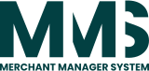
User Guide
MERCHANT MANAGER SYSTEM
VERSION: 2.5.0
REVISION DATE: 25/05/2026

Contents
Introduction 3
System Overview 4
User Guide 5
1. Login & User Authentication 5
2. Stakeholders (Person, Company, Merchant…) 8
2.1. Person 8
2.2. Company 11
2.3. Merchant 15
2.4. Charities 19
2.5. Processors 20
3. Device Manager 22
3.1. Device Registry 22
3.2. Device Manager 25
4. App Manager 53
4.1. Manage Apps 53
4.2. Assign Applications 56
5. Cloud Security 58
5.1. Cloud Security Template 58
5.2. Assign Cloud Security - Restrict Access 60
6. Global Setup 63
6.1. Settings 63
6.2. Industry Categories 66
6.3. Timeouts 67
7. Audit Logs 68

Introduction
This document provides an overview of the Merchant Management System (MMS), including existing features, features currently under development, and planned enhancements, together with their current status and estimated delivery timelines.
The system is designed to manage and operate payment terminals in a centralized manner. It supports the management of terminals, merchants, and companies, and allows administrators to configure and deploy data to terminals efficiently.
Key capabilities of the system include terminal configuration, application and firmware deployment, template-based setup, and centralized control of terminal-related data. The system also supports role-based access control, allowing users to be assigned permissions based on company, role, and organizational responsibilities.
This document is intended for project stakeholders and business users to gain a high-level understanding of the system’s capabilities and current delivery status. Detailed technical specifications and implementation details are out of scope for this document.

System Overview
The Merchant Management System (MMS) is a centralized platform used to manage payment terminals across multiple companies and merchants.
The system enables administrators to register, configure, and maintain terminals, as well as manage merchant and company structures. It allows operational data and configurations to be prepared centrally and deployed to terminals in a controlled and consistent manner.
At a high level, the system supports:
- Terminal lifecycle management, including setup, configuration, and maintenance
- Company and merchant management with hierarchical relationships
- Centralized deployment of applications, firmware, and configuration templates to terminals
- Role-based access control, allowing user permissions to be defined by company and job role
The system is accessed through a web-based interface and is intended for administrators and operational users responsible for terminal operations and system configuration.
At the time of this document, the system includes core terminal and user management capabilities, with additional features being actively developed and enhanced.

User Guide
This section provides step-by-step instructions on how to use the system features. Each feature includes clear guidance to help users perform tasks, along with reference images where applicable.

1. Login & User Authentication
Description:
This guide explains how users can log in to the system securely using their assigned credentials and complete OTP verification.
Test Credentials (For UAT Environment Only):
The following test account is provided for User Acceptance Testing (UAT):
- Email: admin@mms.com
- Password: Admin123@
- OTP Code: 290993
Steps to Log In:
- Open the system login page
- Enter the provided Email and Password
- Click Login
- Enter the OTP Code provided for testing (or received via email)
- Click Verify
- If your account has access to multiple companies:
  - Select the desired Company
- Click Continue to access the system
Notes:
- These credentials are for testing purposes only
- Do not use these credentials in a production environment
- OTP may be fixed for testing or dynamically sent via email
- Contact the administrator if you are unable to log in or encounter any issues
Reference Images:

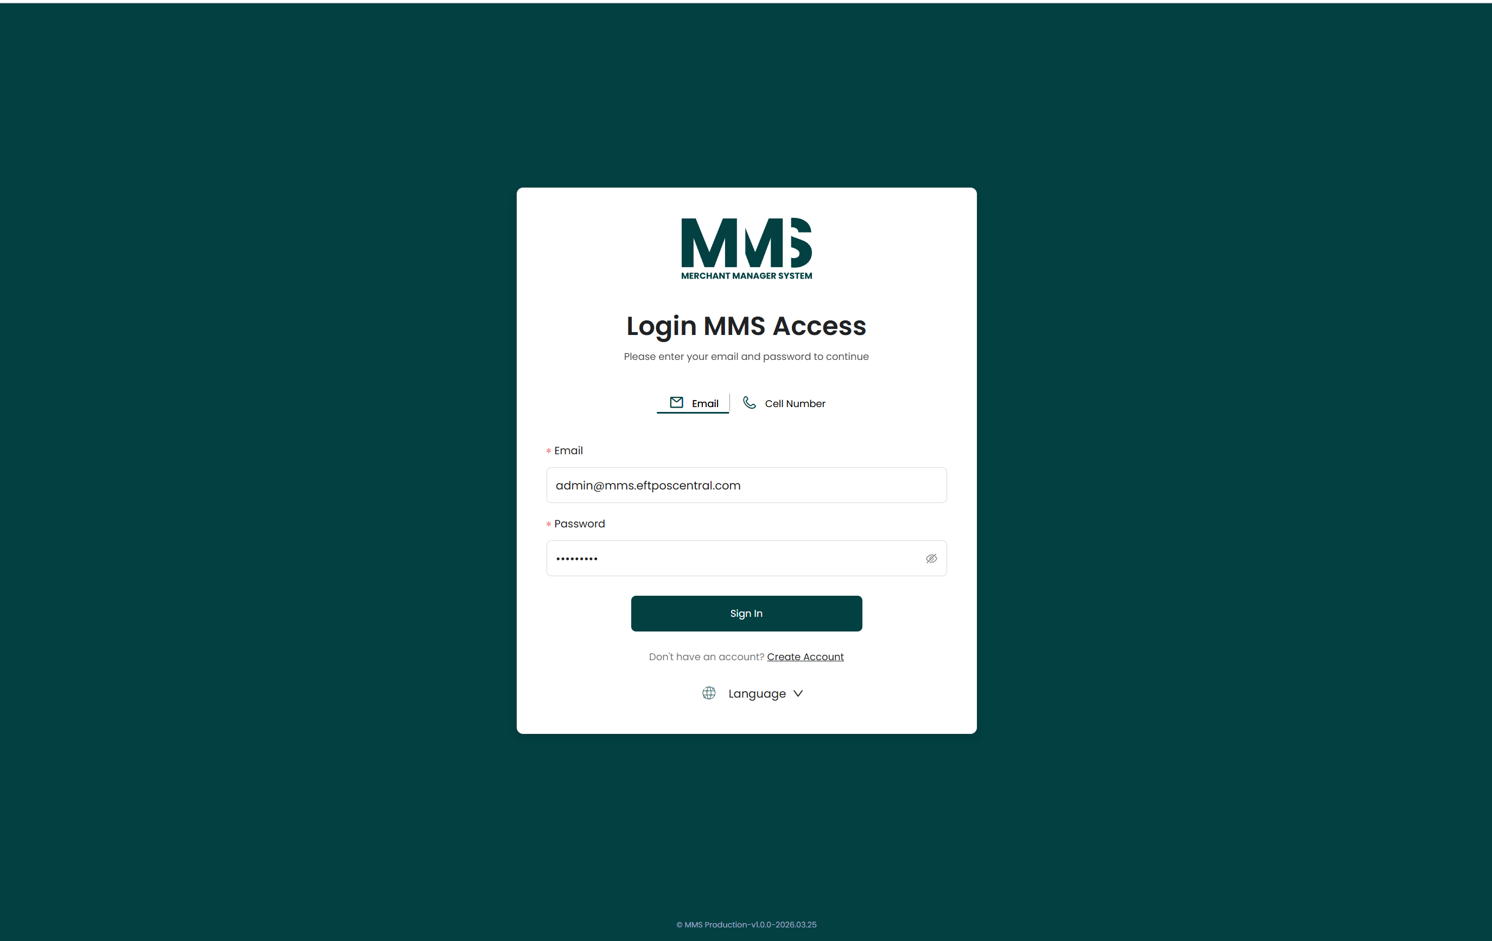
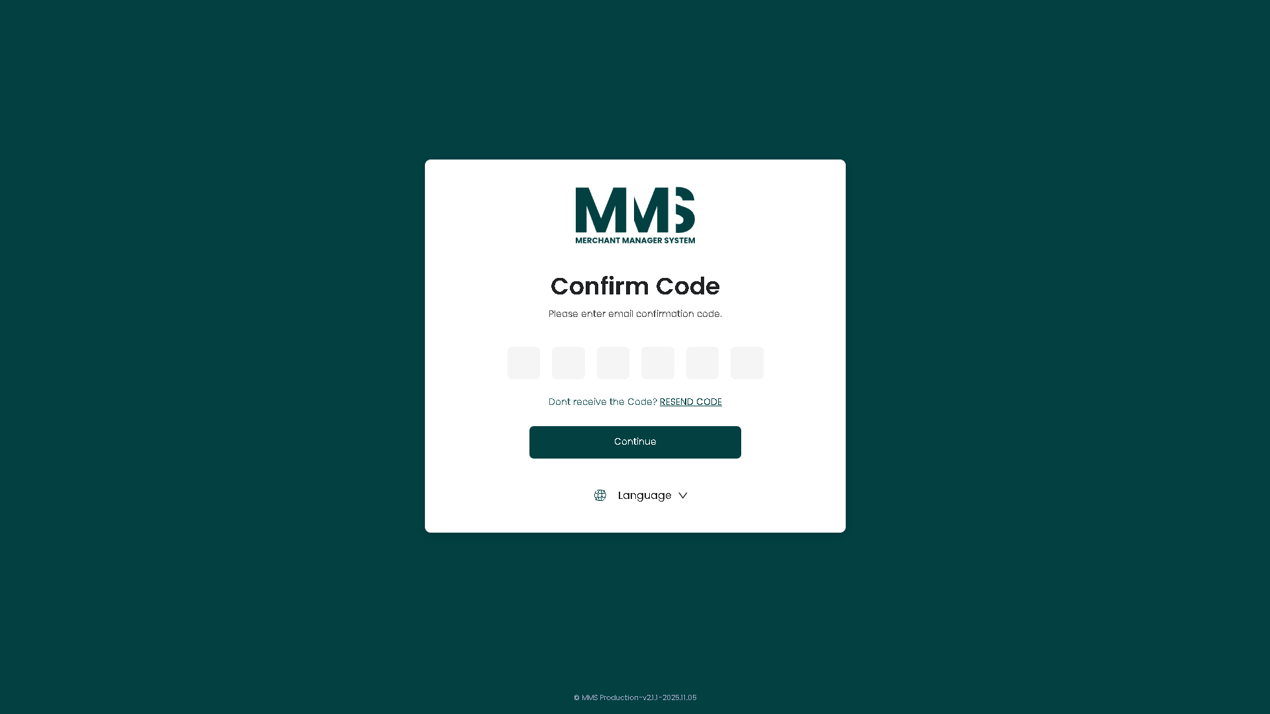
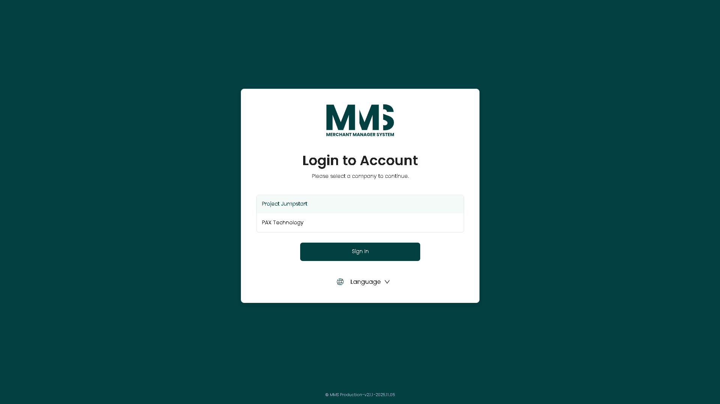

2. Stakeholders (Person, Company, Merchant…)

2.1. Person
Description:
This guide explains how to manage user (person) accounts, including creating, updating, and controlling user access within the system.
Steps to manage Person:
- Navigate to the Person page
- Click Add Person to add new a person
- Click the MMS Security Access button to:
  - Enter login information such as Login ID and Password
  - Configure account active time and deactive time (if applicable)
- In the MMS Access tab: Assign user roles and permissions to access the MMS system
- In the Device Access tab: Configure user permissions for assigned devices
- Click Save to create the user account
- Select an existing user from the list to view or update details
- Update information as needed:
  - MMS Security Access button: Update login credentials or active period
  - MMS Access tab: Modify system access permissions
  - Device Access tab: Update device-level permissions
- Lock or unlock the user account to control system access (Suspend Access switch button in MMS Security Access screen)
- Delete the user account if it is no longer required
Notes:
- Ensure login information is correctly configured before saving
- Access permissions determine which features and data the user can access
- Device access settings control operations at the device level
- Setting active/deactive time will automatically control login availability
- Changes may take effect immediately
Reference Images:

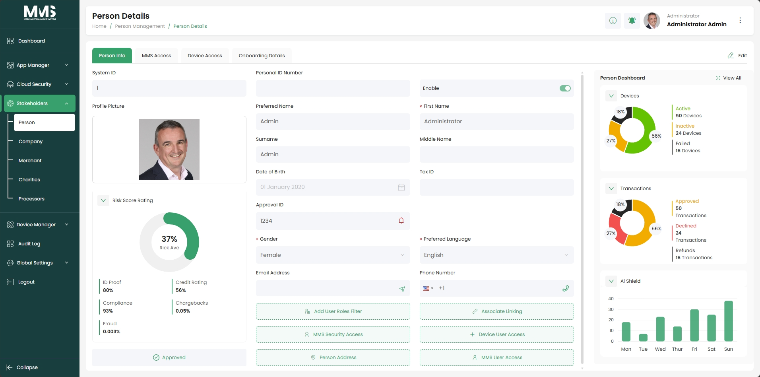

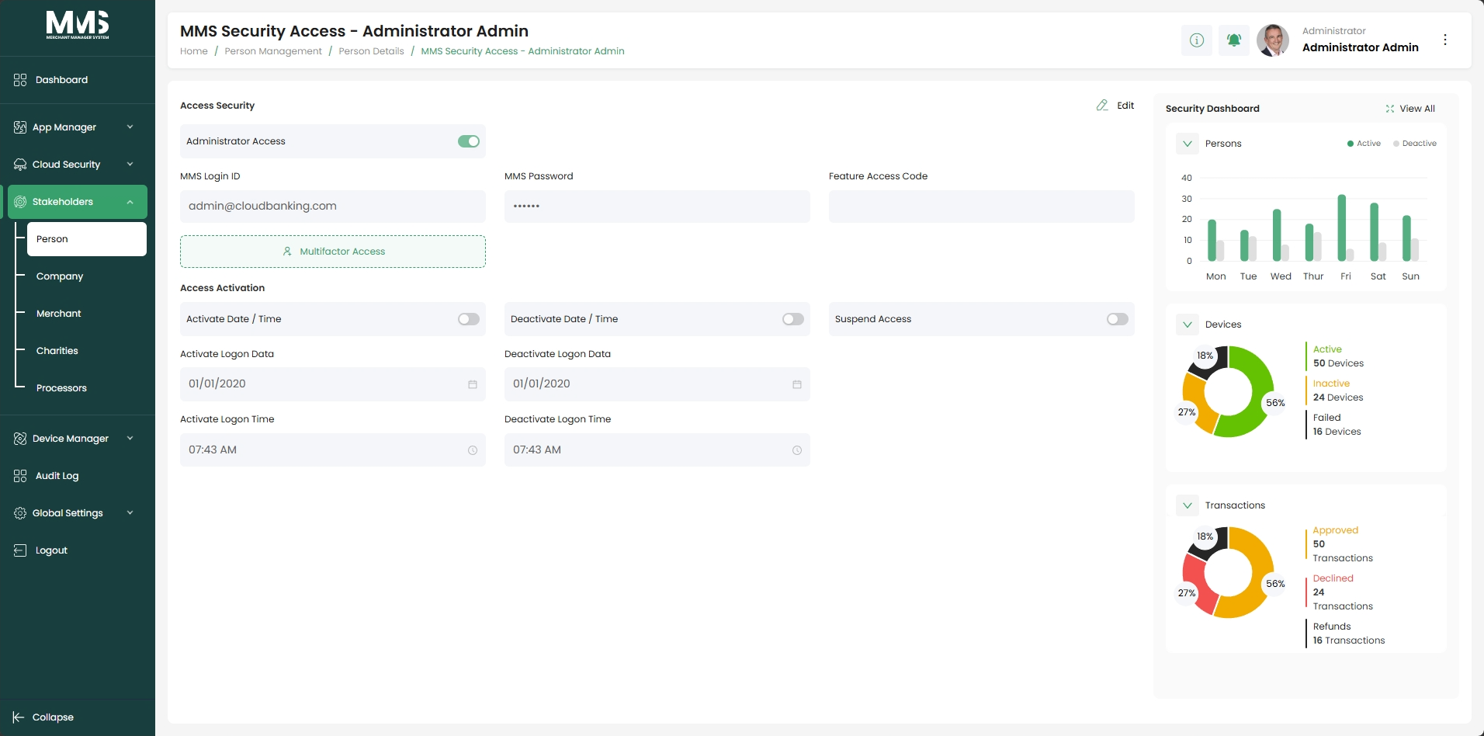

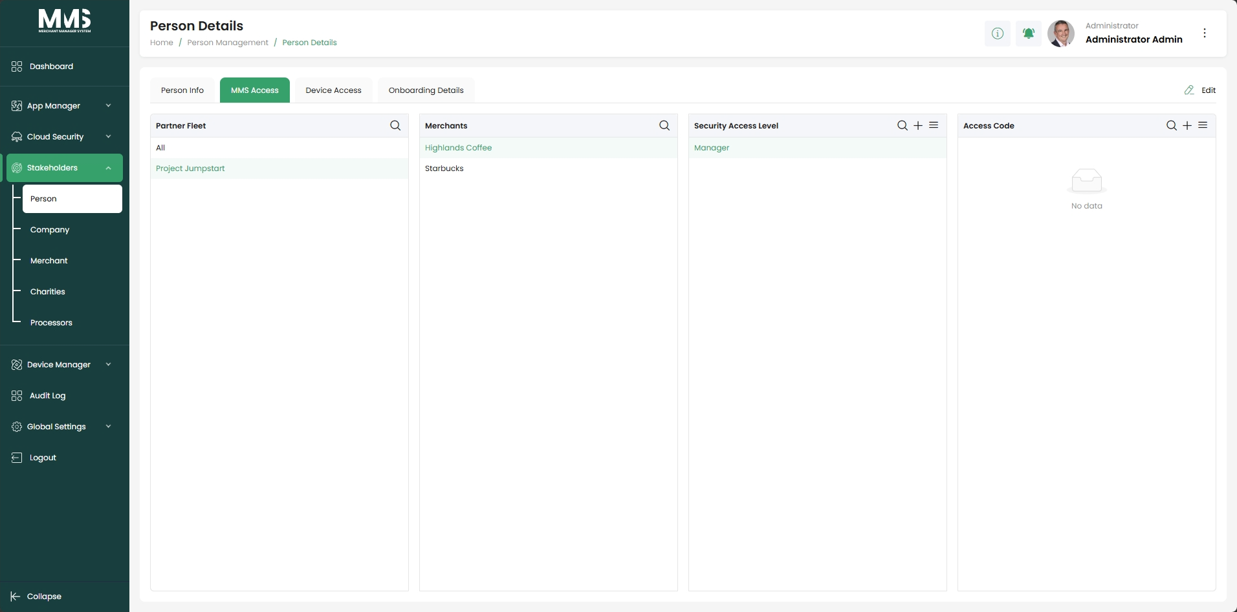

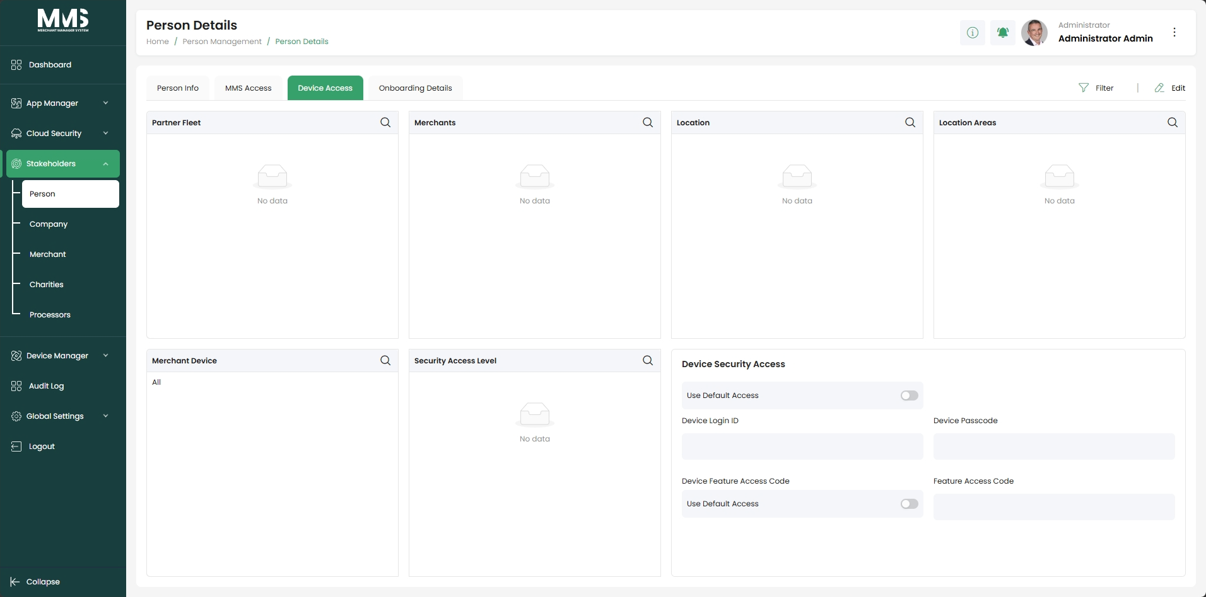

2.2. Company
Description:
This guide explains how to manage companies, including creating, updating, and controlling company access within the system.
Steps to Manage Companies:
- Navigate to the Company page
- Click Add Company
- In the Company Details tab: Enter company information such as name, contact details, and status
- In the Company Employees tab: Assign users (persons) to the company
- In the Company Devices tab: View or assign devices associated with the company (if applicable)
- In the MMS Access tab: View company employees, merchants and assign MMS Access Level to specific employee.
- Click Save to create the company
- Select an existing company from the list to view or update details
- Update information in each tab as needed:
  - Company Details: Edit company details
  - Company Employees: Add or remove assigned users
  - MMS Access: Manage employee access level for each merchant
  - Company Device: Manage associated devices
- Lock or unlock the company to control system access
- Delete the company if it is no longer required
Reference Images:

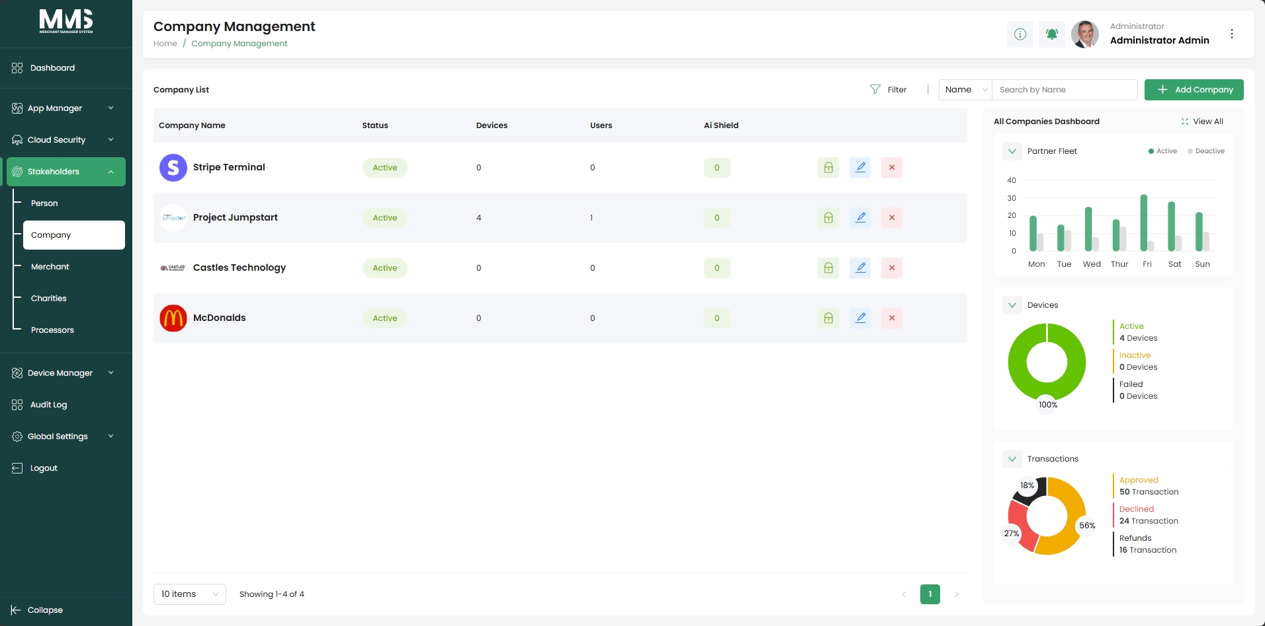

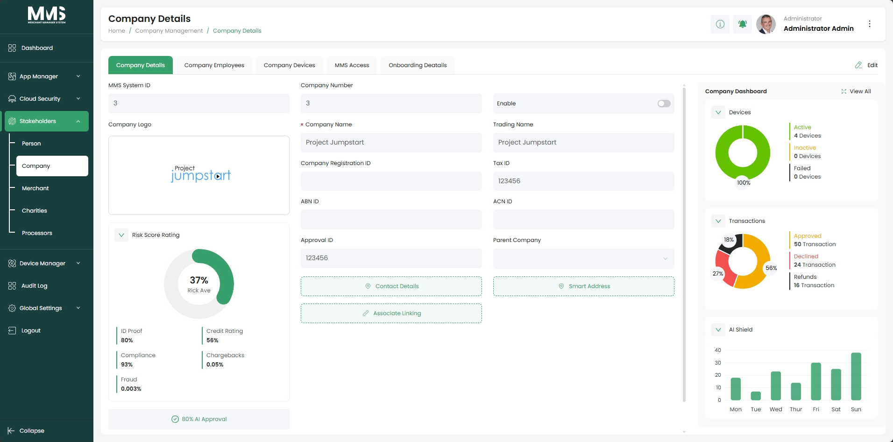

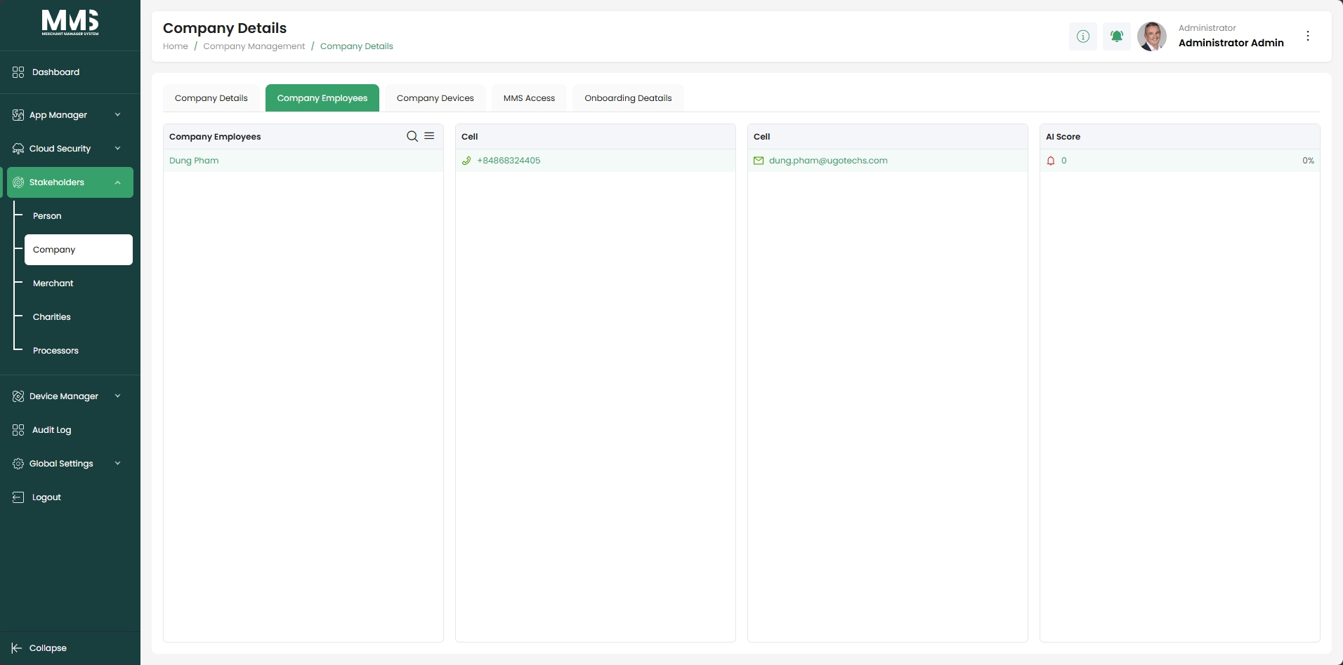

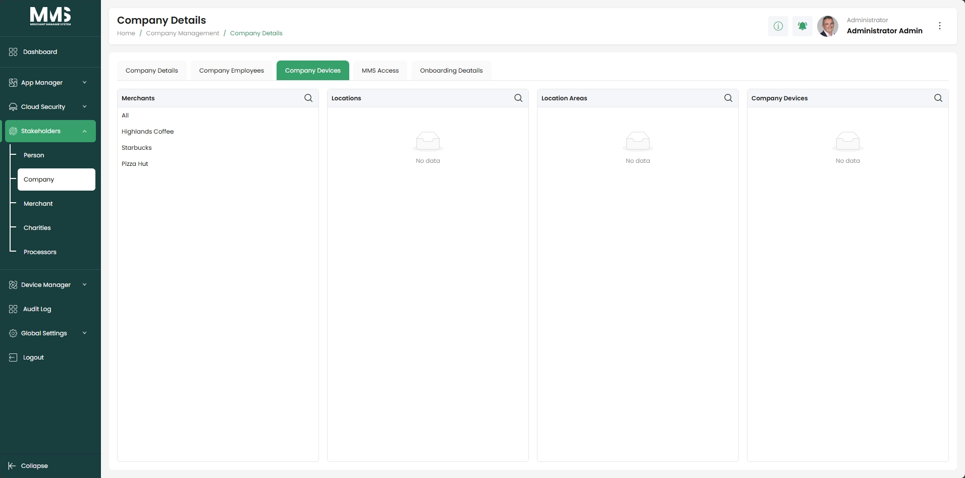

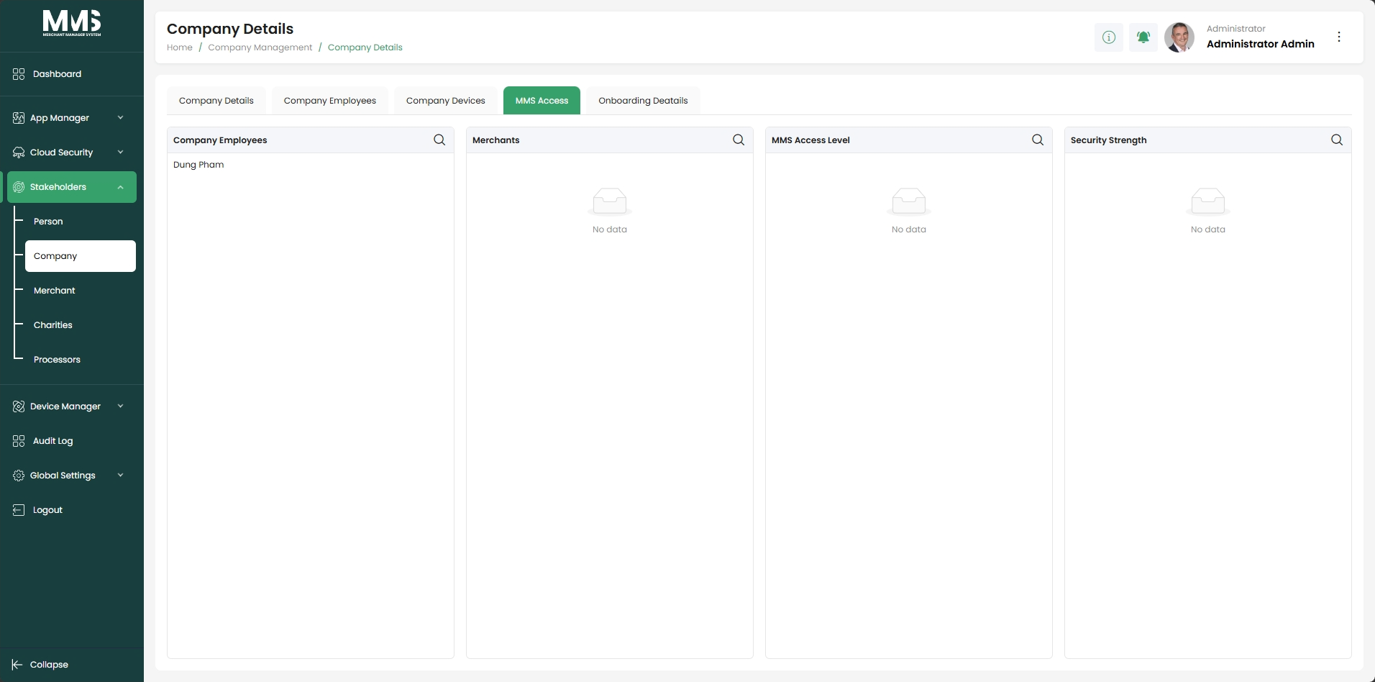

2.3. Merchant
Description:
This guide explains how to manage merchants, including creating merchant profiles, controlling account status, and monitoring operational information.

Steps to Manage Merchants:
- Navigate to the Merchant Management page
- View the list of merchants or use search/filter to find a specific merchant
- Click Add Merchant
- In the Merchant Details tab:
  - Enter merchant profile information such as name, status, and other details
  - Click on Smart Address button to set up address information for merchant (Street, Shipping, Billing)
- In the Merchant Employees tab: Assign users (persons) to the merchant
- In the Merchant Devices tab: View or assign devices associated with the merchant
- Click Save to create the merchant
- Select an existing merchant from the list to view or update details
- Update information in each tab as needed:
  - Merchant Details: Edit merchant details
  - Merchant Employees: Add or remove assigned users
  - Merchant Devices: Manage associated devices
- Activate or deactivate the merchant to control account status
Reference Images:
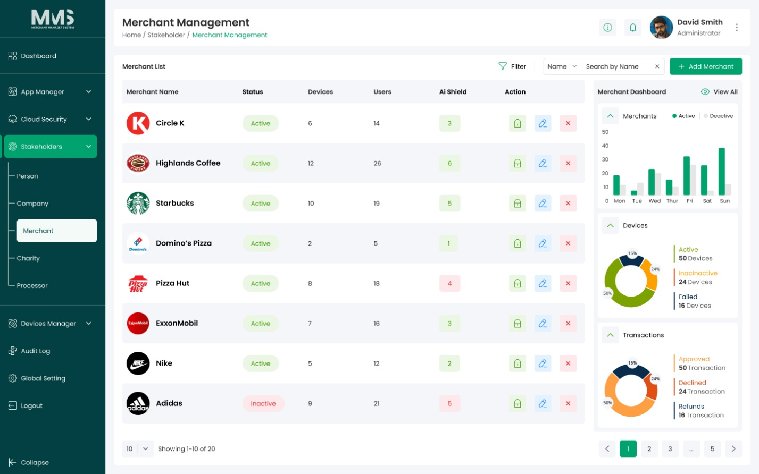
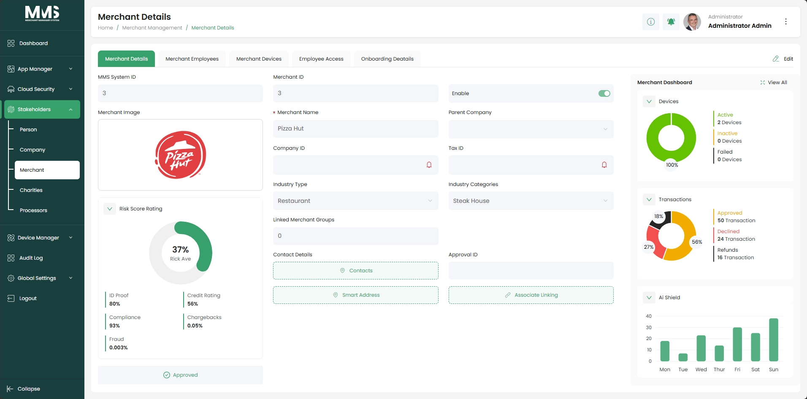

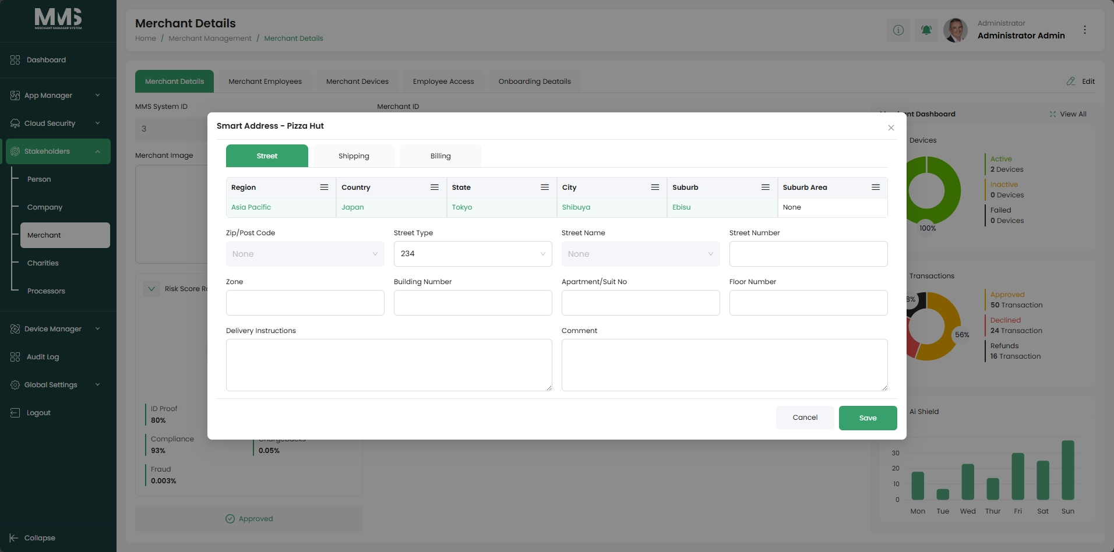

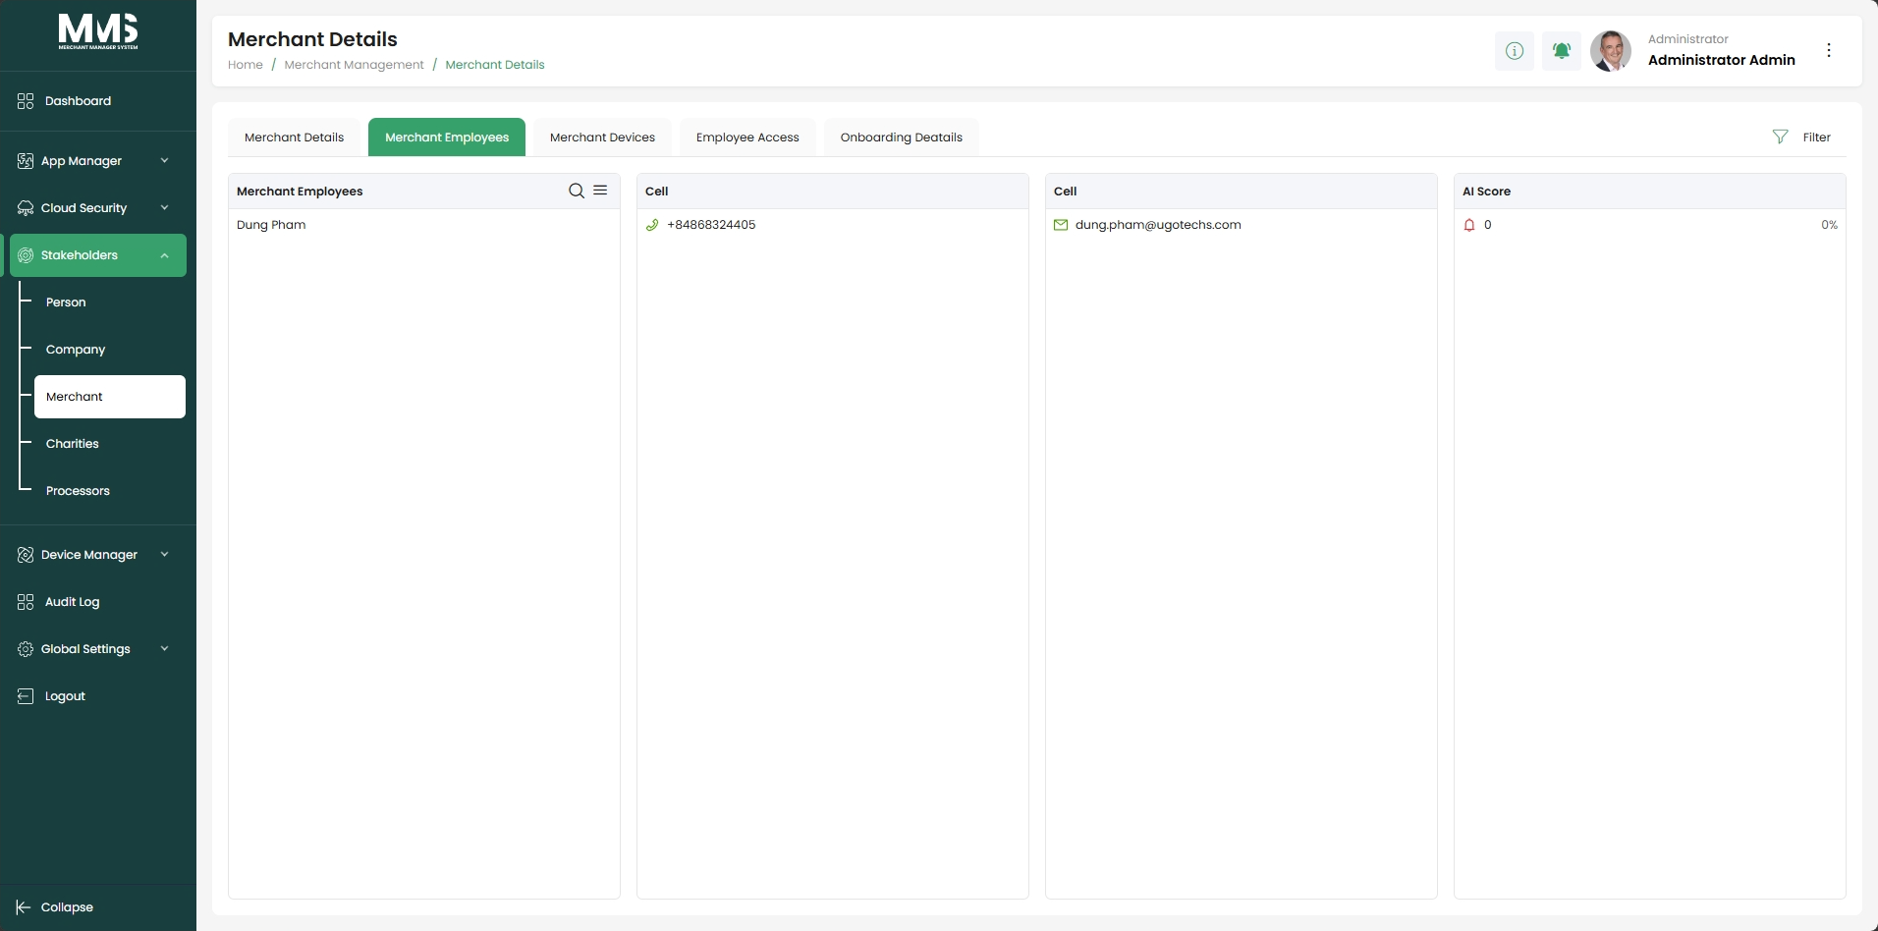

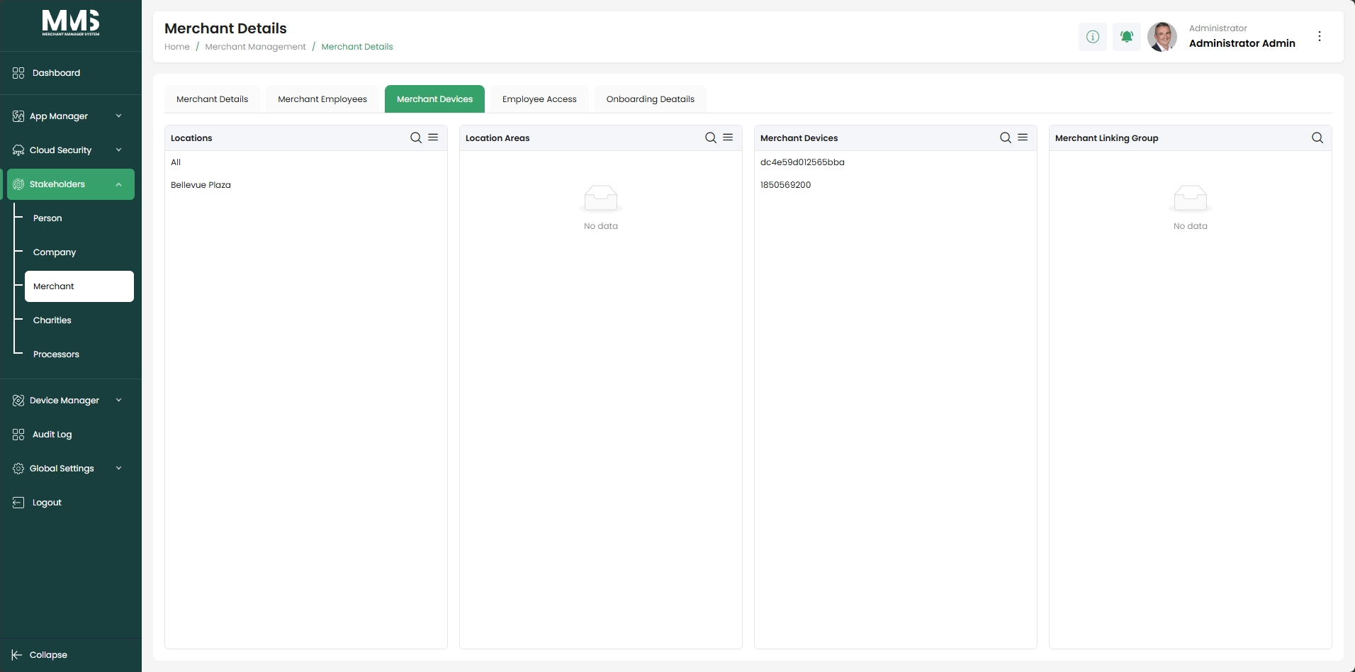

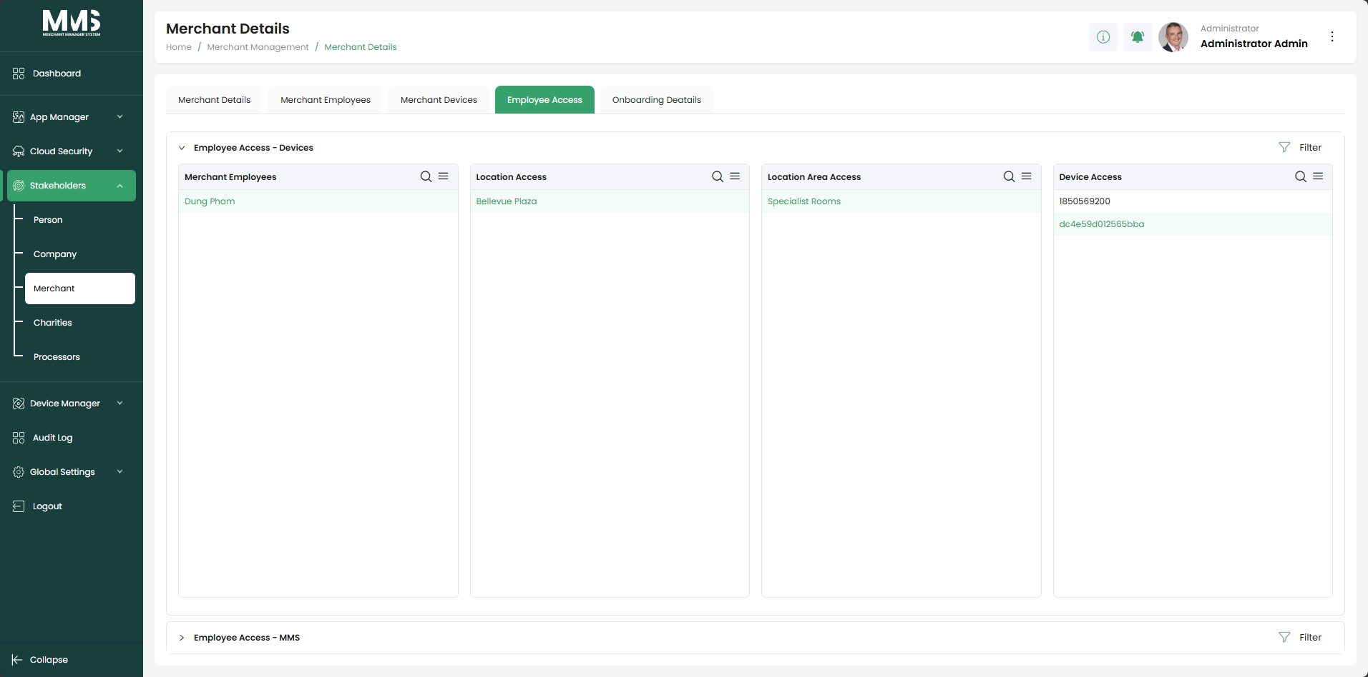

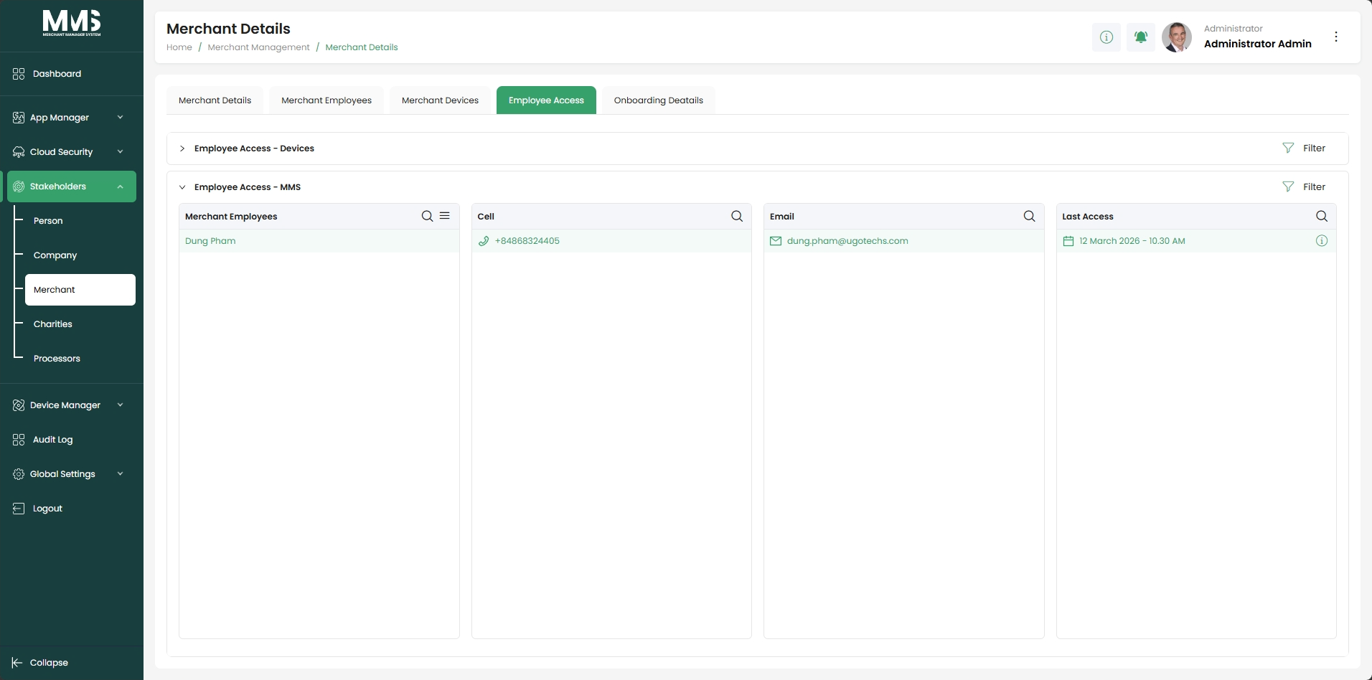

2.4. Charities
Description:
This guide explains how to manage charity records and use them as a shared data source for templates, with the ability to customize settings per template.
Steps to manage Charities:
- Navigate to the Charities page
- View the list of existing charity records in Charities column
- Expand the Menu icon and select Add option to create new a charity
- Enter charity information (Charity Details on the right side), including:
  - Charity name and reference information
  - Charity amounts
- Upload charity images or advertising visuals (if applicable)
- Configure advertising settings (enable or disable, if applicable)
- Click Save to create the charity record
- Select an existing charity from the list to view or update details
- Edit charity information as needed
- Use the charity record within templates as a global data source
Reference Images:

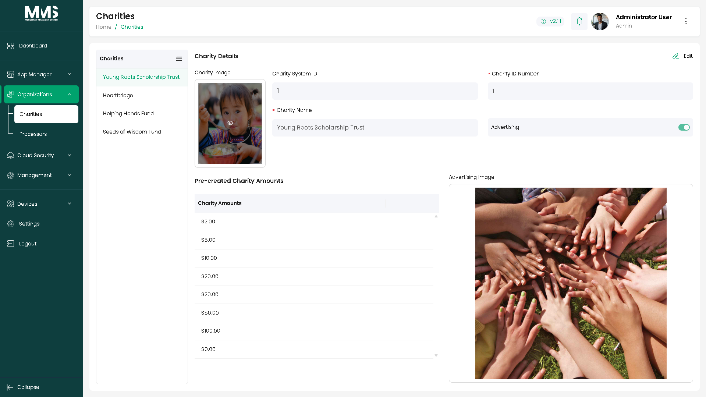

2.5. Processors
Description:
This guide explains how to manage payment processor configurations and use them as a shared data source for templates, with the ability to customize settings per template.
Steps to manage Processors:
- Navigate to the Processors page
- View the list of existing processor records
- Expand the Menu icon and click Add option to create new processor
- In the Processor Info tab:
  - Enter processor information such as processor name, system ID, and company name
  - Upload processor logos or reference images (if applicable)
- In the Processor Interface tab:
  - Configure processor libraries and processor numbers
  - Configure BIN tables for card routing
  - Set network, software, and terminal-related settings
- Click Save to create the processor record
- Select an existing processor from the list to view or update details
- Update information in each tab as needed:
  - Processor Info: Edit basic processor details
  - Processor Interface: Update integration and routing configurations
- Use the processor configuration within templates as a global data source
Reference Images:

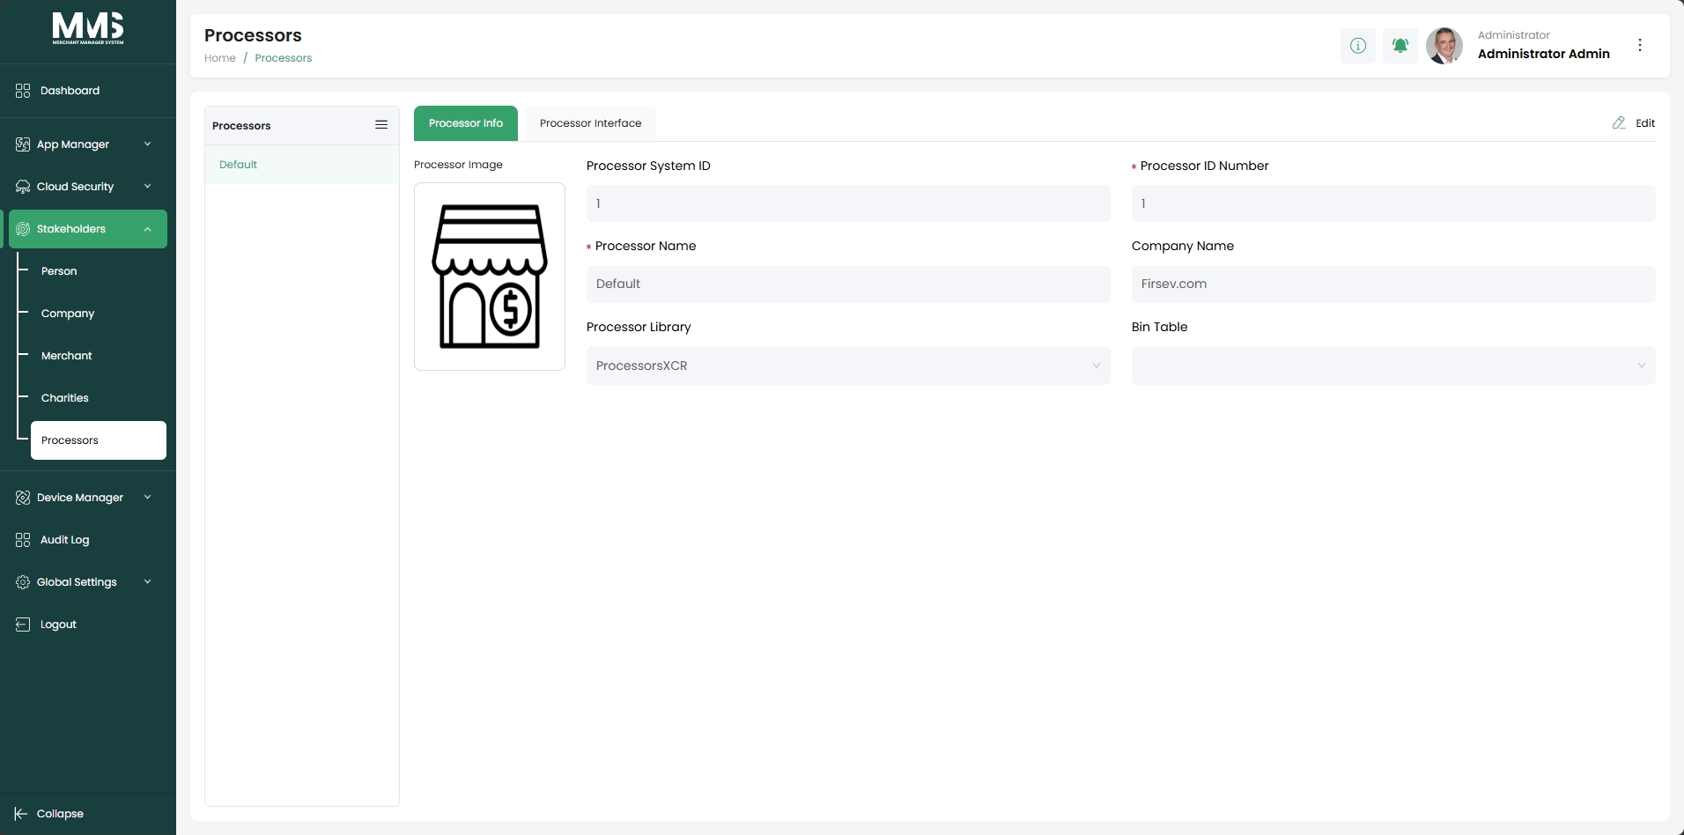

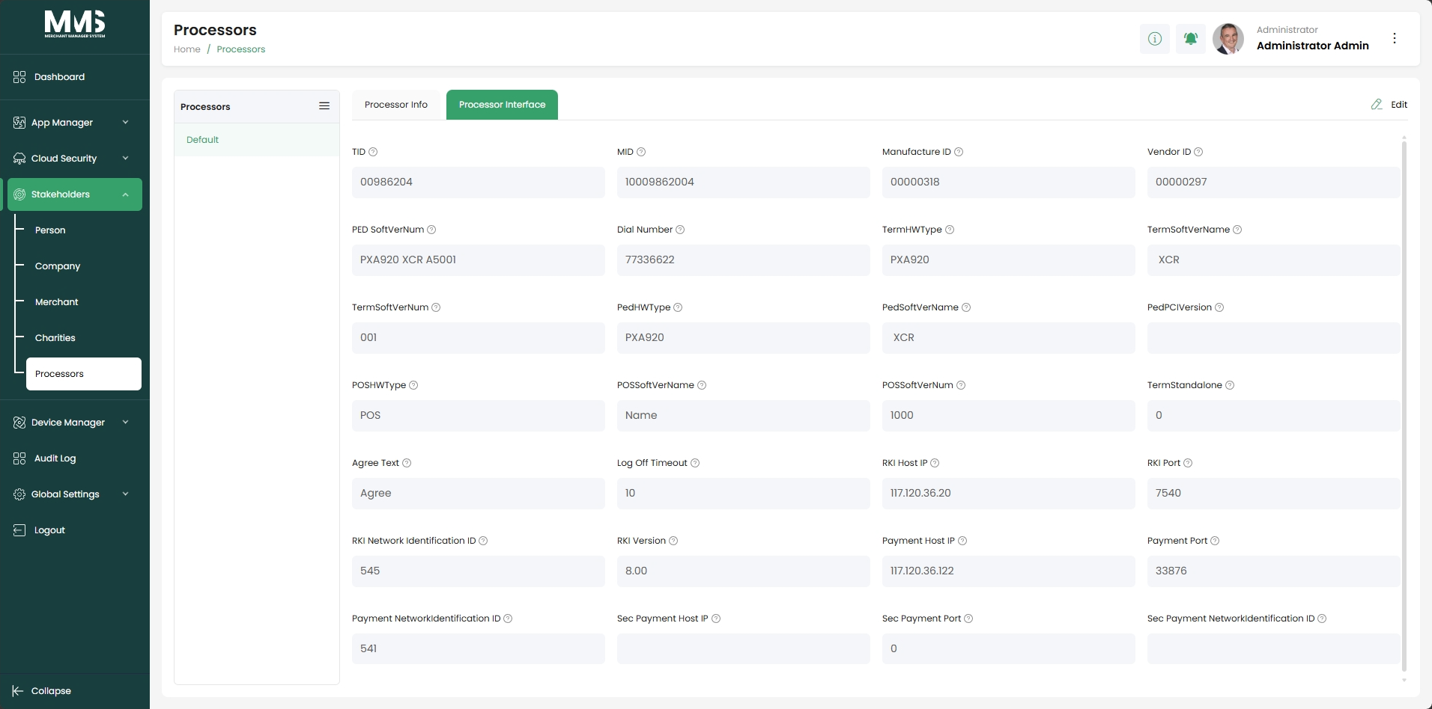

3. Device Manager

3.1. Device Registry
Description:
This guide explains how to register and manage device records before assigning them for operational use within the system.
Steps to manage Devices:
- Navigate to the Device Registry page
- View the list of registered devices
- Click Add Device
- Enter device information, including:
  - Serial number
  - Brand and model
  - Owner or organization (if applicable)
- Click Save to register the device
- Select an existing device from the list to view or update details
- Edit device information as needed
- Import devices in bulk (if required):
  - Upload a CSV file
  - Or use MAXSTORE API integration
- Review registered devices before assignment or activation
Reference Images:

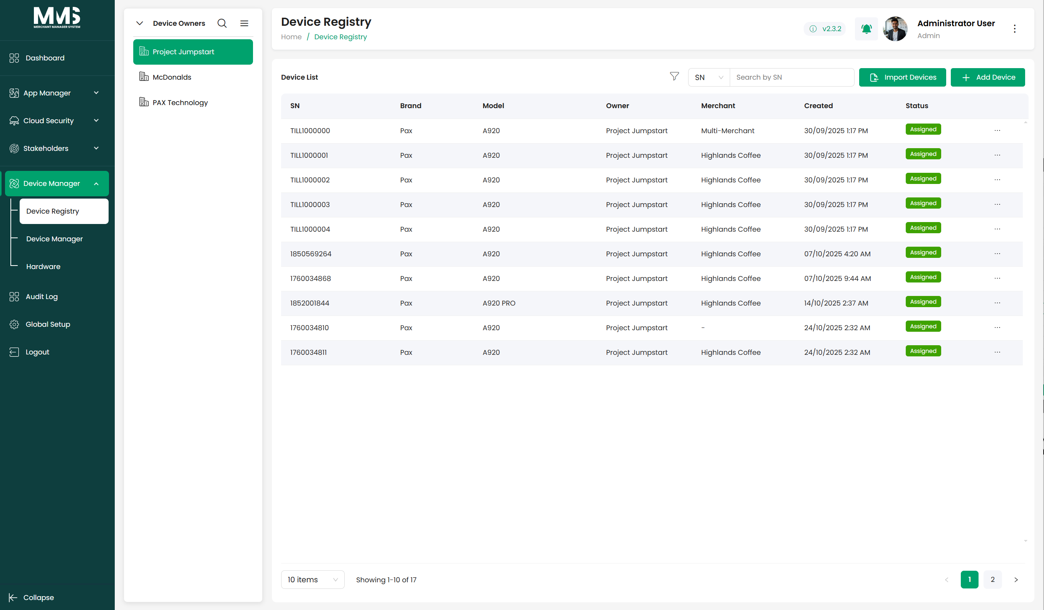

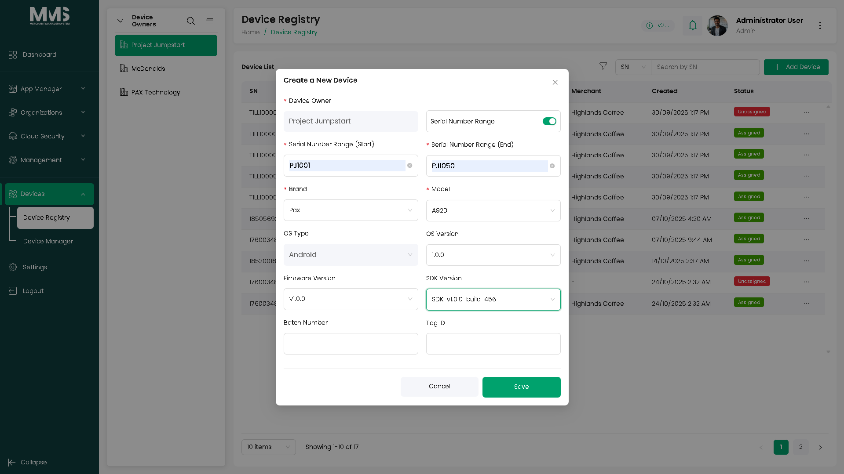

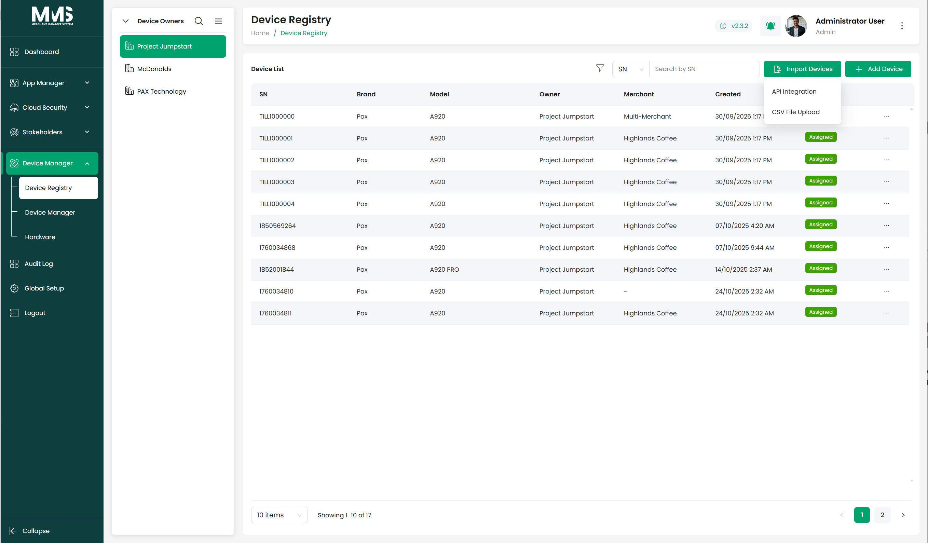

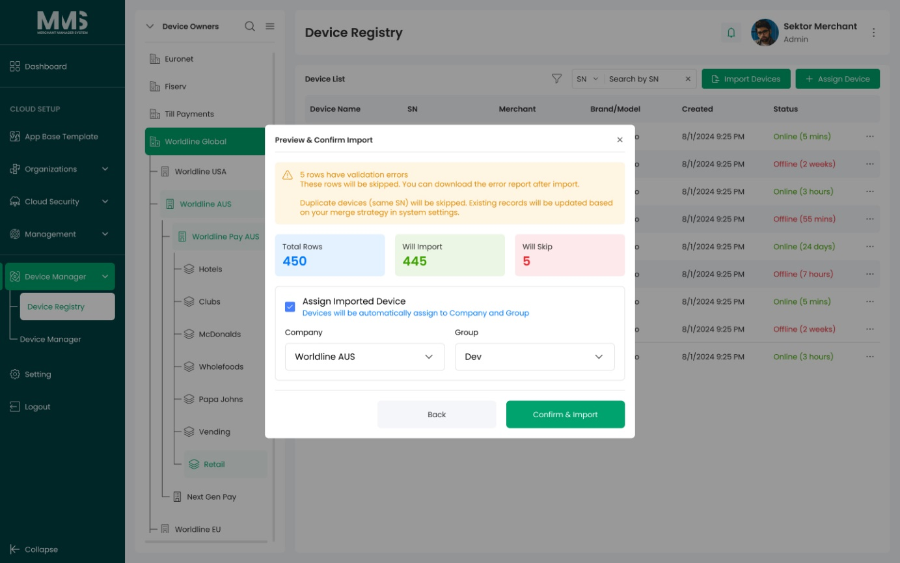

3.2. Device Manager
Description:
This guide explains how to assign registered devices and manage them within the organizational structure, including companies, groups, locations, and merchants.
Steps to Manage Devices:
- Navigate to the Device Manager page
- View the list of devices or use filters to locate specific devices
- Select a device from the list
- Click Assign Device (if using Merchant Location Filter) or Select Devices (if using Linked Merchant Filter) button
- Choose the assignment details, including:
  - Company, subsidiary, or group
  - Location (select from the hierarchical location tree)
  - Linked Merchants
  - Merchant (if applicable)
- Confirm the assignment
- View the assigned device within the corresponding organizational structure
- Update device assignment or information as needed
- Use filters or the location tree to view devices by hierarchy or scope
Reference Images:

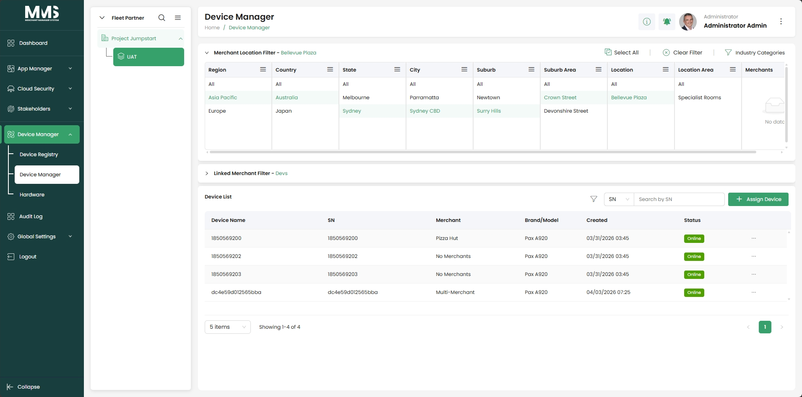
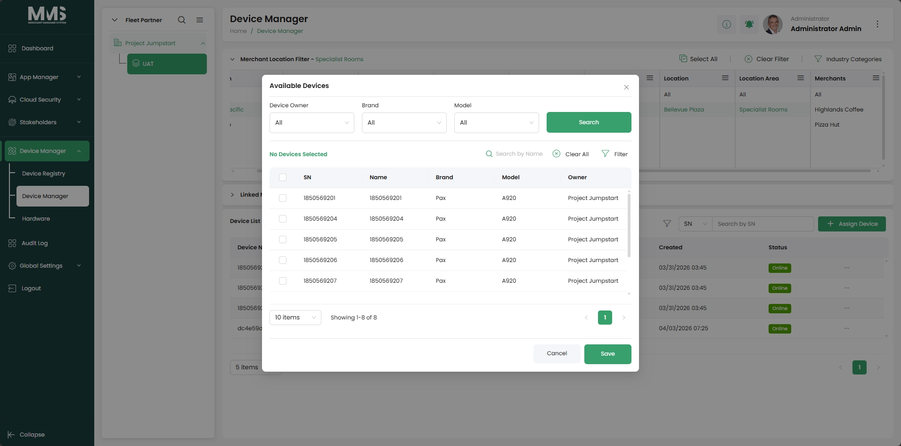
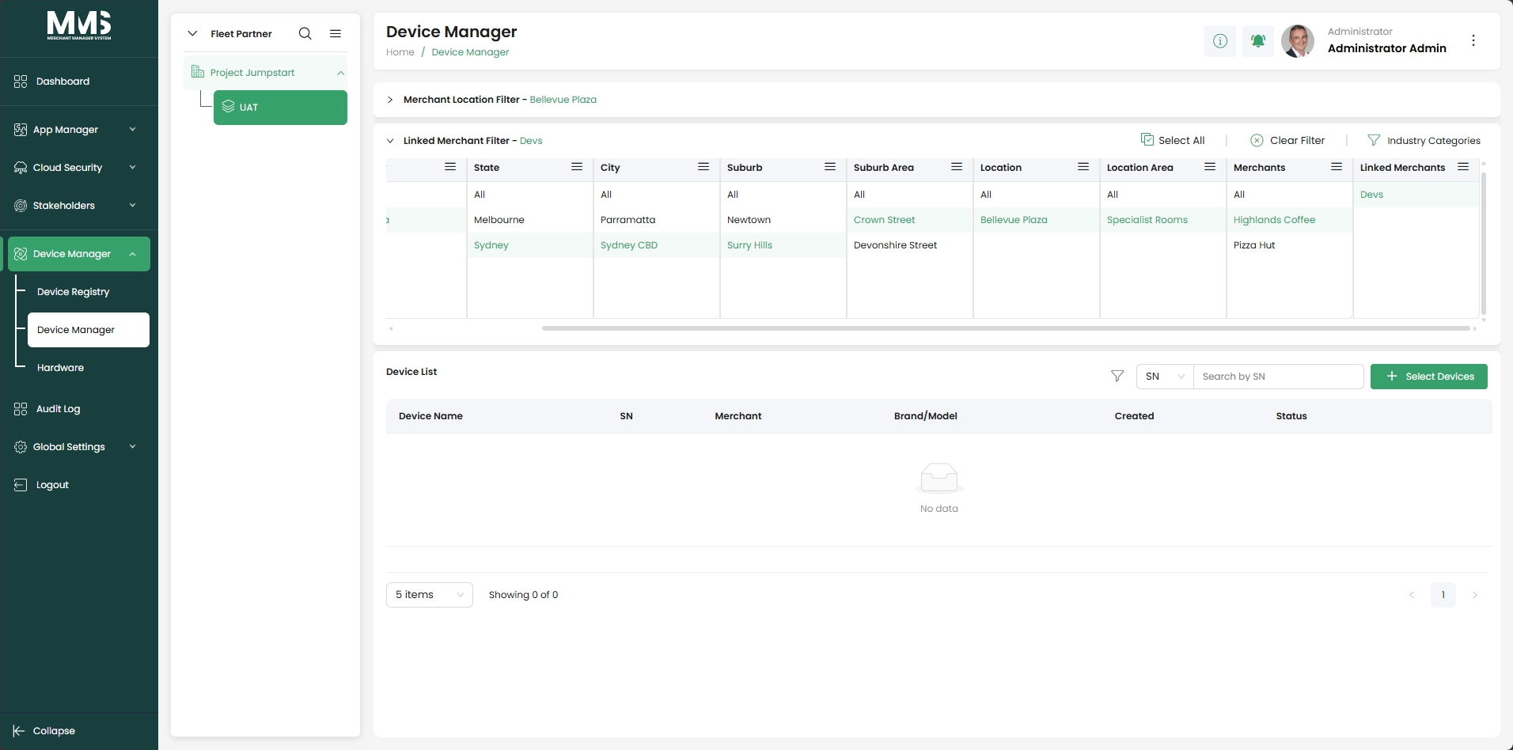
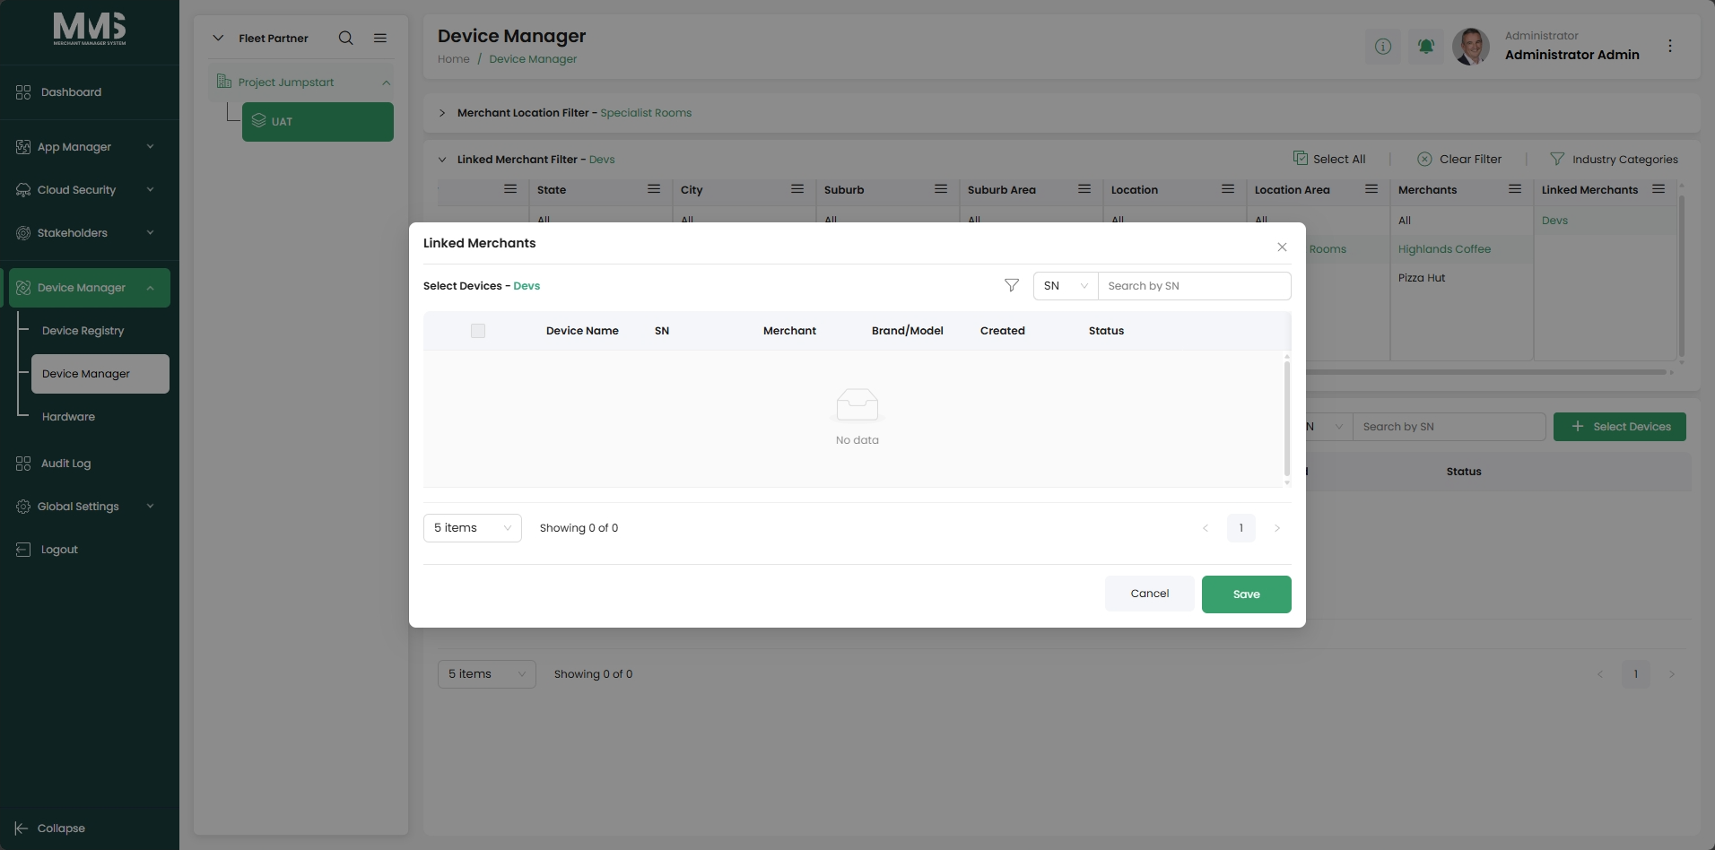
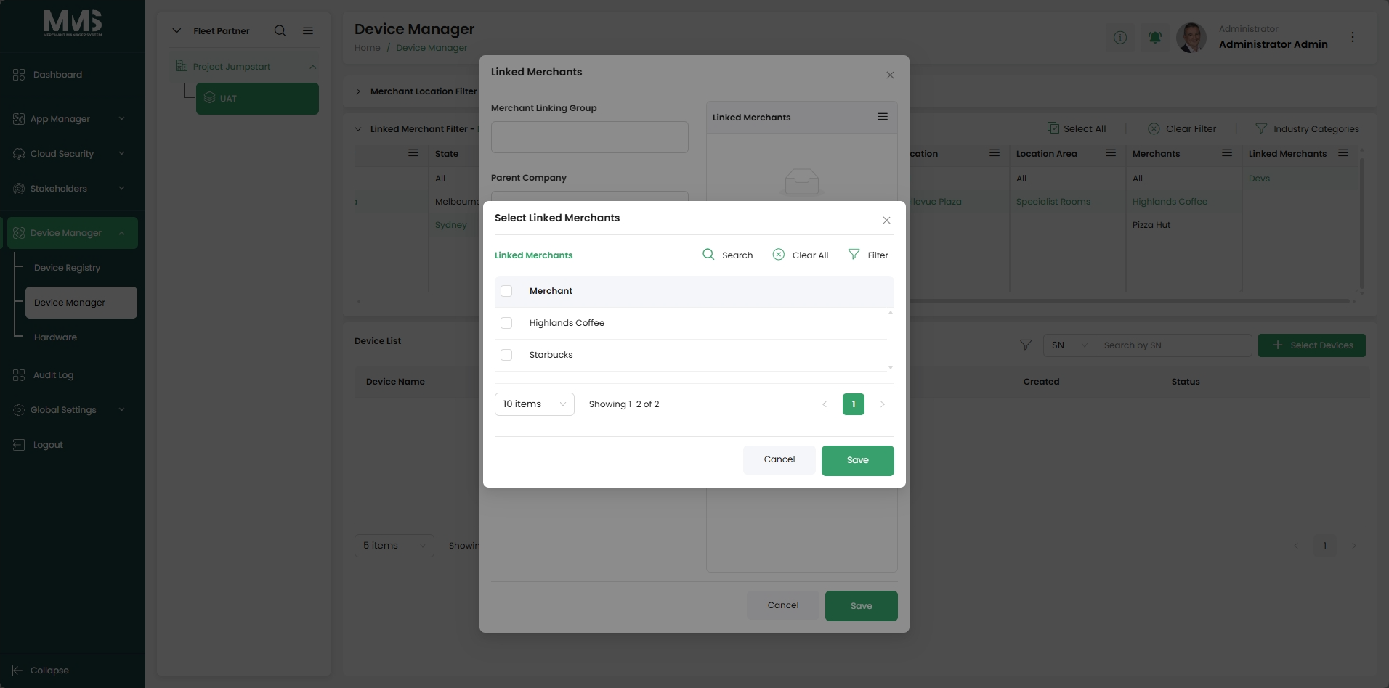

3.2.1. Company Tree
Description:
This guide explains how to manage the hierarchical structure of companies, subsidiaries, and groups within the system. The company tree is used to organize entities and control access, visibility, and device assignment.
Steps to manage Company Structure:
- Navigate to the Company Tree page
- View the hierarchical structure of companies, subsidiaries, and groups
- Select a parent node (e.g., company or subsidiary)
- Click Add to create a new child entity
- Enter required information for the new entity
- Click Save to add it to the hierarchy
- Select an existing node to view or update details
- Edit entity information as needed
- Use the tree structure to locate specific companies or groups
- Apply the hierarchy when assigning users or devices (if applicable)
Notes
- Groups cannot contain child entities
- The company tree defines organizational structure and relationships
- Changes in the hierarchy may affect user access and device assignments
Reference Images:
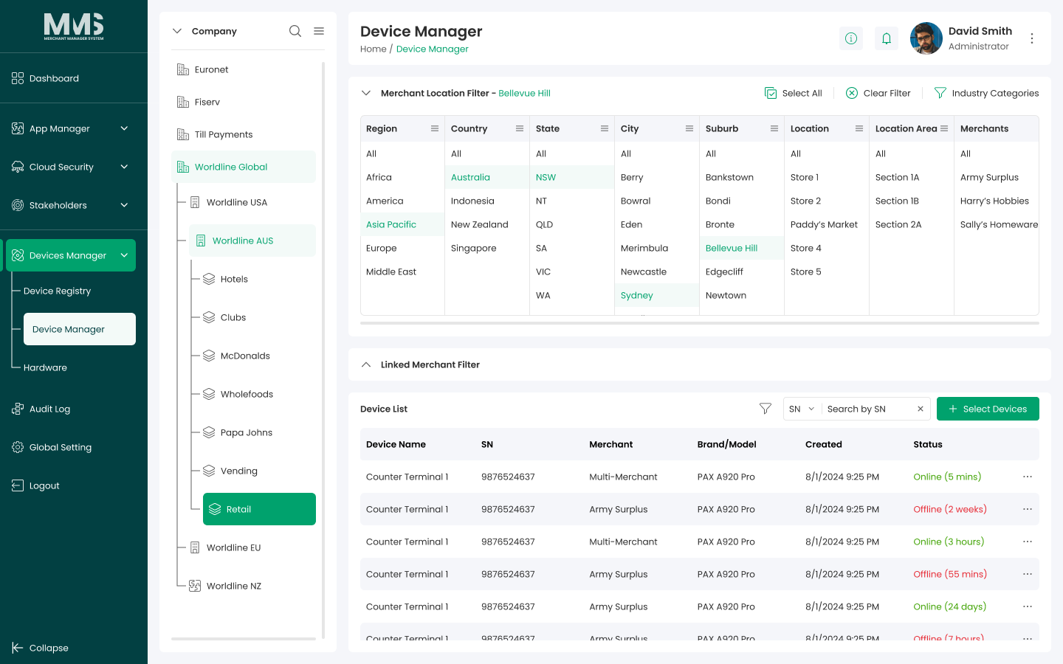

3.2.2. Location Tree
Description:
This guide explains how to create and manage location hierarchies to organize devices and support location-based operations within the system

Steps to Manage Locations:
- Navigate to the Location Tree page
- View the hierarchical structure of locations
- Select a parent location (or root level)
- Click Add to create a new location
- Enter location information (e.g., location name and details)
- Click Save to add the location to the hierarchy
- Select an existing location to view or update details
- Edit location information as needed
- Create sub-locations under a selected location (if required)
- Use the location tree to organize and locate devices
- Apply location selection when assigning devices in Device Manager
- Use location-based filters to view devices by specific locations
- Create a Location that allows selecting one or multiple merchants:
  - Can add a Location with a single Merchant or use the Multi-Merchant Location option, which allows you to select multiple Merchants within the Location Area of ​​the Location.
Reference Images:
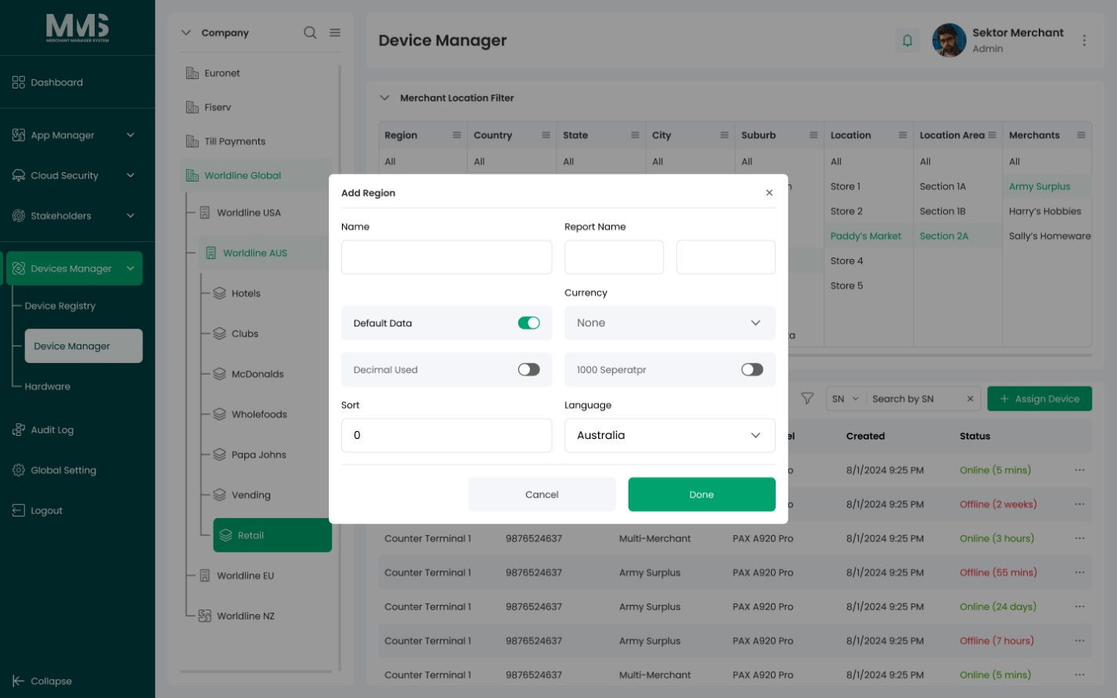

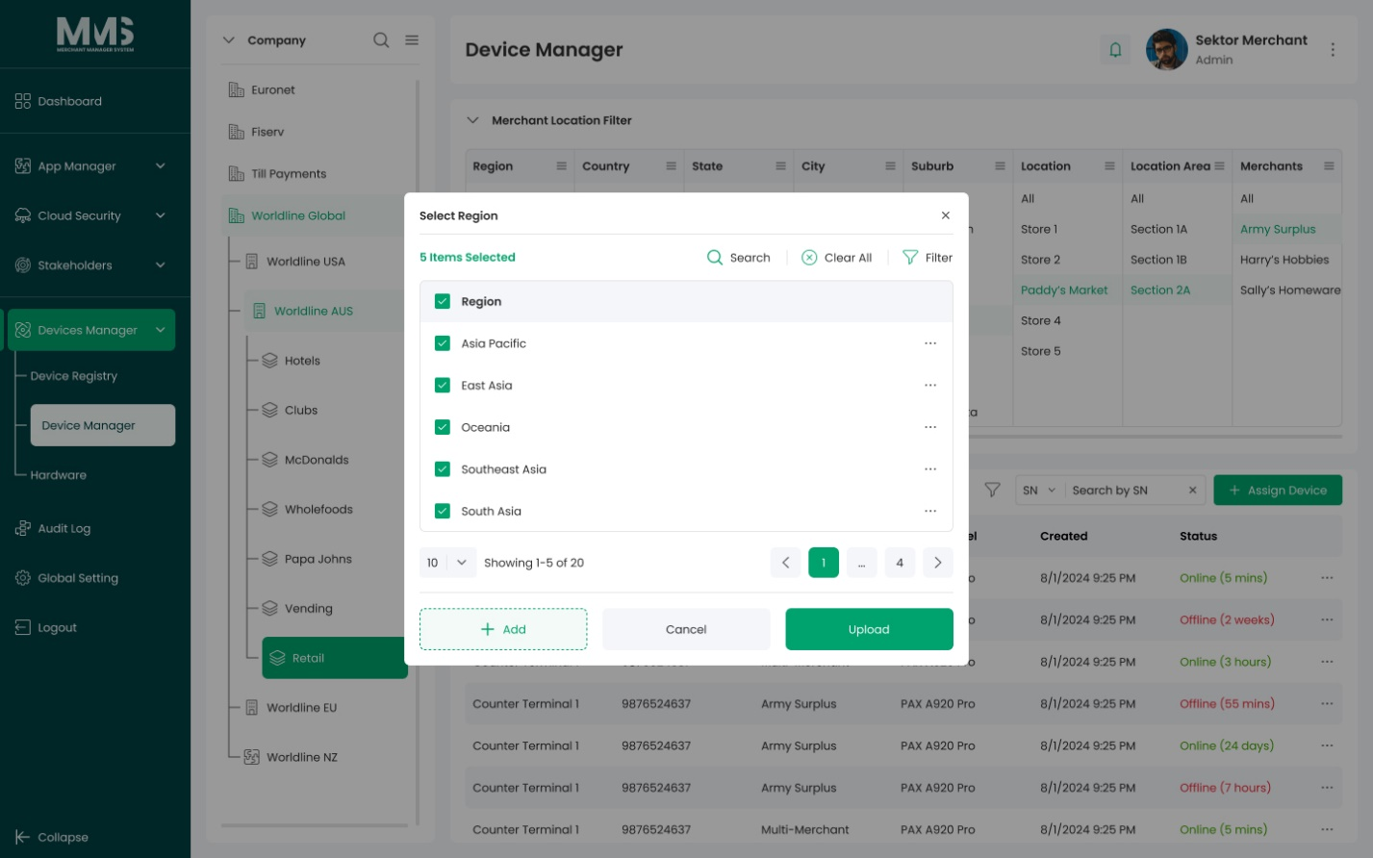
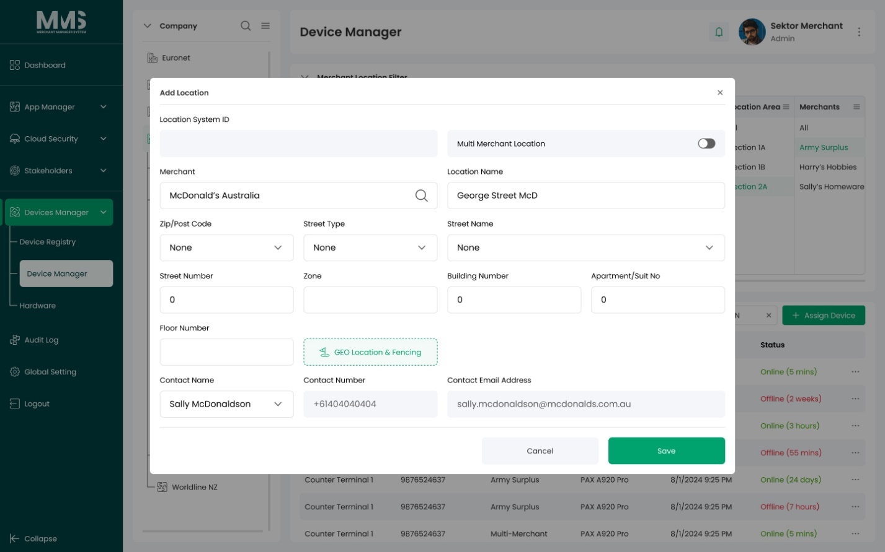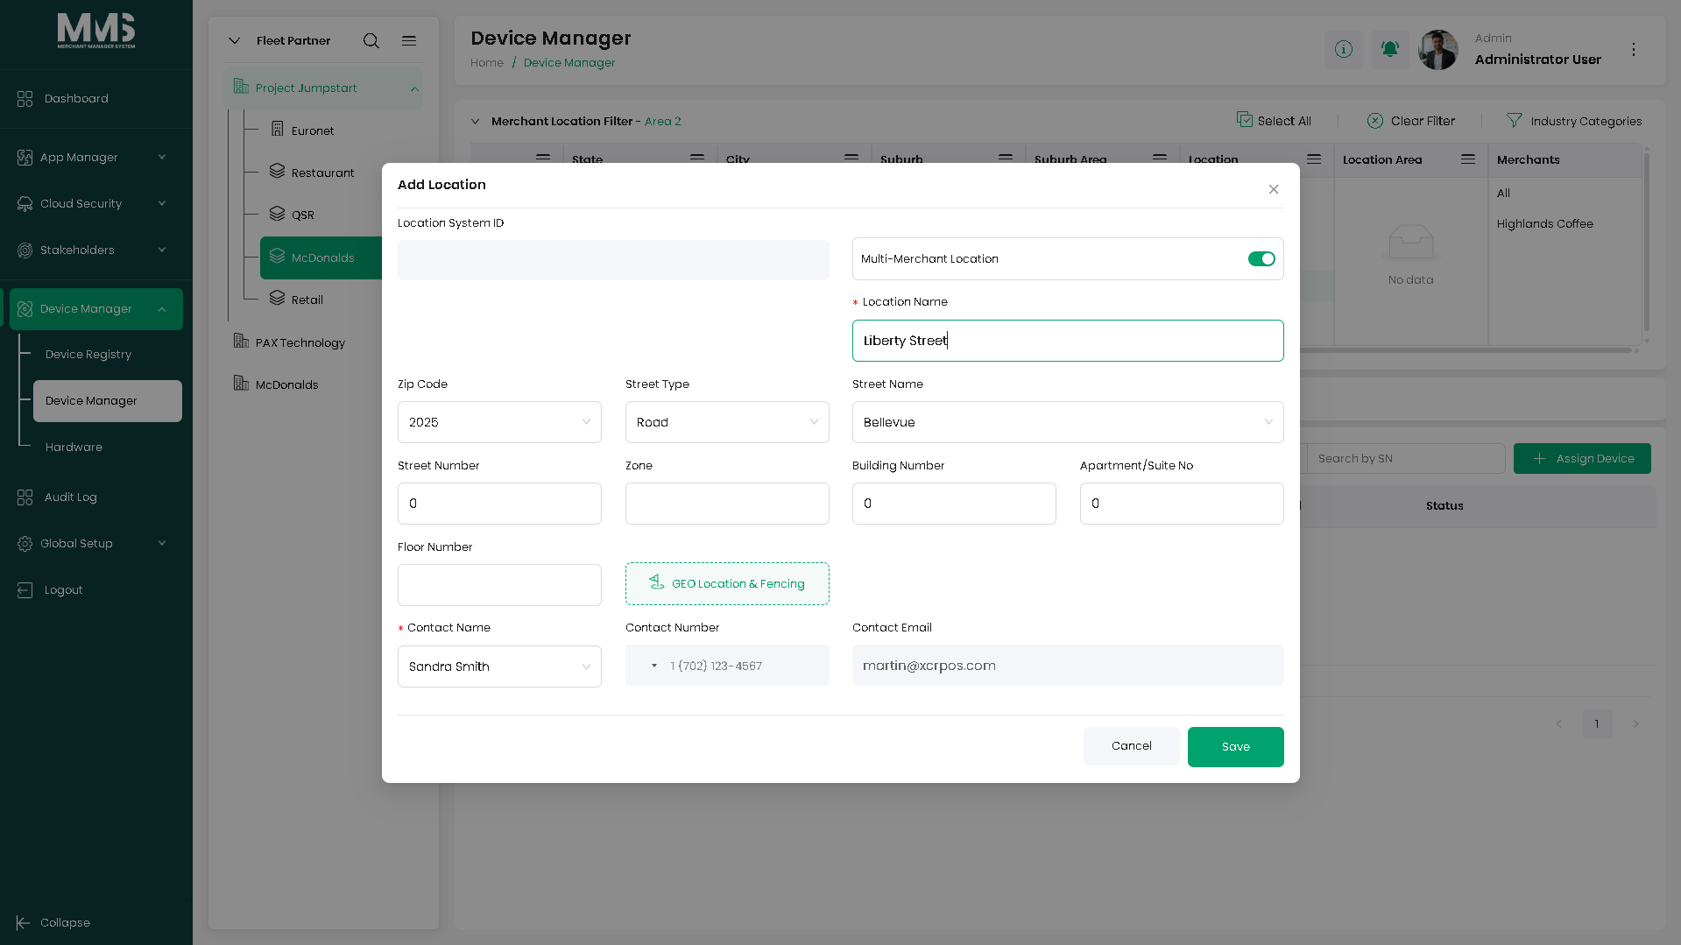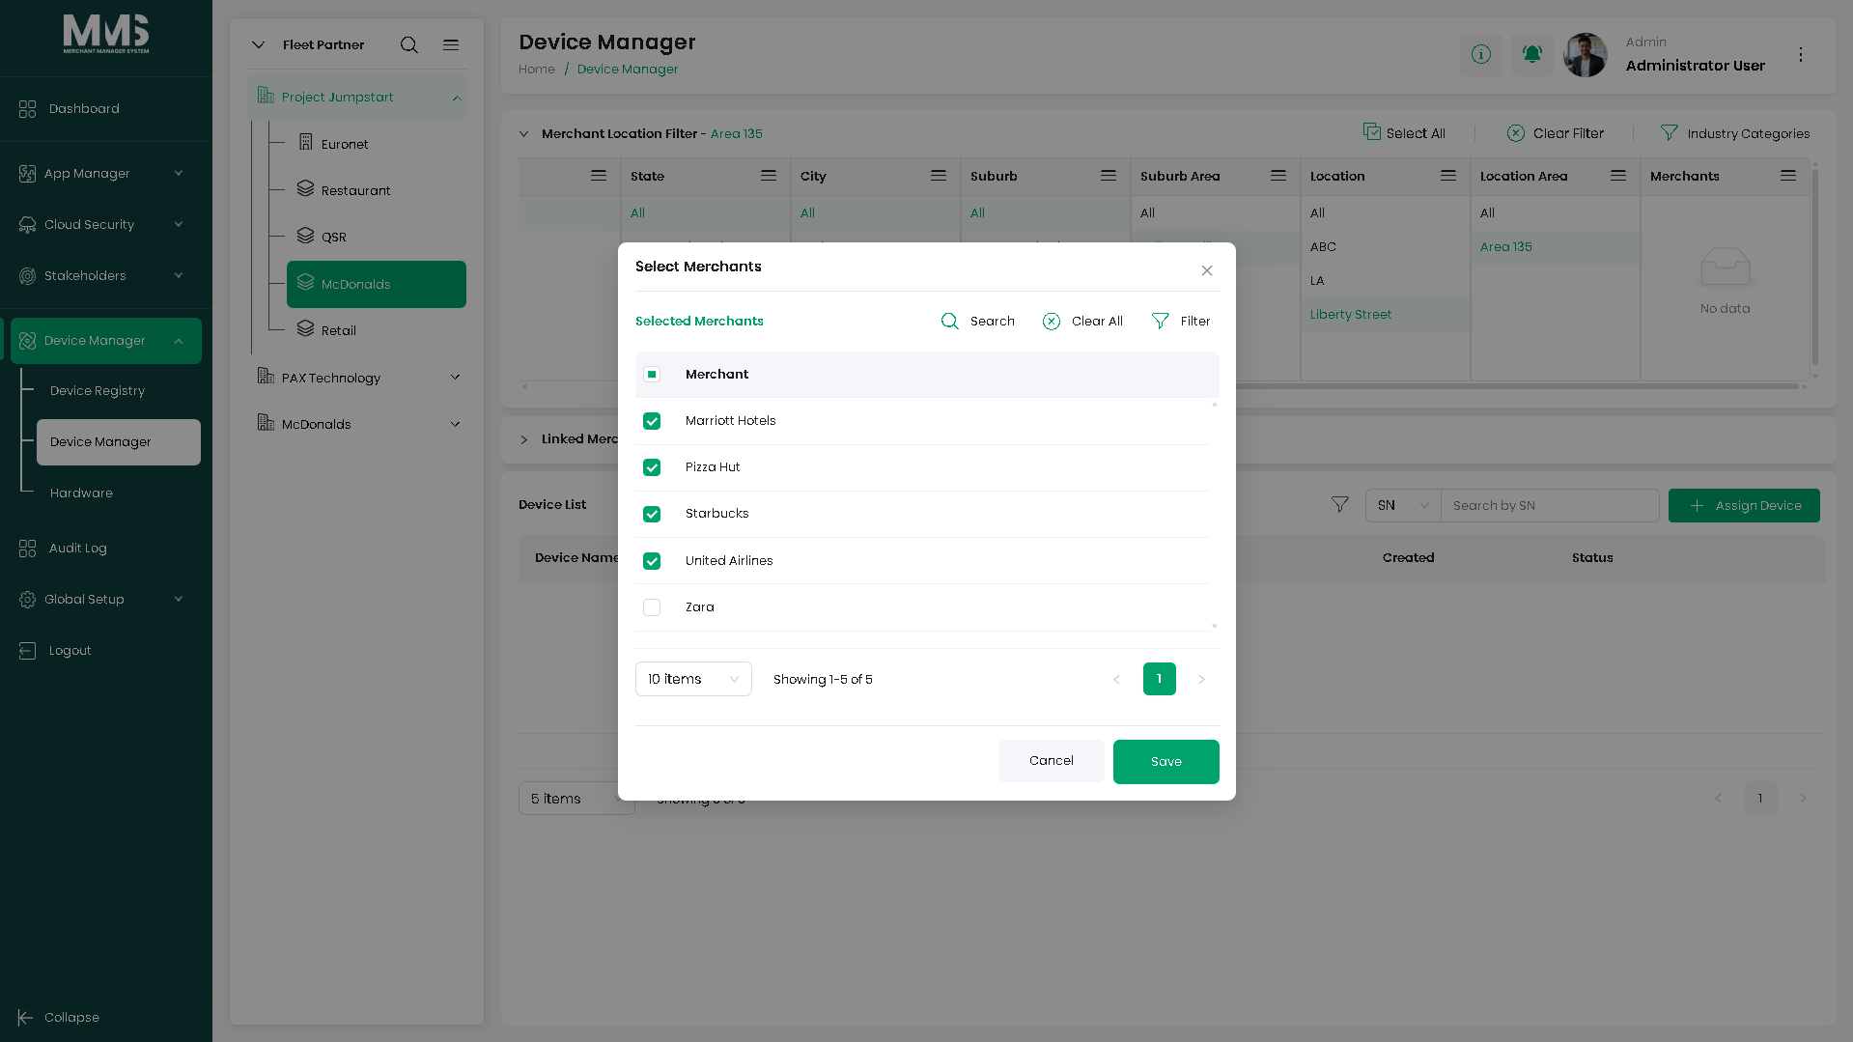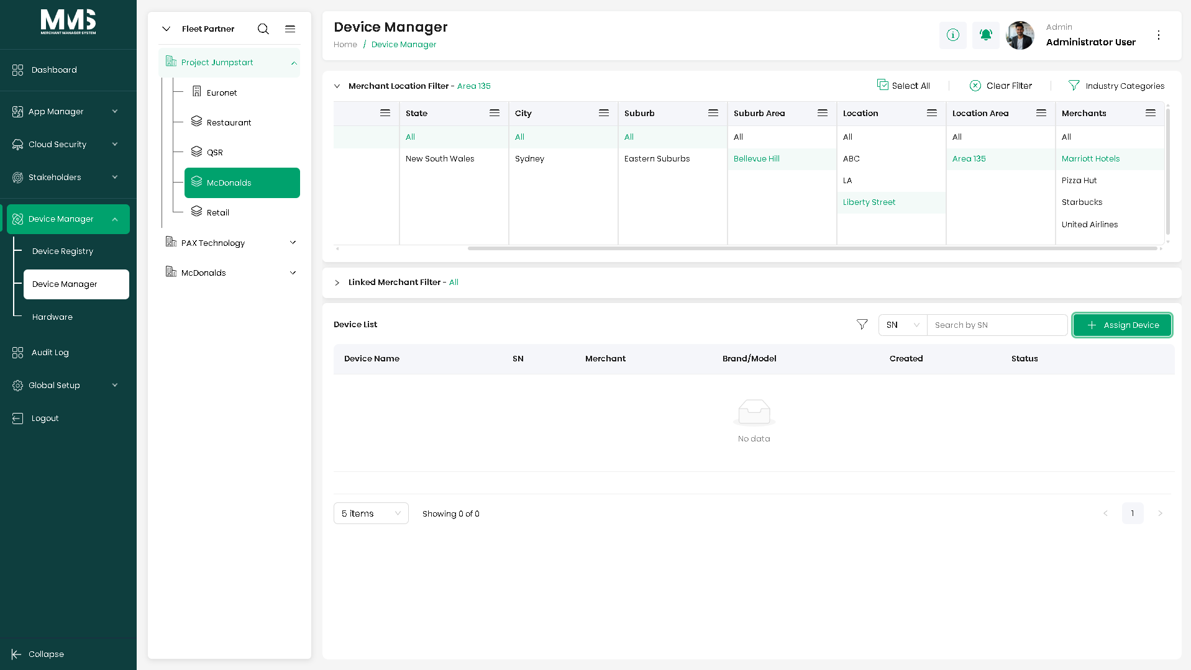
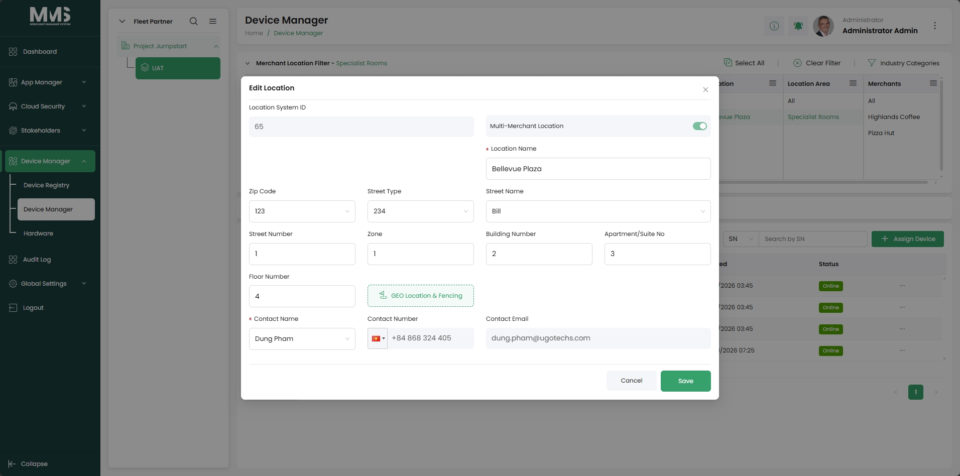
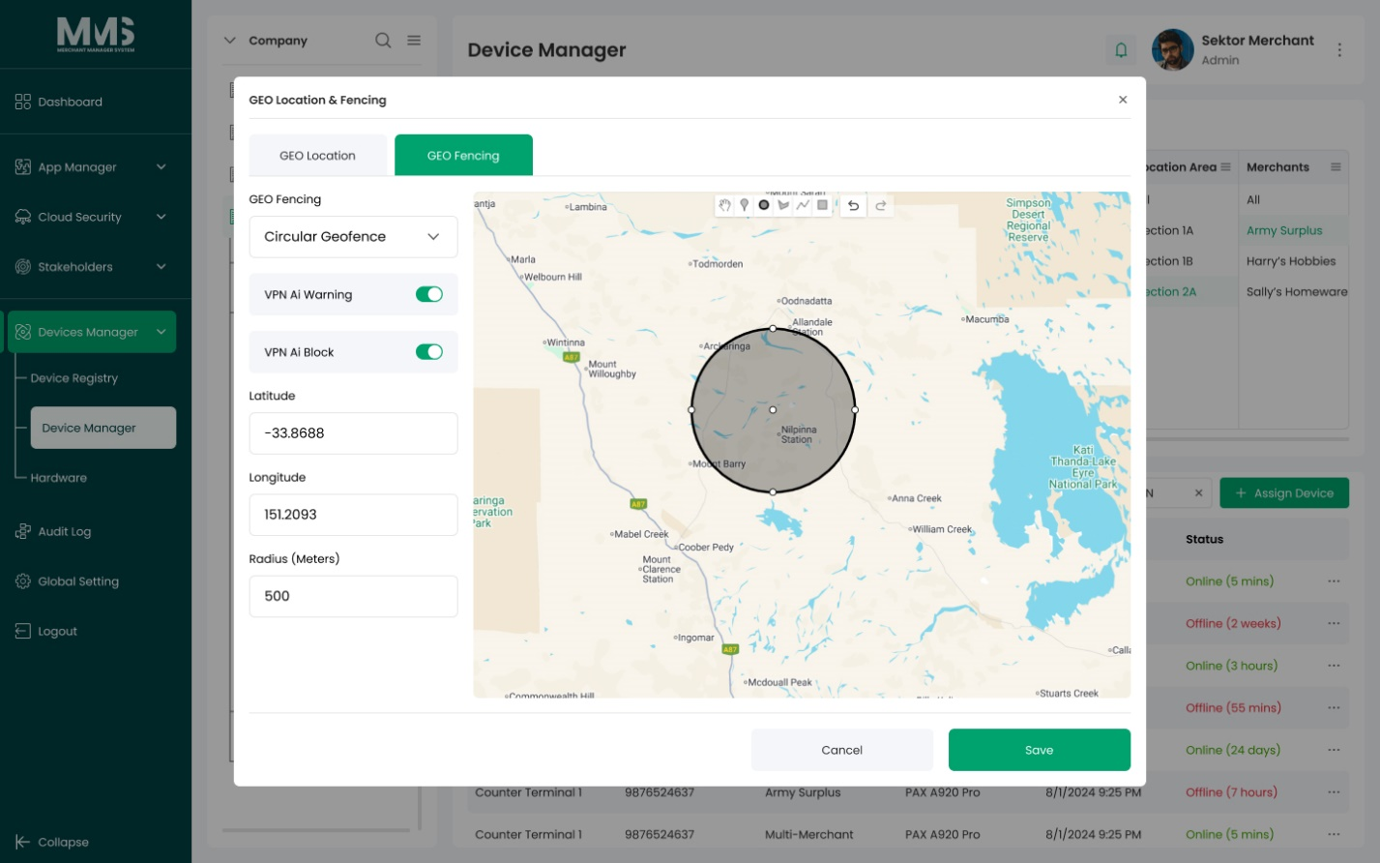
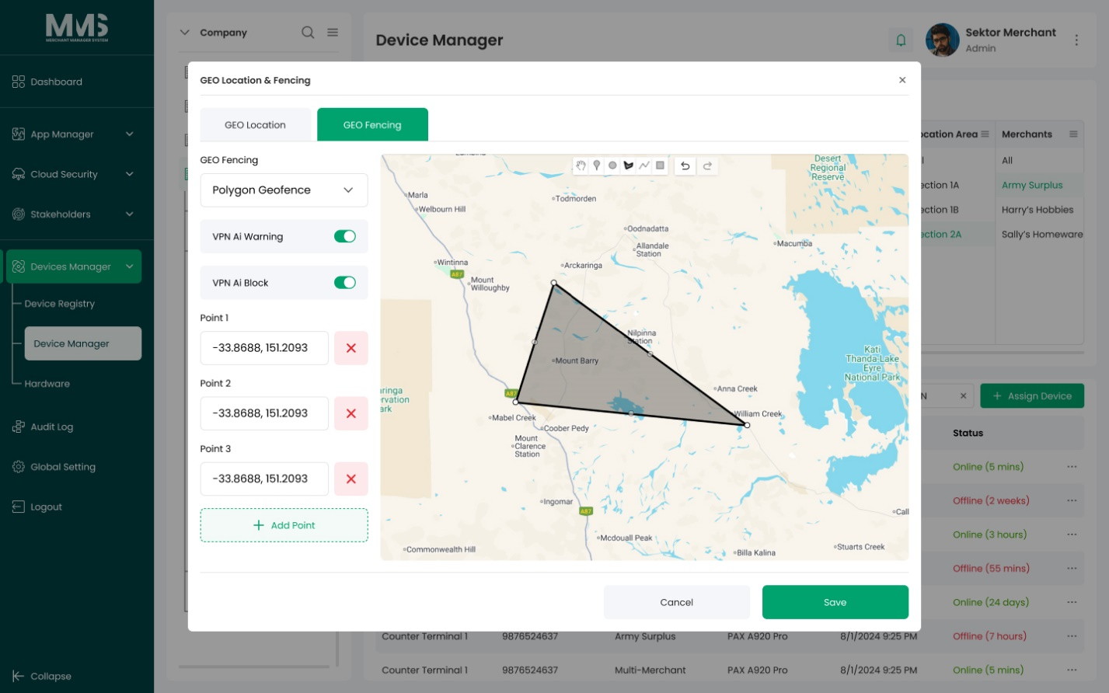

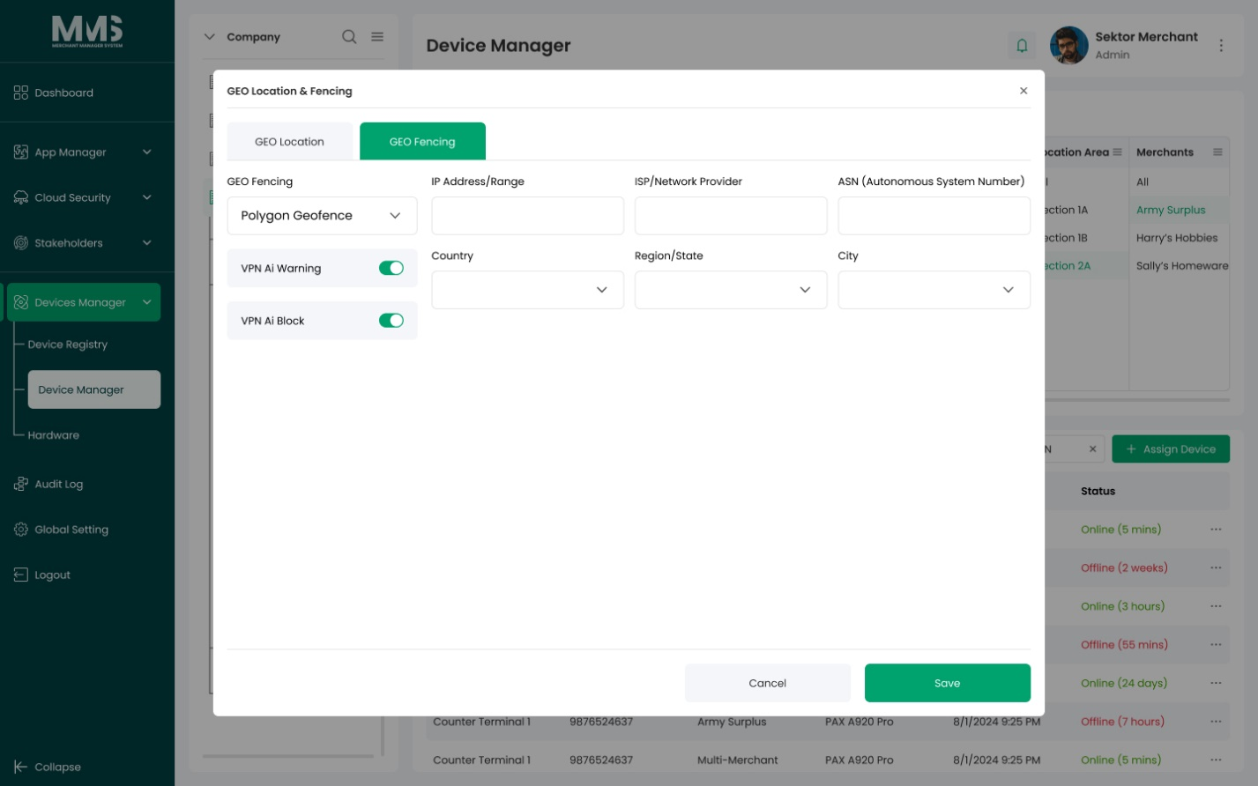

3.2.3. Linked Merchants
Description
This guide explains how to create and manage Merchant Linked Groups, which define relationships between merchants to support grouping, filtering, and device management.

Steps to manage Merchant Linked Groups:
- Navigate to the Merchant Linked Group page
- Open the Linked Merchant Filter panel
- In the list of Location Items, click the menu for the desired location
- Select Add Linked Merchant
- A Linked Merchant column will be created next to the selected location
- In the Linked Merchant column:
  - Click Add Linked Merchant Group
  - Enter the Group Name
  - Select the merchants to include in this group. The list of merchants is filtered according to the selected Company Group ID
- Click Save to create the Linked Merchant Group
Reference Images:
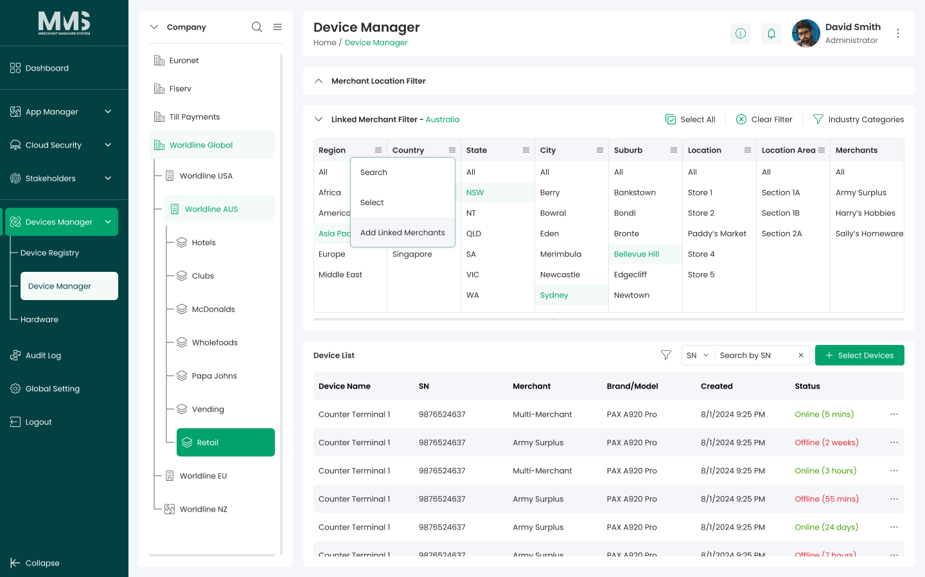

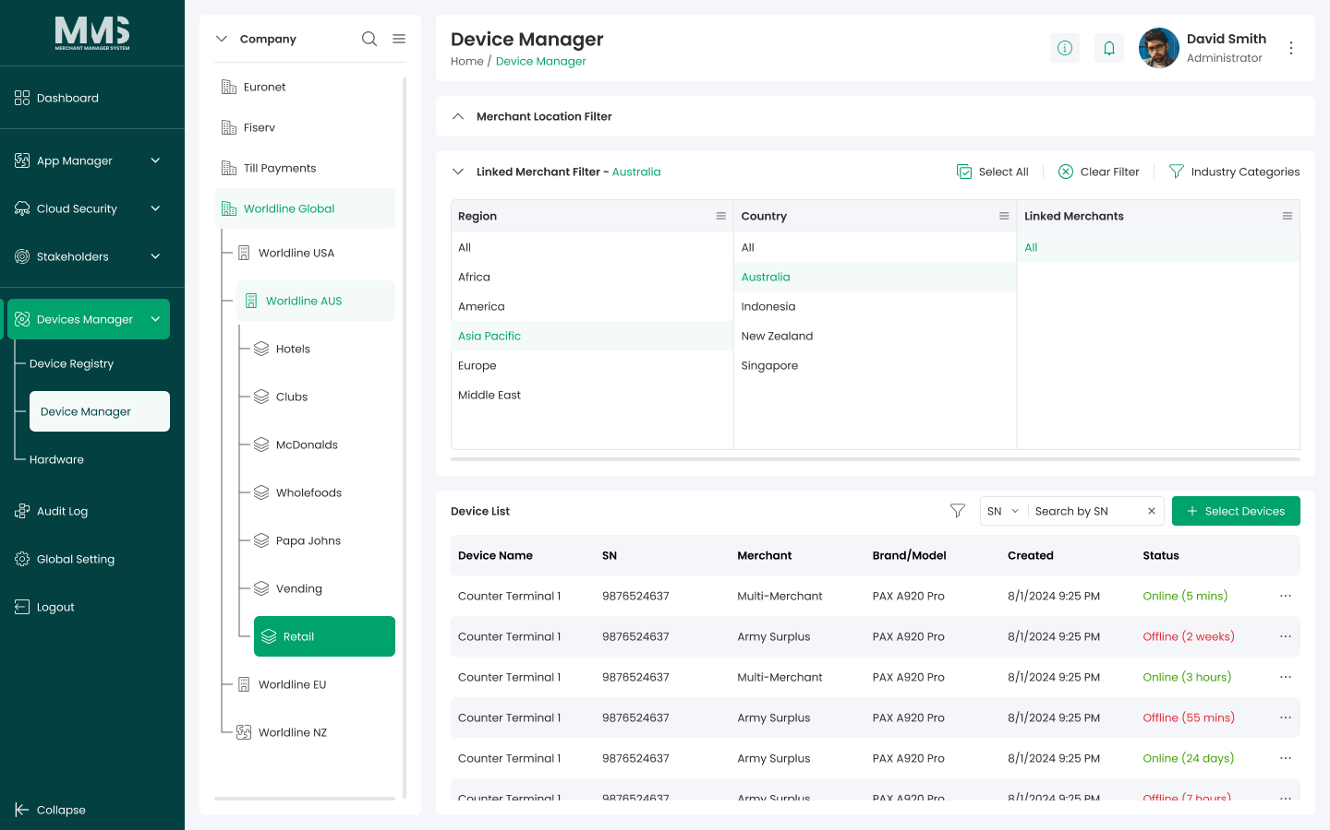

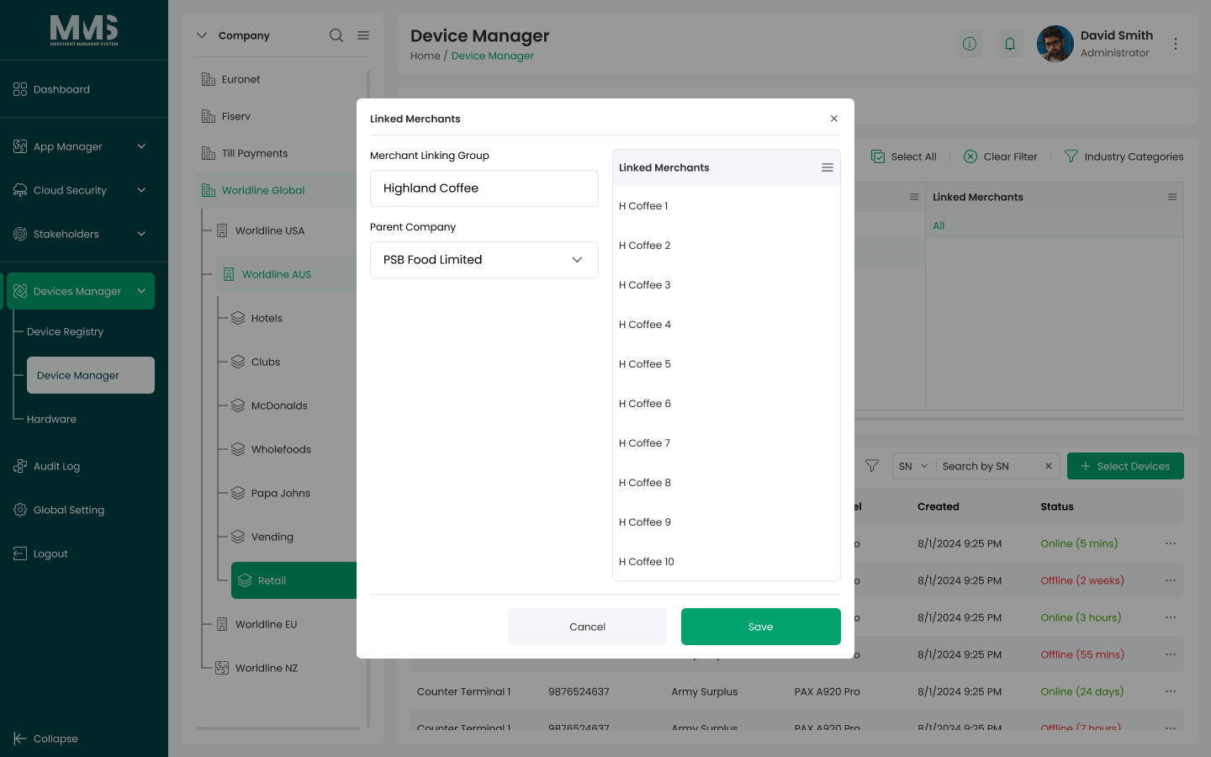

3.2.4. Assign Device
Description:
This guide explains how to assign device registries to specific locations and link devices to merchants, including the necessary configuration steps and management considerations.

Steps to Assign Devices to a Location:
- Navigate to the Device Manager page
- Select the desired Location and Location Area to assign devices
- Click the Assign Device button
- The Assign Device modal will open
- In the modal:
  - Filter devices based on desired conditions
  - Select the devices to assign by checking the corresponding boxes
- Click Save to complete the assignment
Steps to Assign Devices to a Merchant:
- Navigate to the Device Manager page
- Ensure the devices have already been assigned to a Location
- In the device list, click the options menu (three dots “...”) on the desired device
- Select Assign Merchant
- The Assign Merchant modal will open
- In the modal, select the merchant(s) to assign to the device by checking the corresponding boxes
- Click Save to complete the assignment

a. Assign Devices to a Location
Reference Images:
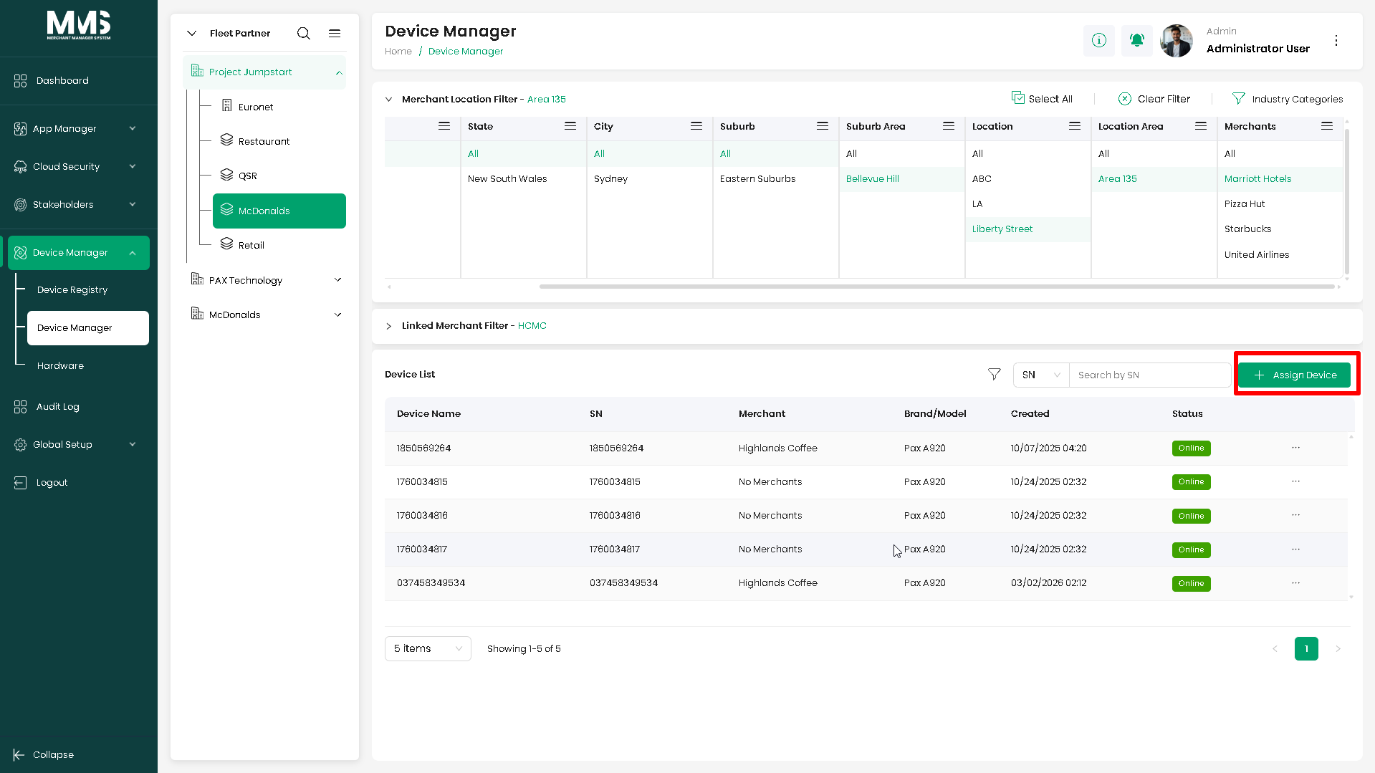
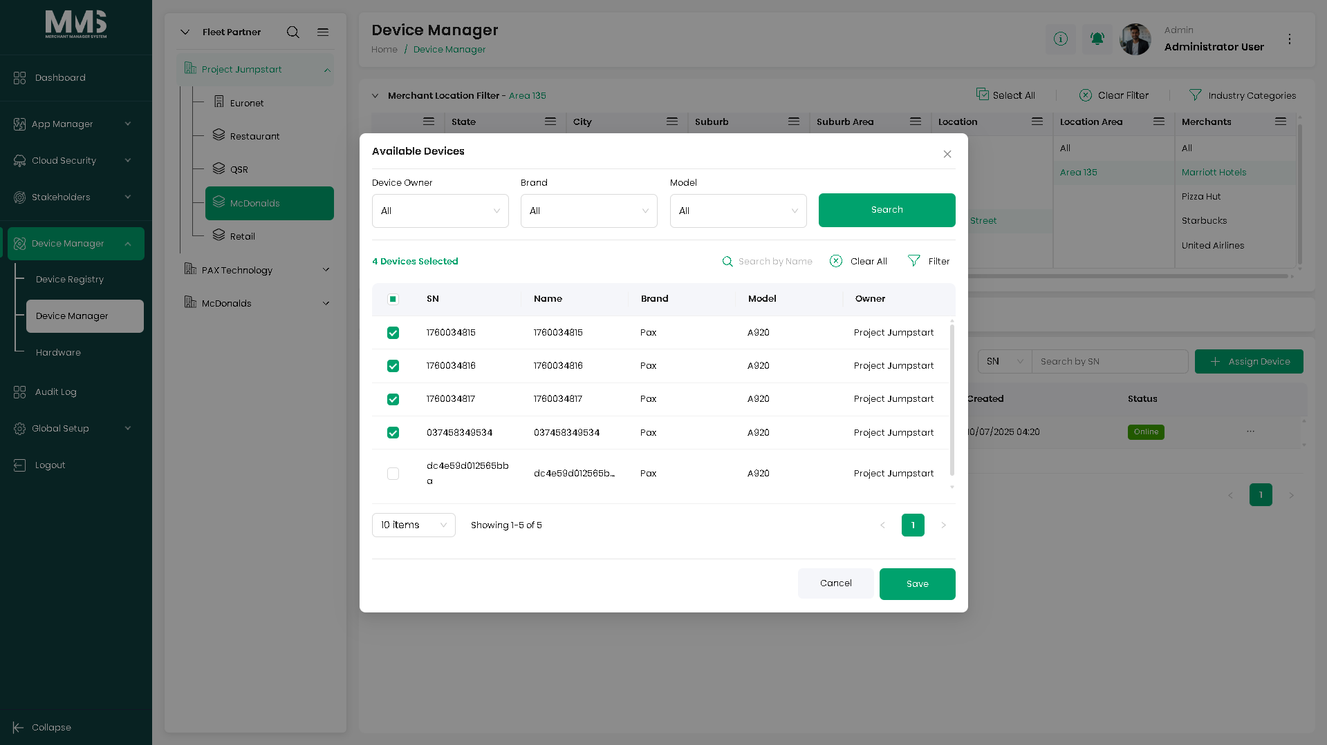

b. Assign Devices to a Merchant
Reference Images:
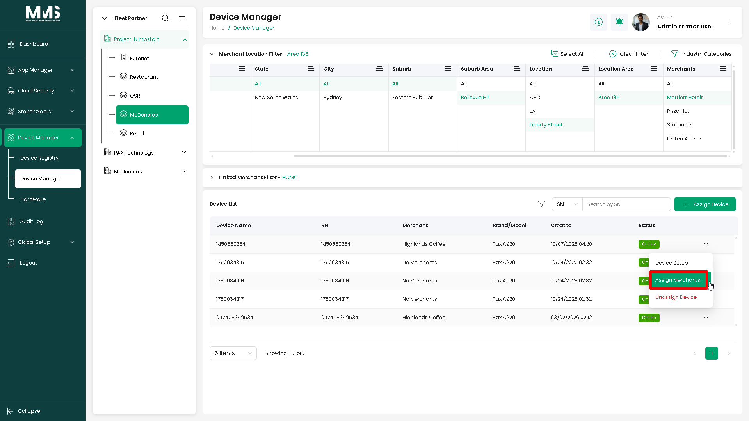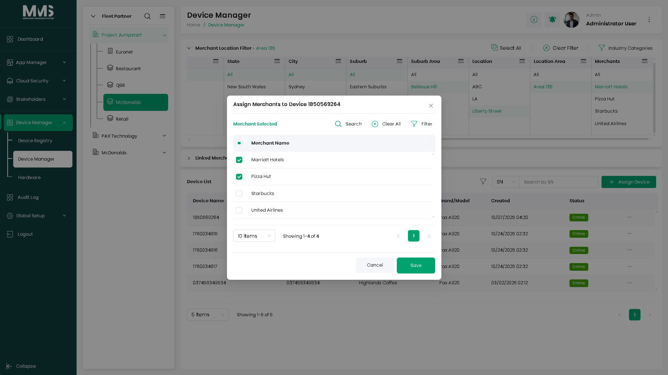

3.2.5. Select Linked Merchant Device
Description
This guide explains how to configure and manage assigned devices, including selecting devices for linked merchants based on devices that have already been assigned to merchants within the linked merchant group.
Steps to Select Devices for a Linked Merchant
- Navigate to the Device Manager page
- Open the Linked Merchant Filter panel
- Select the Location that contains the desired linked merchants
- Choose a Linked Merchant from the list
- Click the Select Devices button
- The Select Devices modal will open
- In the modal, select the devices by checking the corresponding boxes
- Click Save to complete the selection

Reference Images:
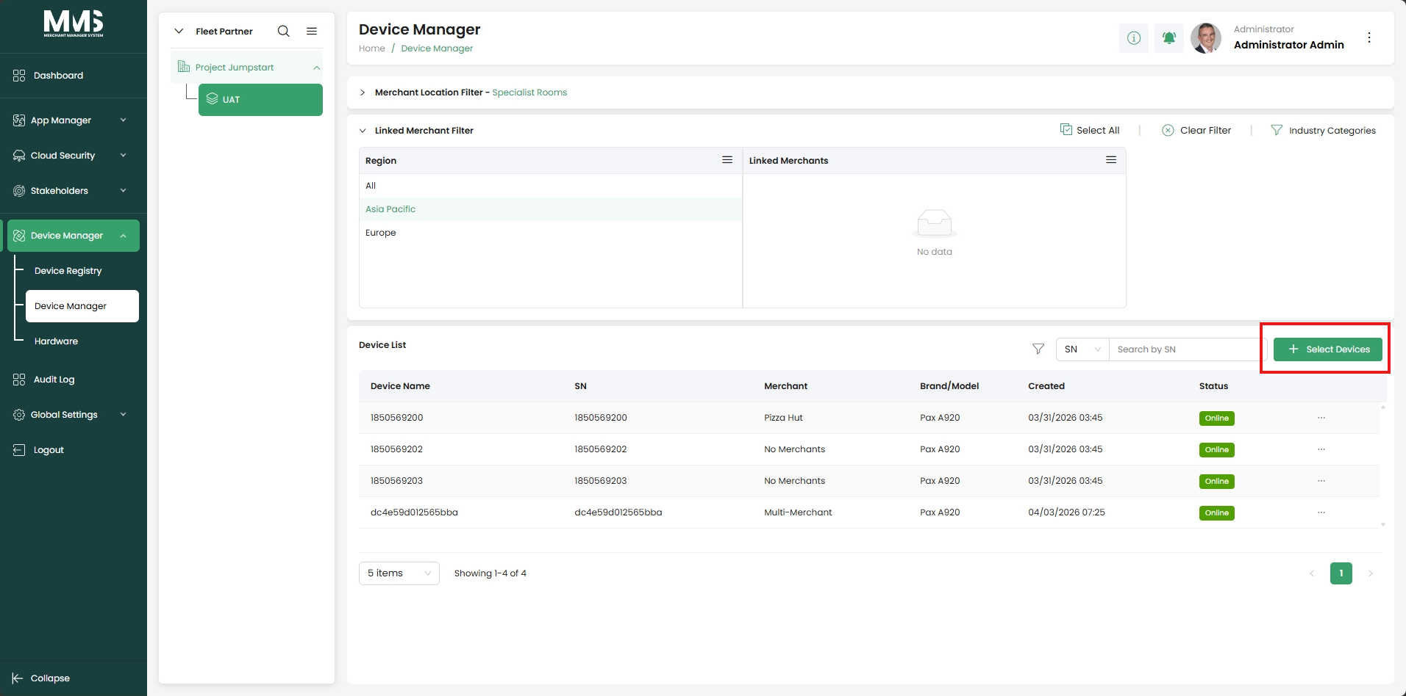
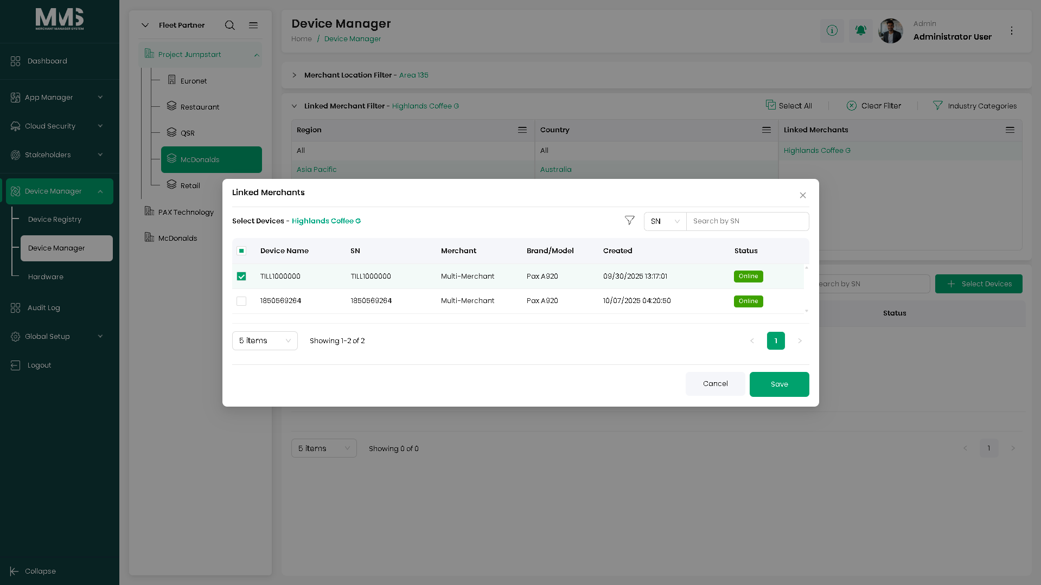
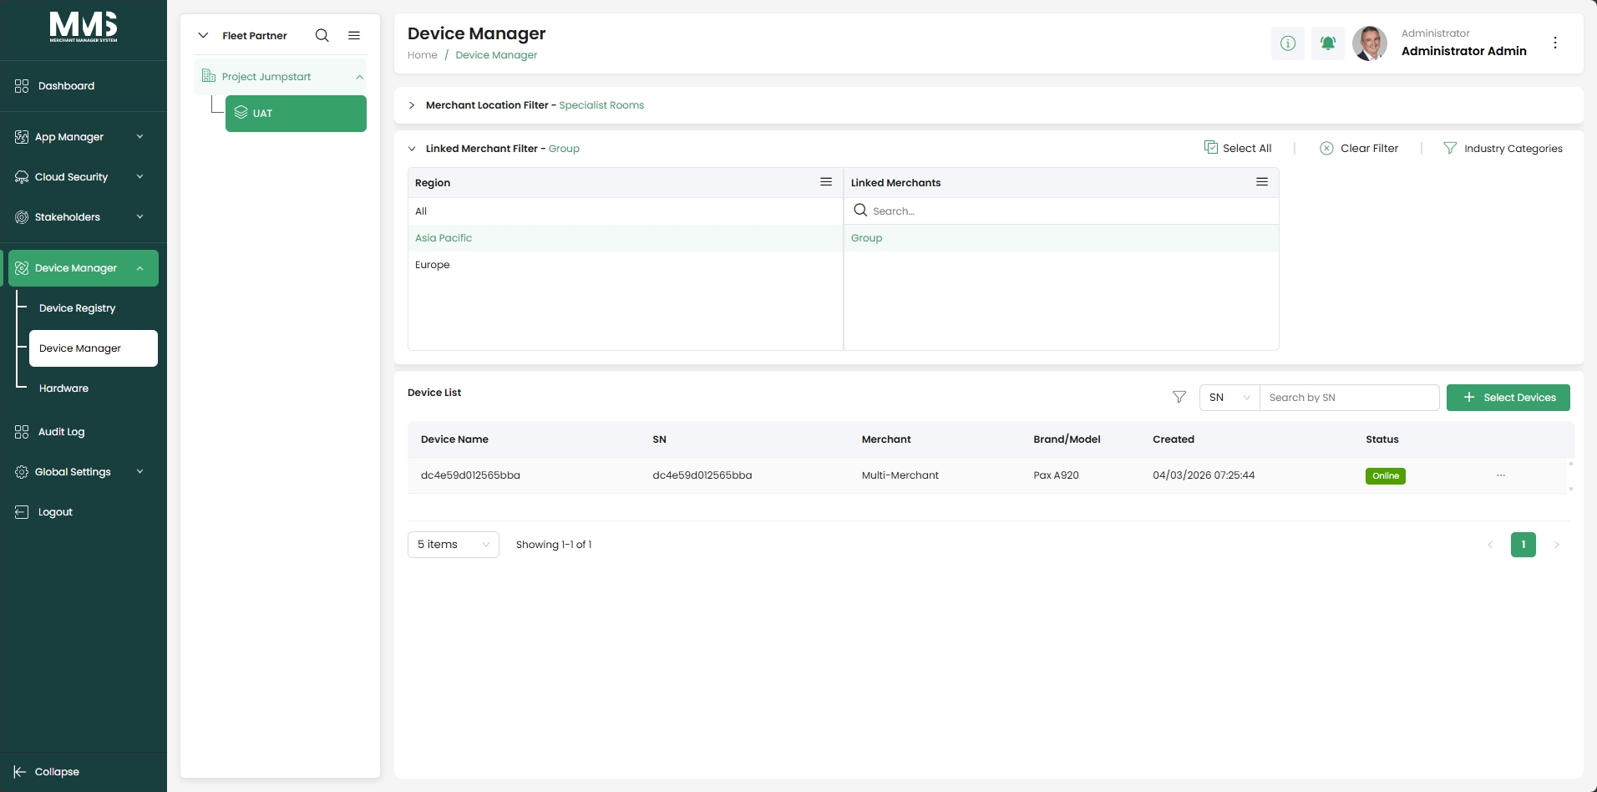

3.2.6. Device Setup
Description
This guide explains how to configure and manage assigned devices, including applications, firmware, templates, and operational settings.
Key Capabilities
- Dashboard: View an overview of device status, key information, and recent activities
- App & Firmware: Manage application and firmware versions applied to devices
- Update Tasks: Schedule and monitor application and firmware update tasks
- App Templates: Apply configuration templates to standardize device setup
- Geo Location: Track and manage device location information
- Backups: Manage device configuration backups and restore points
- Logs: View device activity and operational logs
- Settings: Configure device-specific operational and system settings
a. Dashboard
Reference Images:
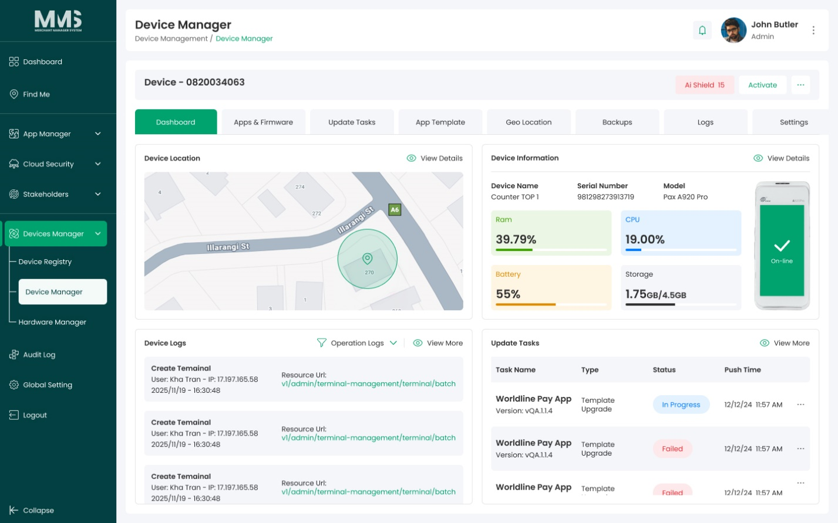

b. App & Firmware
Reference Images:
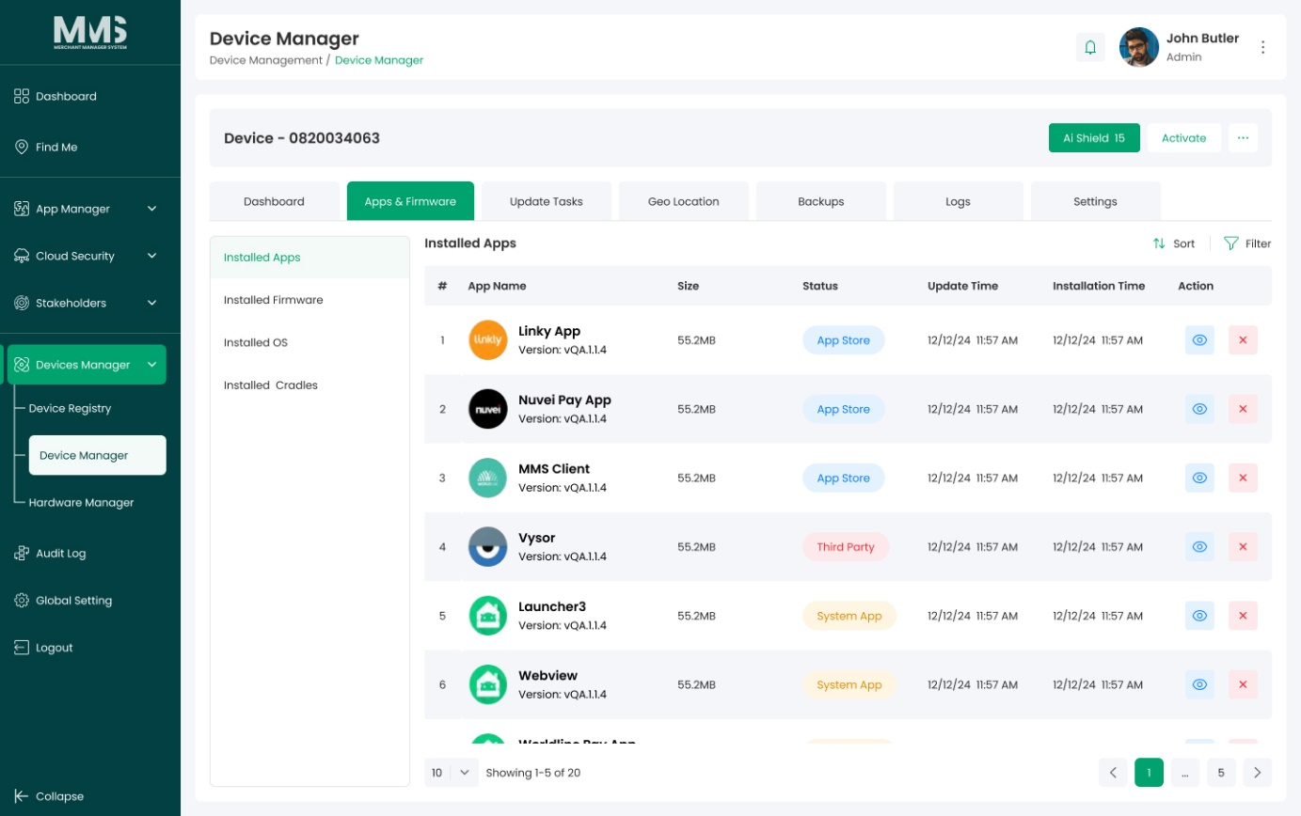
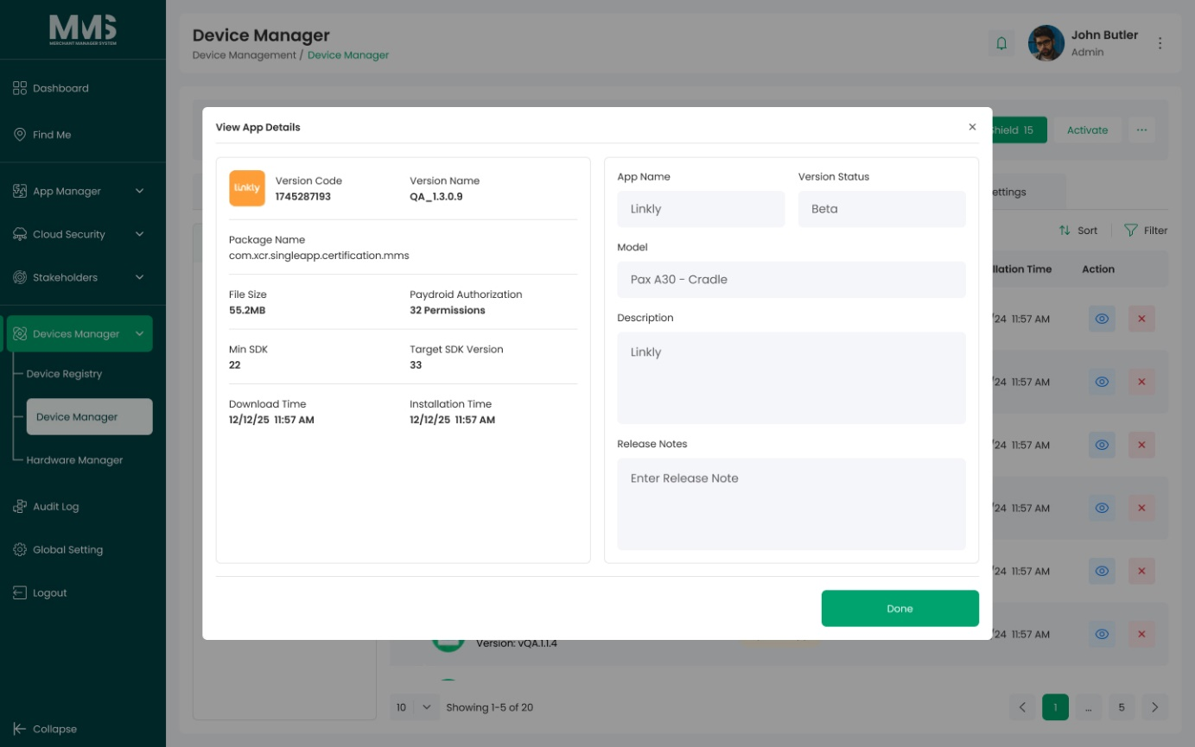

c. Update Tasks
Reference Images:
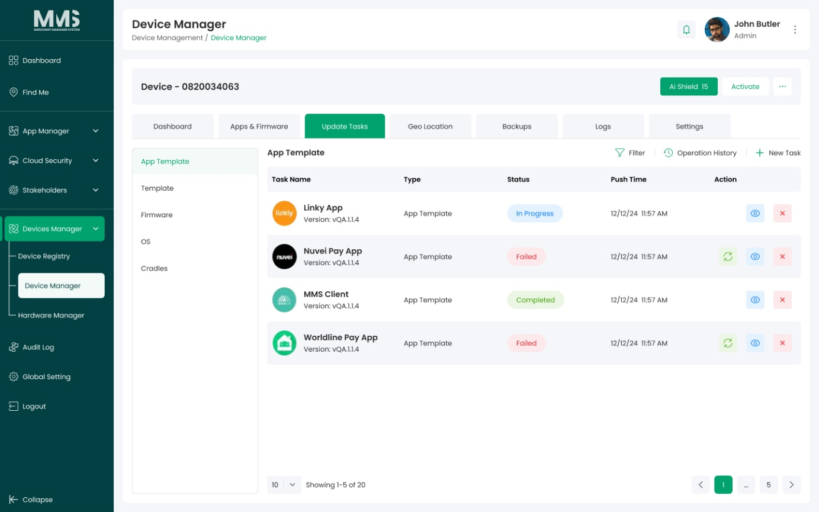
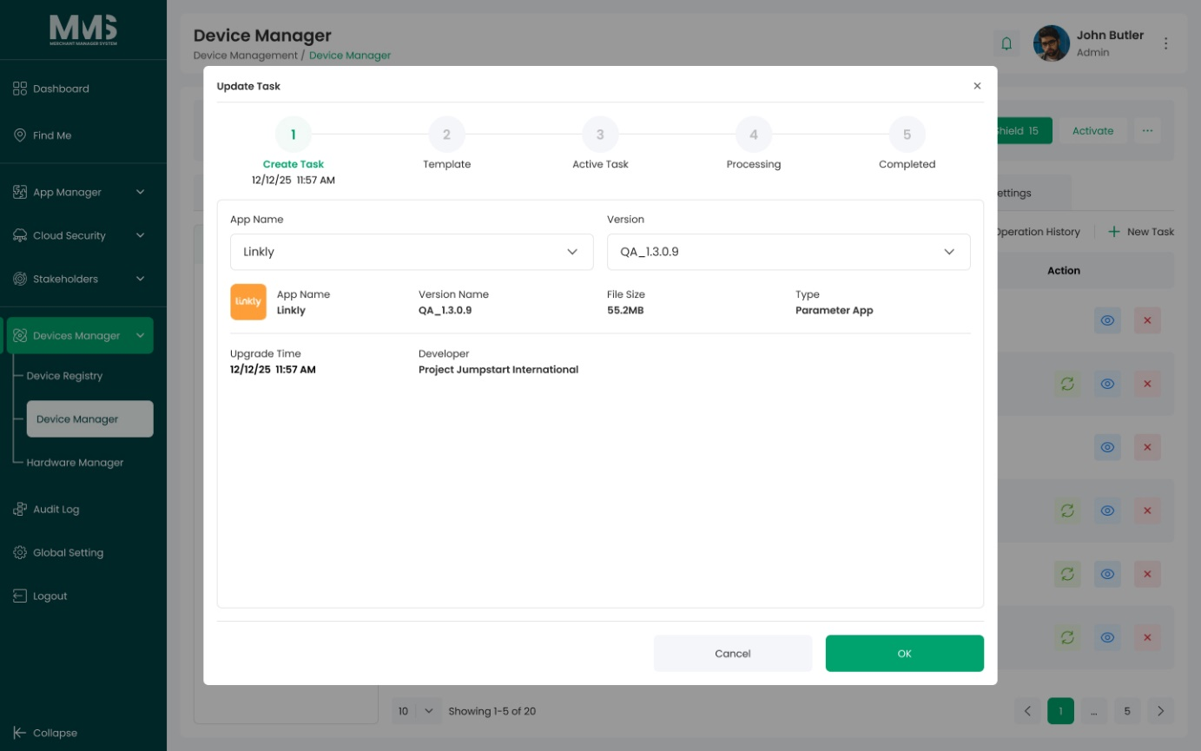
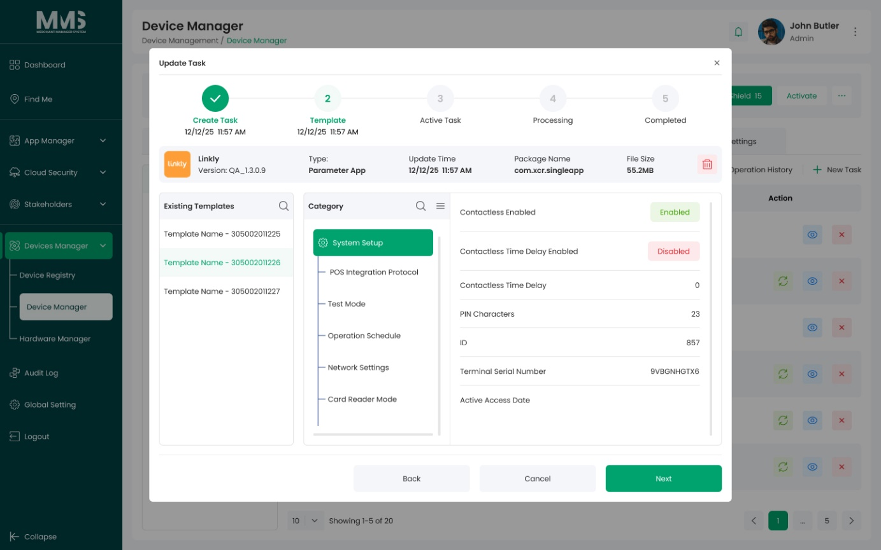
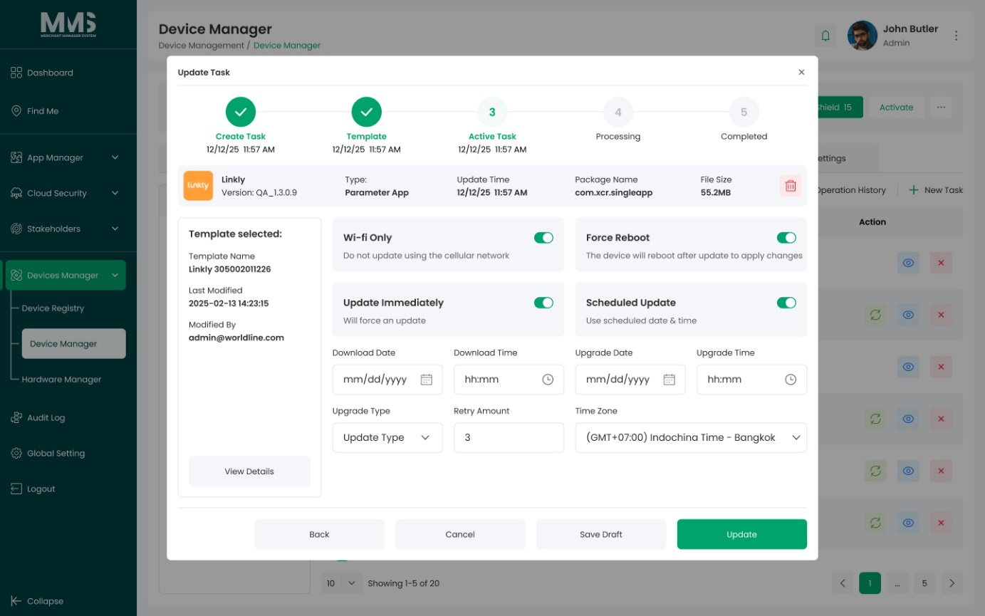

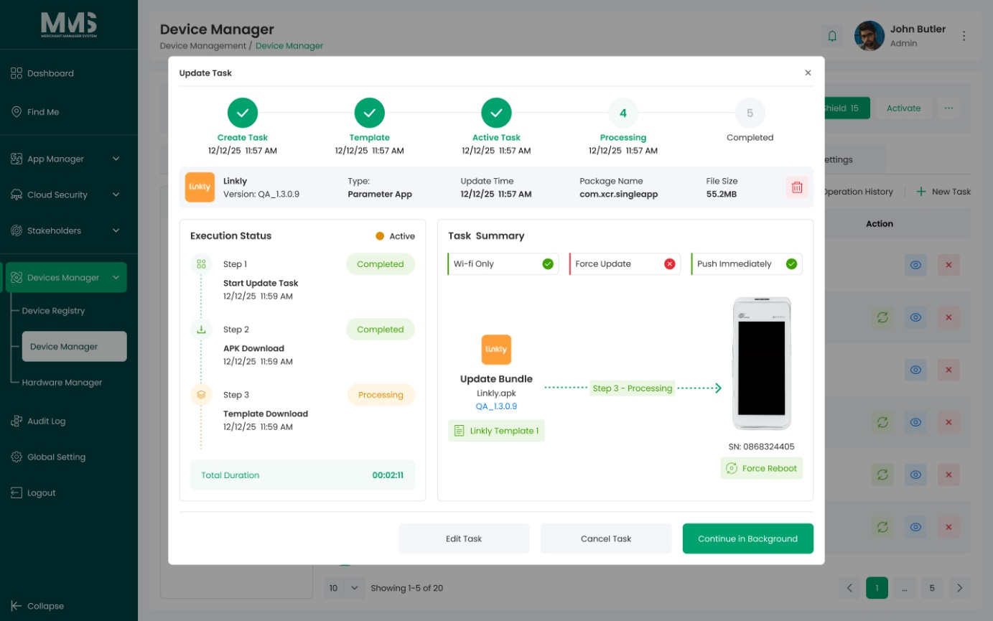
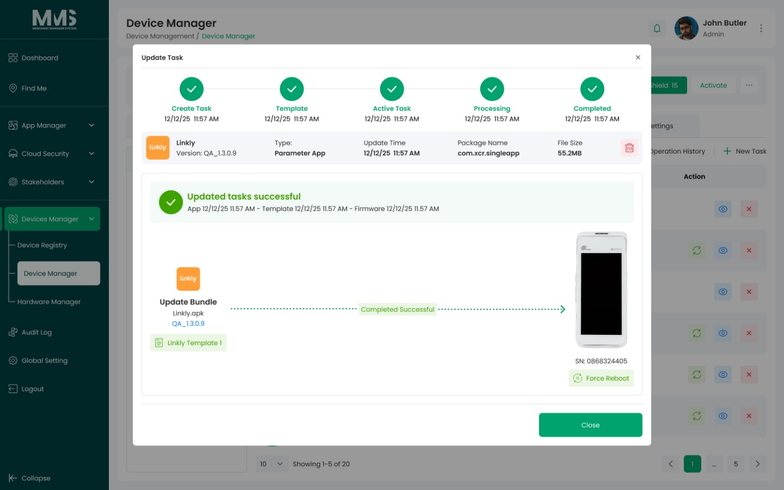
d. App Template
Reference Images:
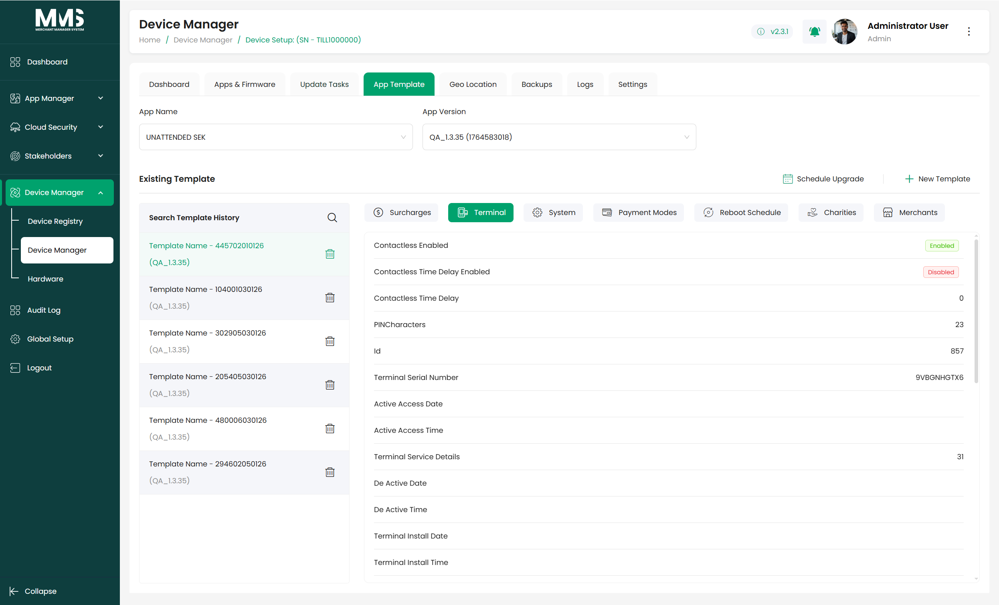
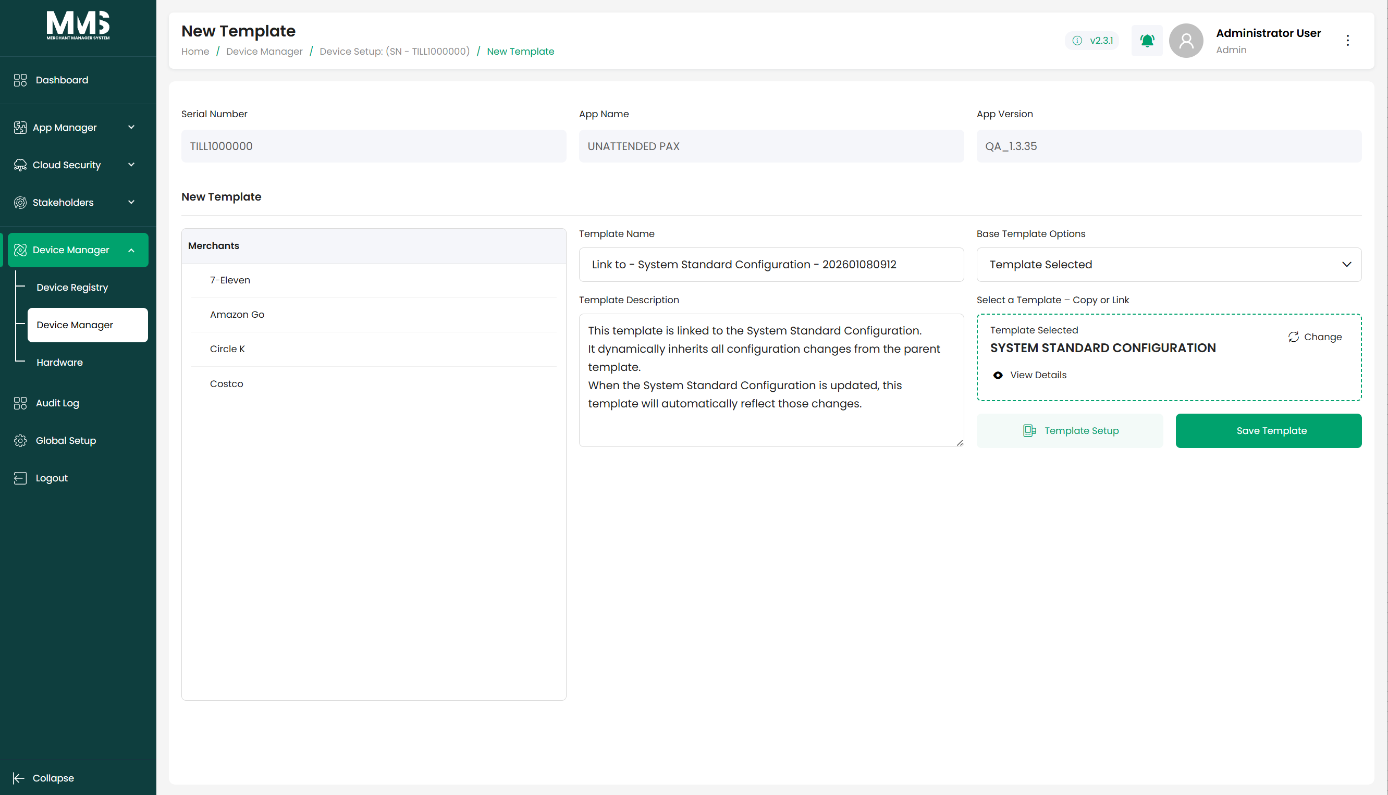
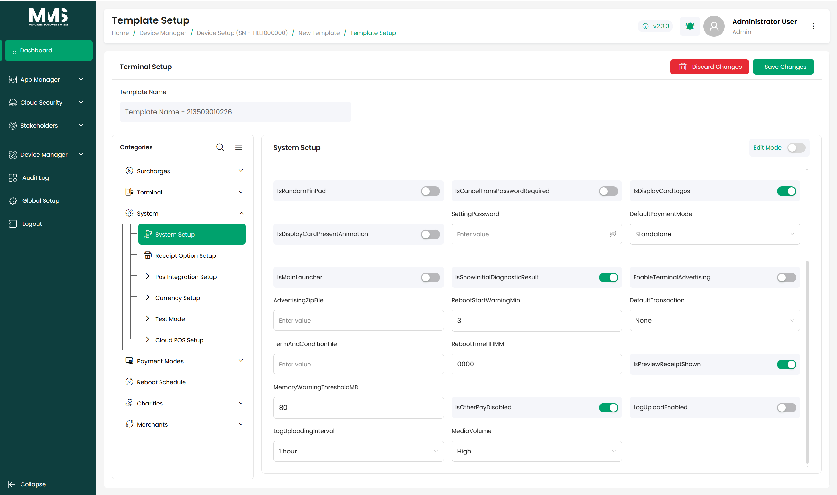

e. Geo Location
Reference Images:
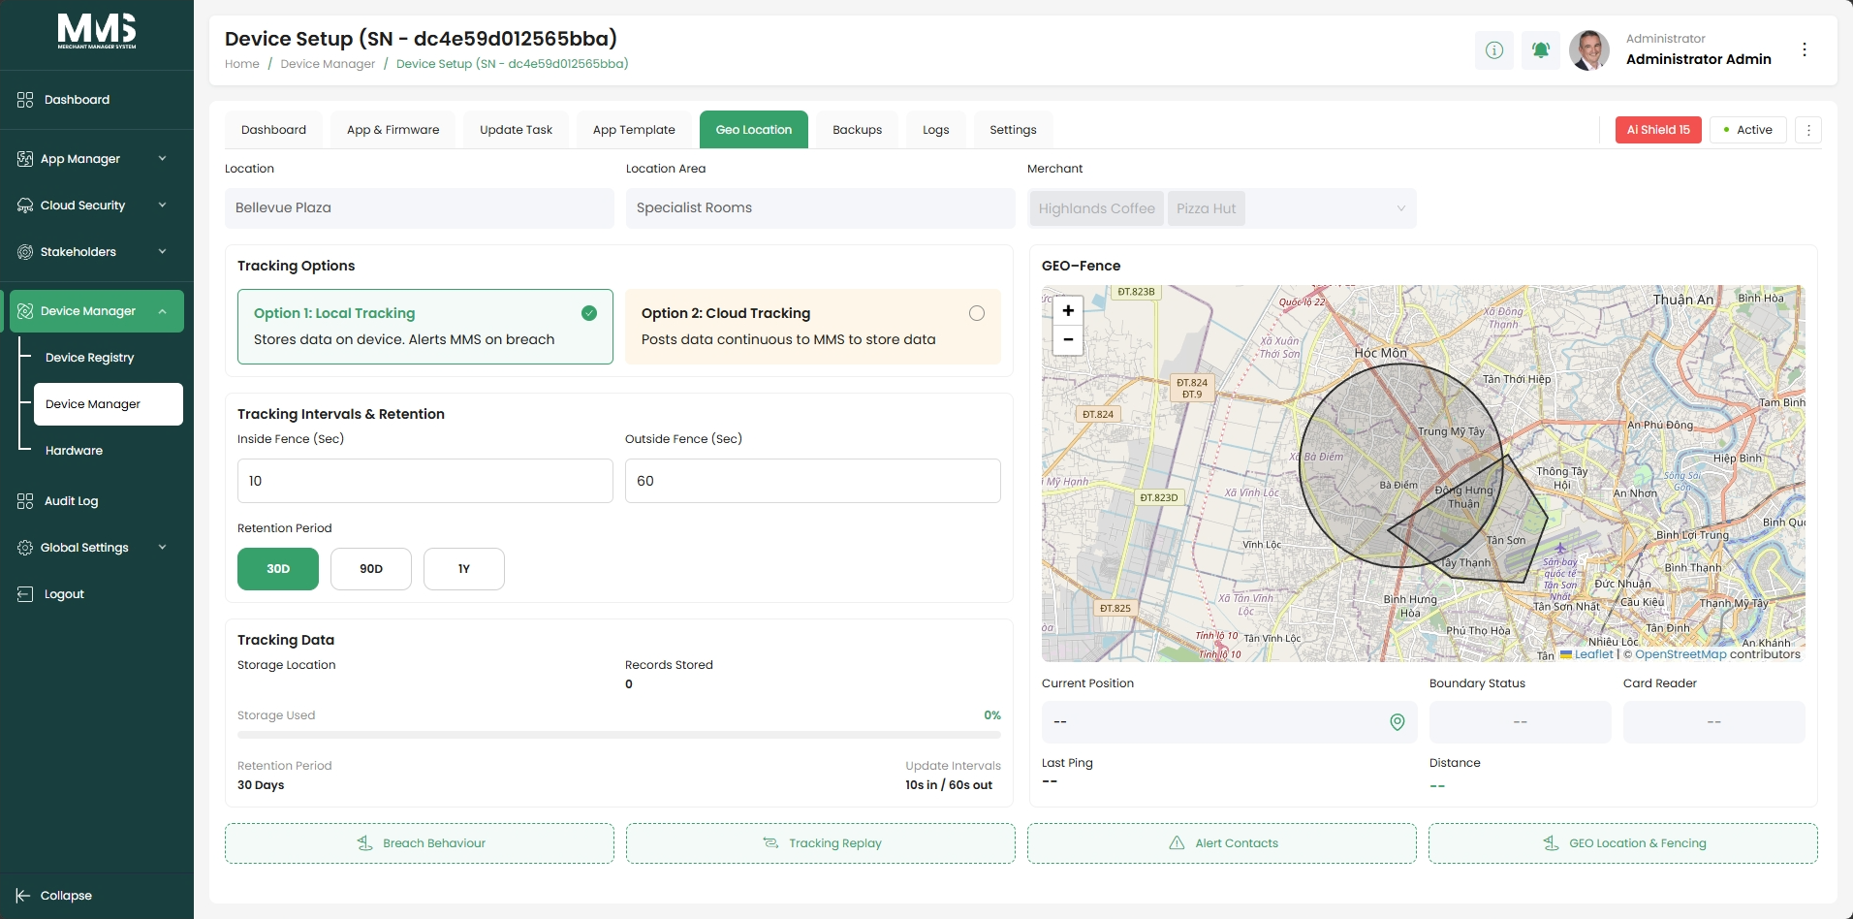
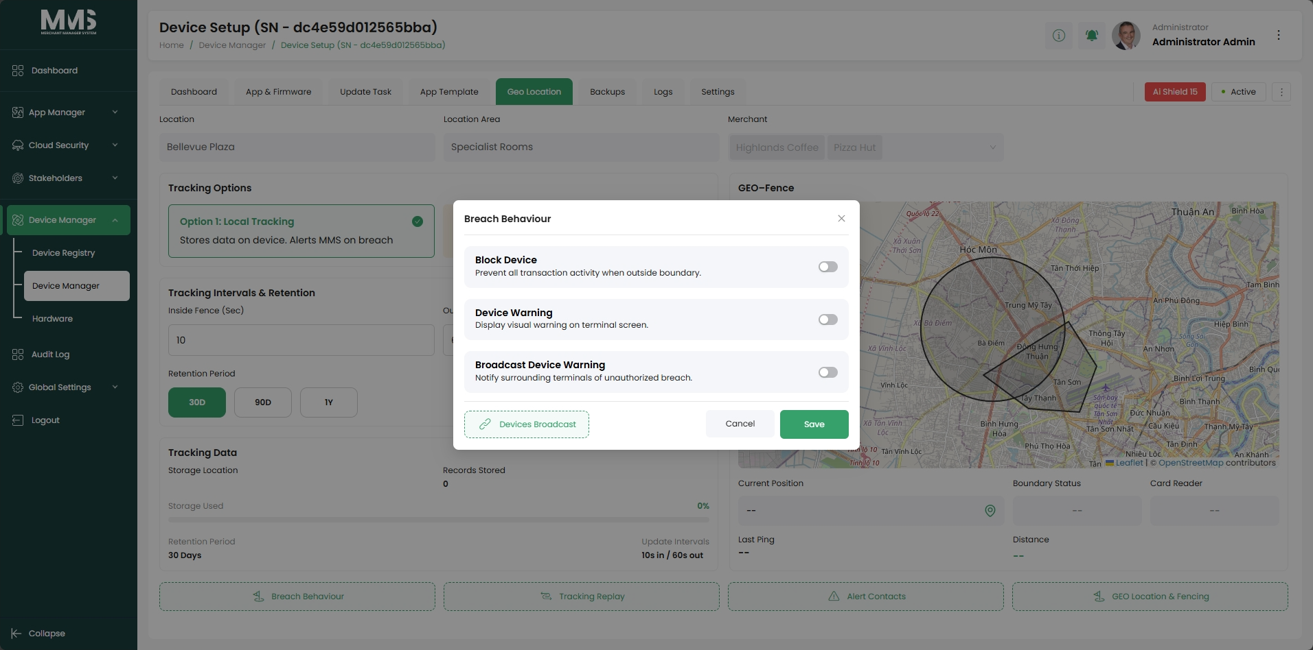
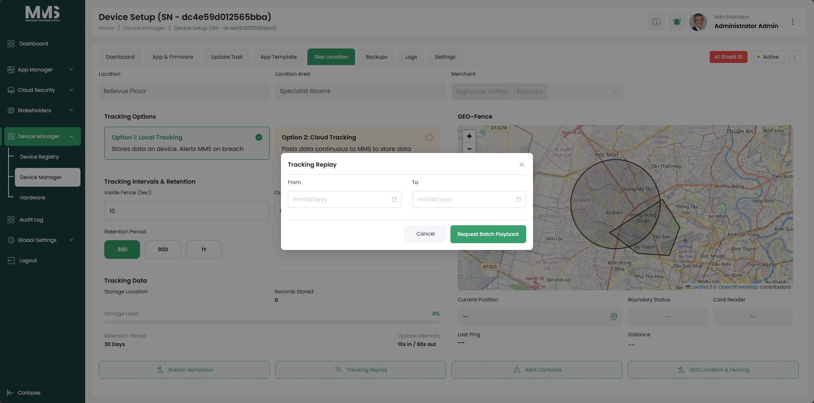
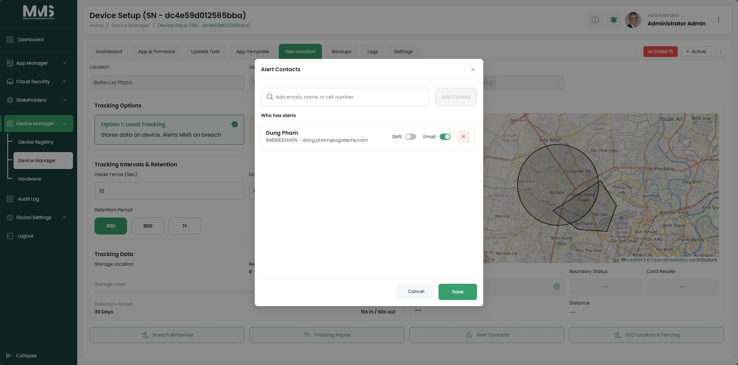
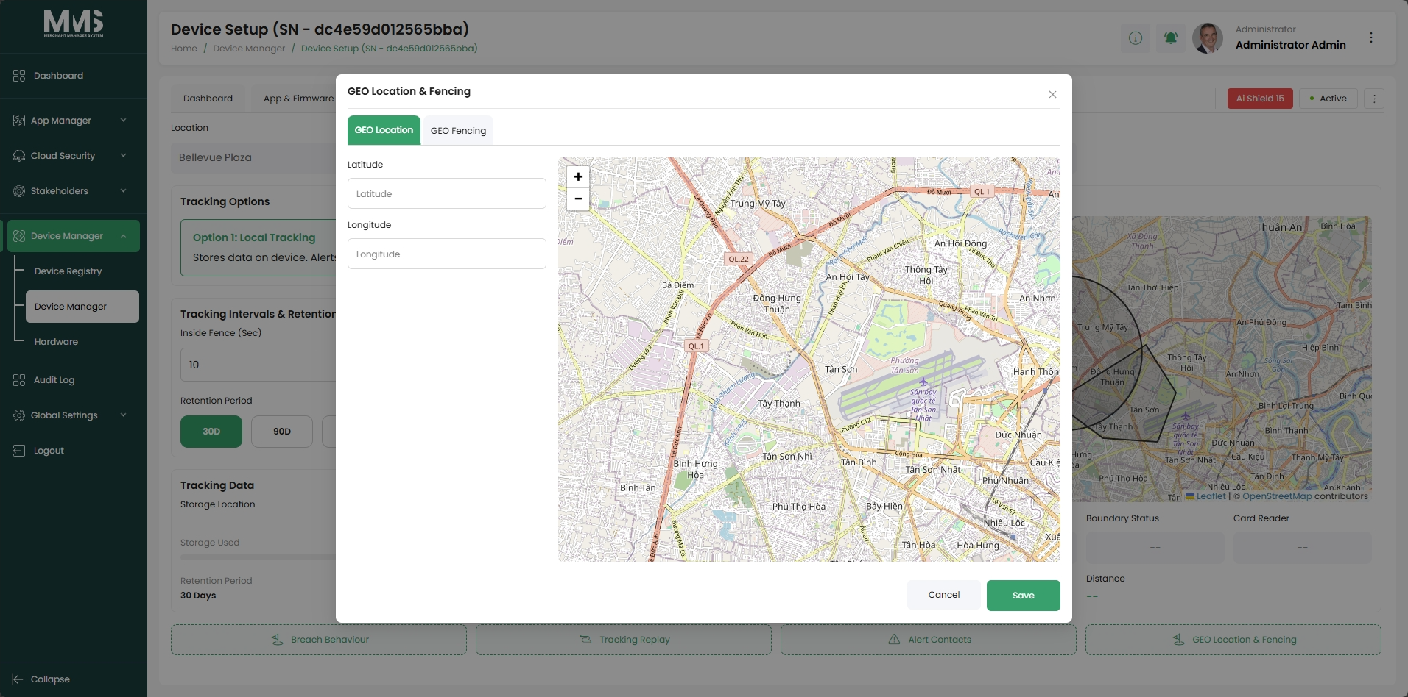
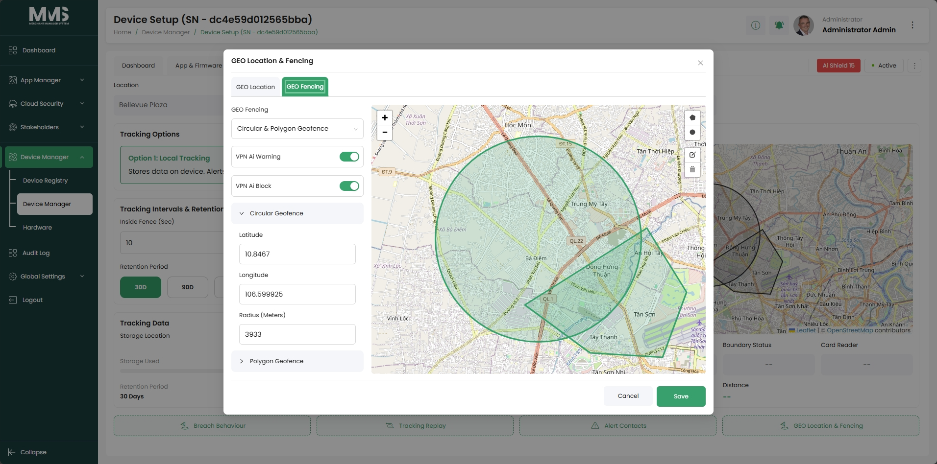
f. Backups
Reference Images:
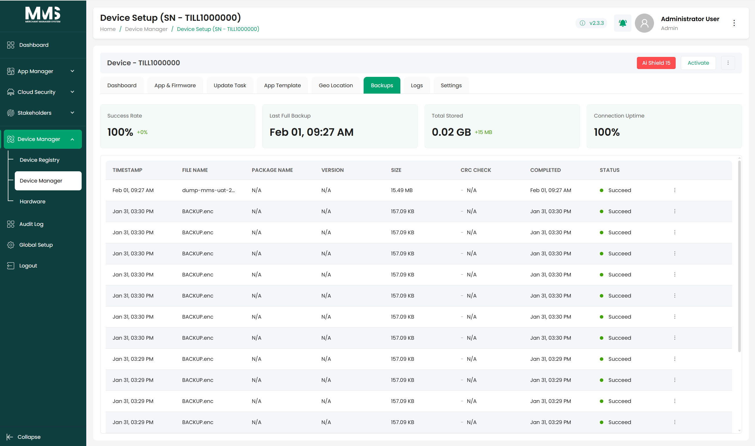

g. Logs
Reference Images:
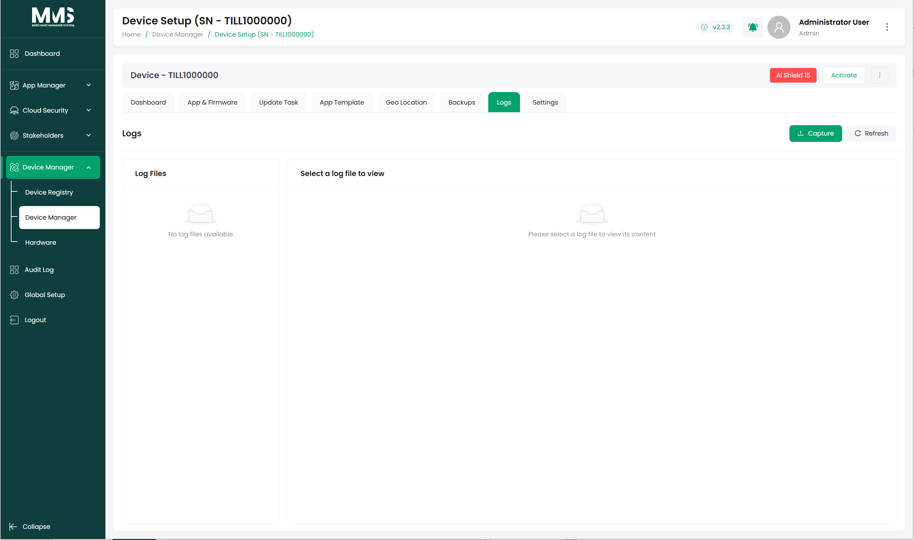
h. Settings
Reference Images:
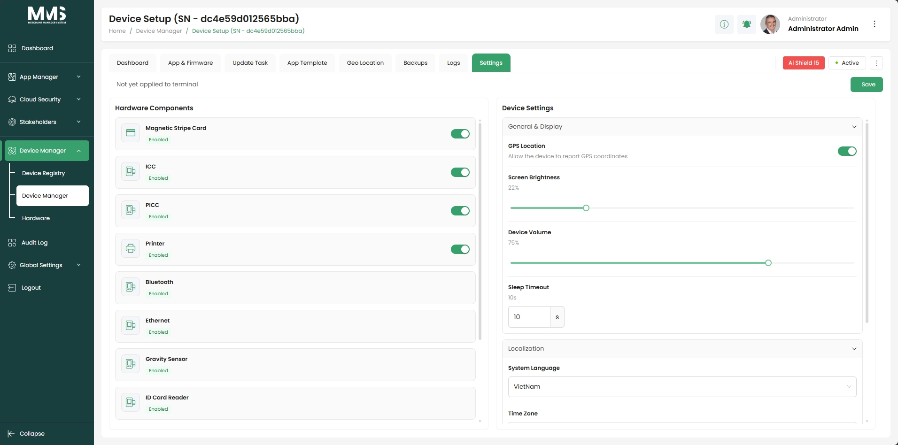

4. App Manager

4.1. Manage Apps
Description
This guide explains how to create applications, upload APK files, and manage application versions within the system.
Steps to Manage Applications
- Navigate to the Manage Apps page
- Click the Plus icon to create new application
- Enter the required application information (e.g., Application Name)
- Click Save
- Select the created application from the list
- After create new app, you’ll see App Versions (on the right side) show nothing. Click New Version button to create an app version
- In modal, choose the APK file from your device
- Click Upload
- Review the application information automatically displayed by the system, including:
  - Package name
  - Application name
  - Version and build number
  - Application icon
- View the list of uploaded versions for the application
- Select a version to view details (if required)
Notes
- Multiple APK versions can be uploaded for a single application
- Application information is automatically extracted from the APK file
- Ensure the APK file is valid before uploading
Reference Images:
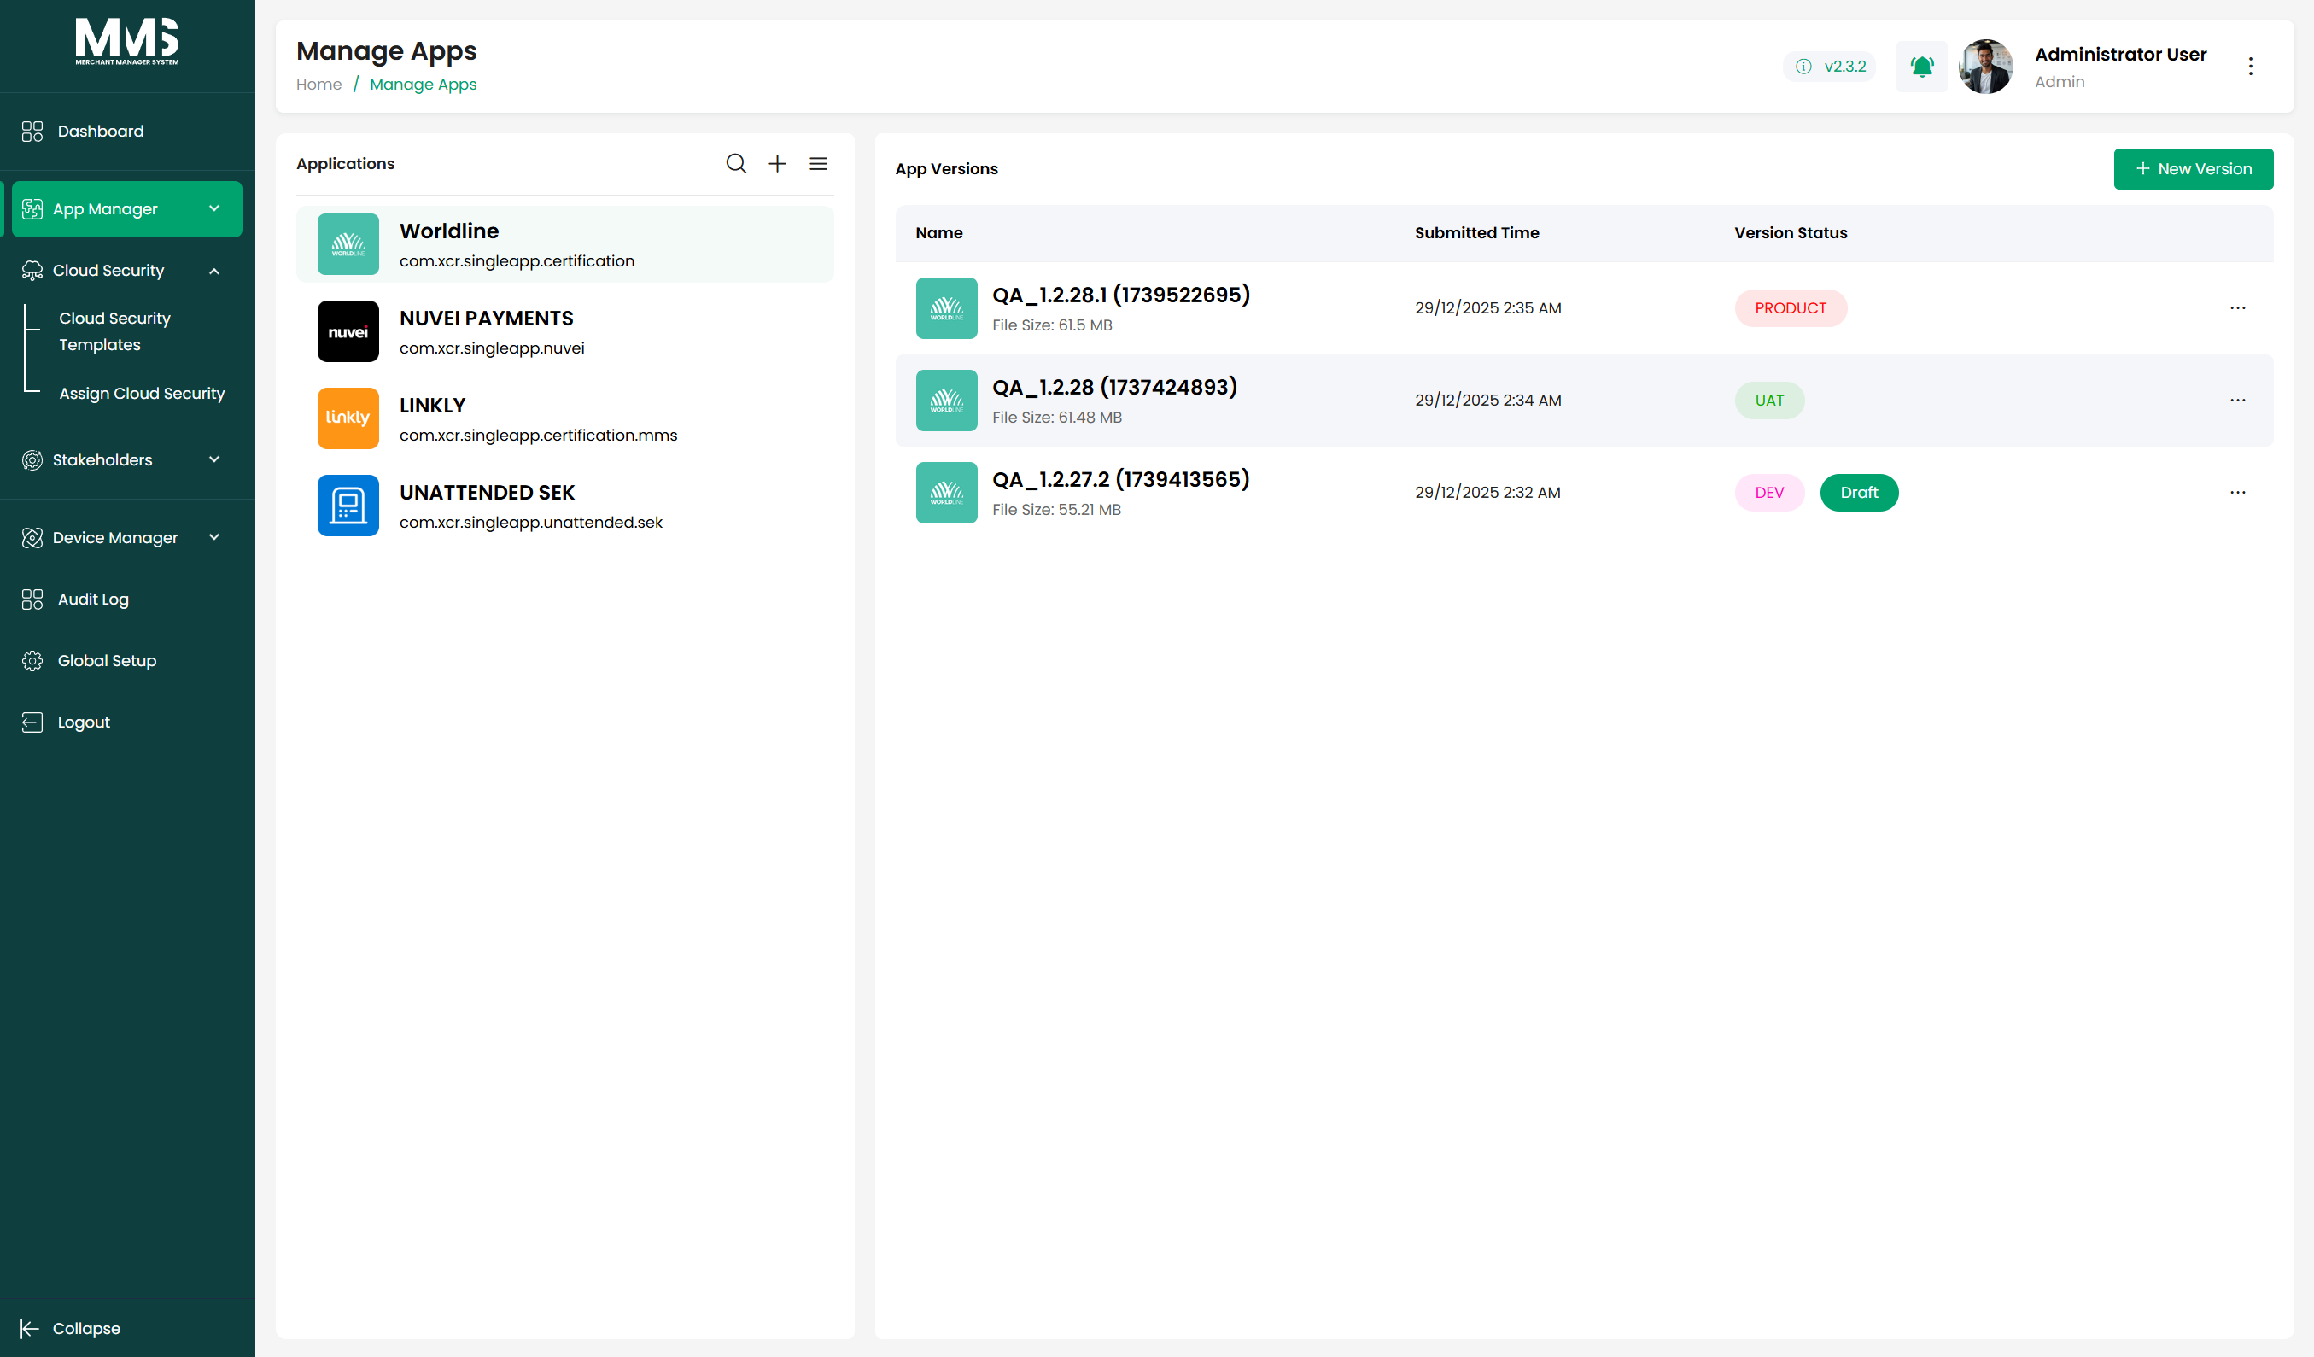
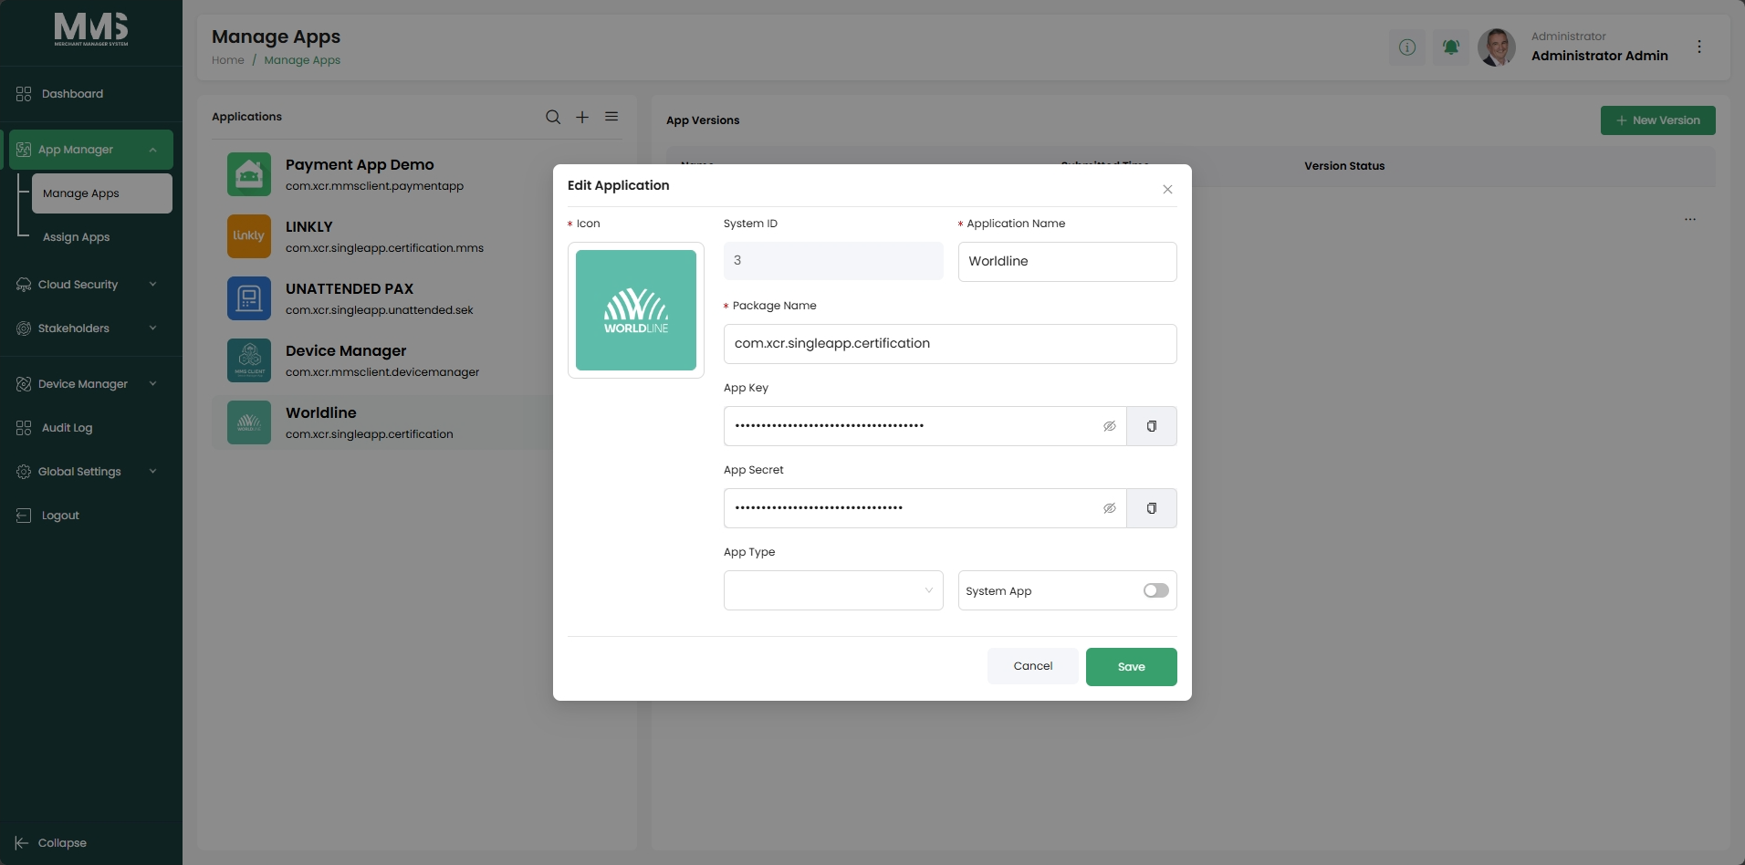
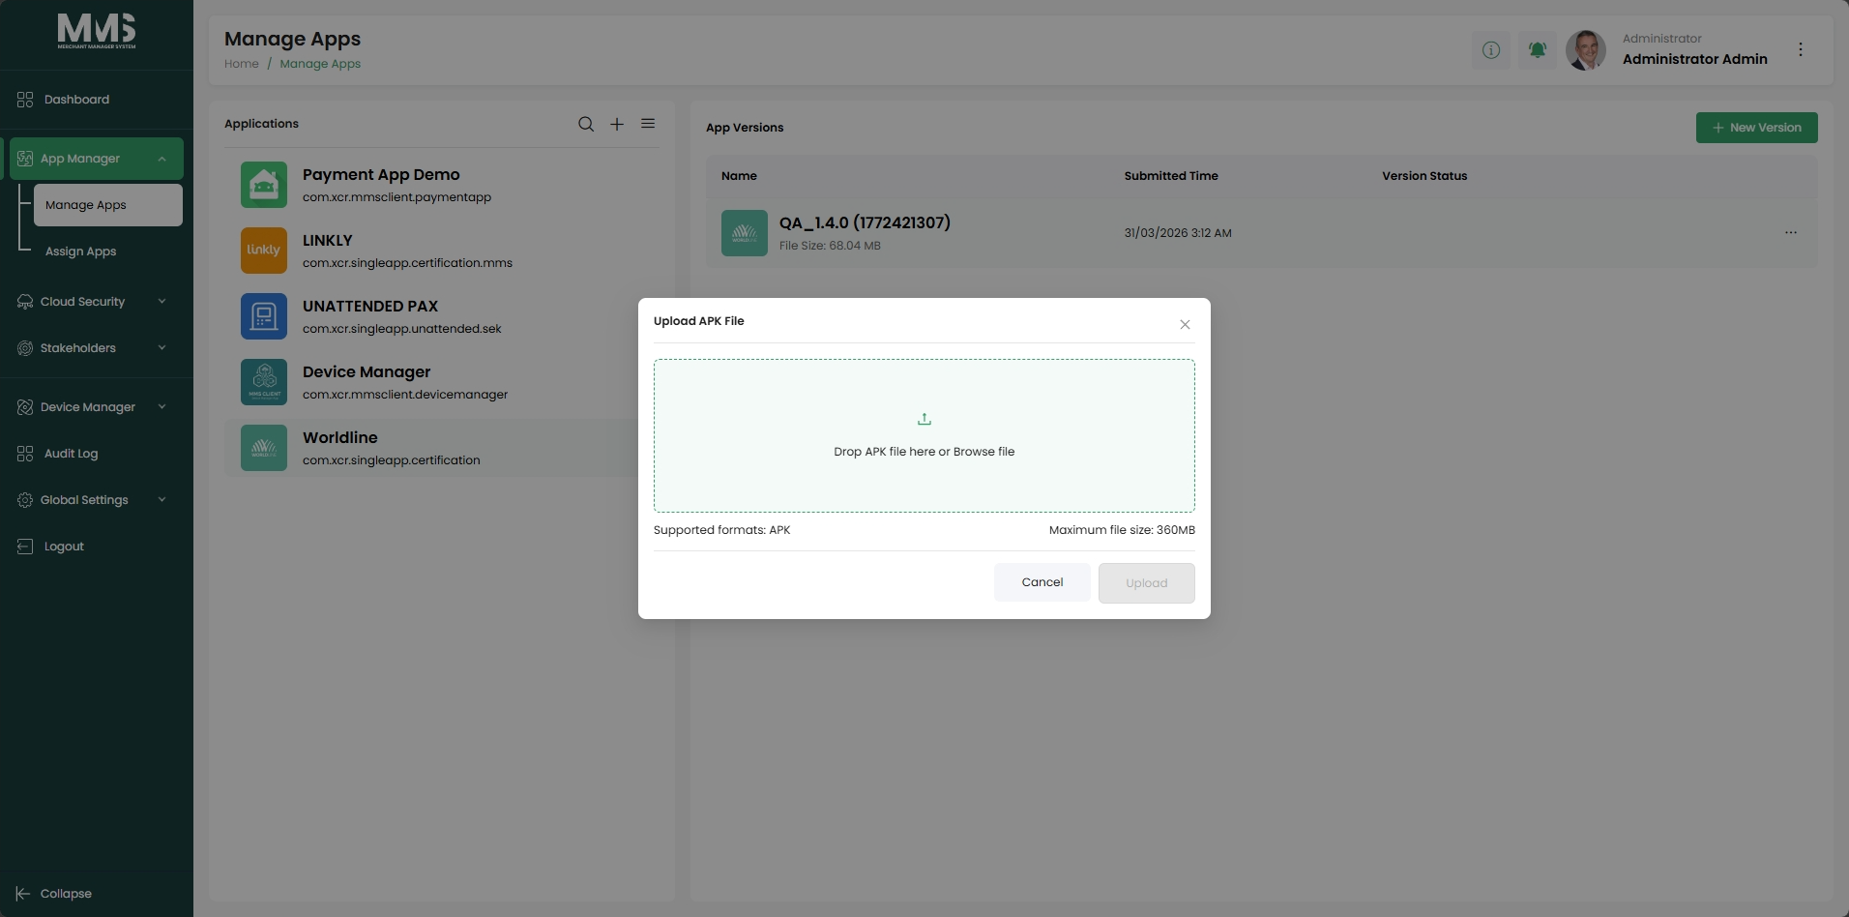
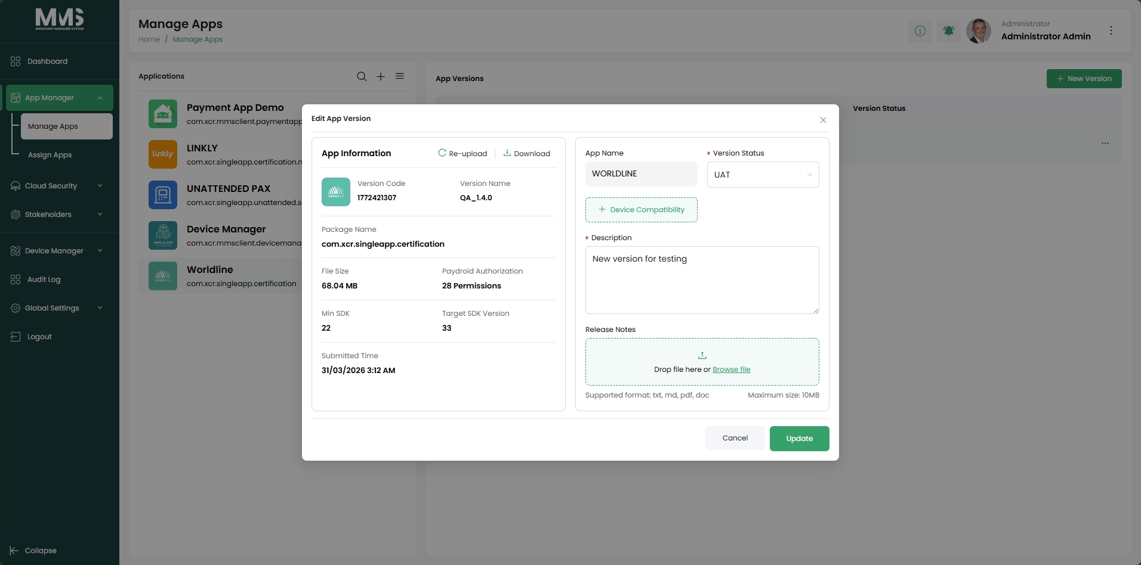

4.2. Assign Applications
Description:
This guide explains how to assign applications to companies and create base templates to standardize configuration settings across merchants and devices.
Additional Information:
Detailed setup is provided in the App Template documentation.
Reference Images:
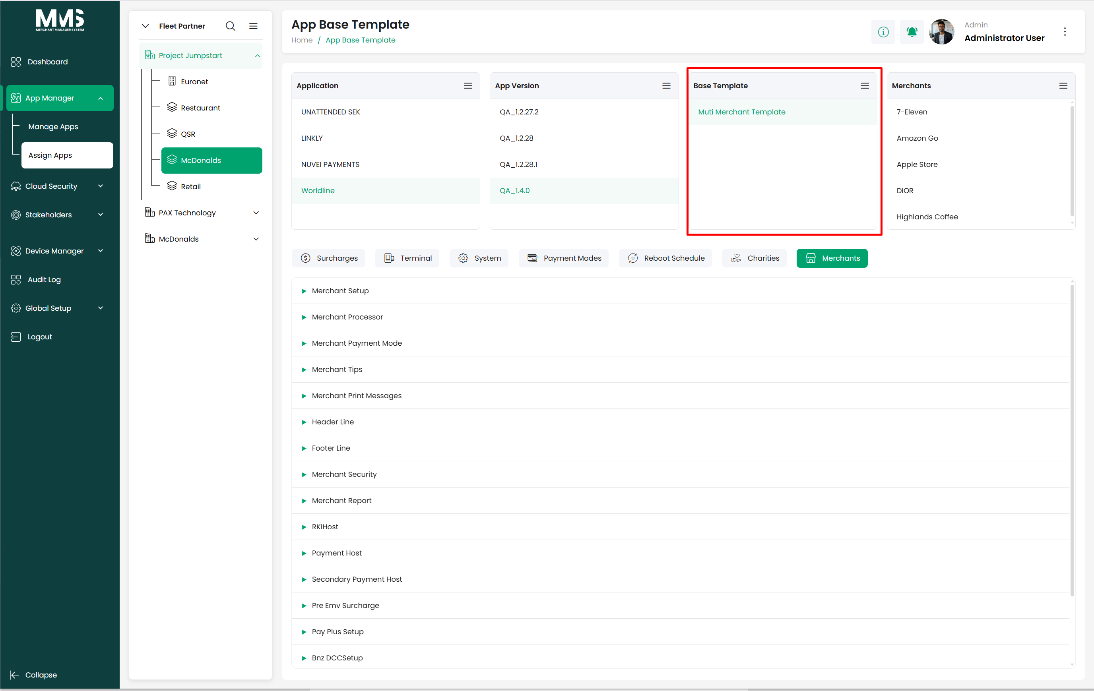

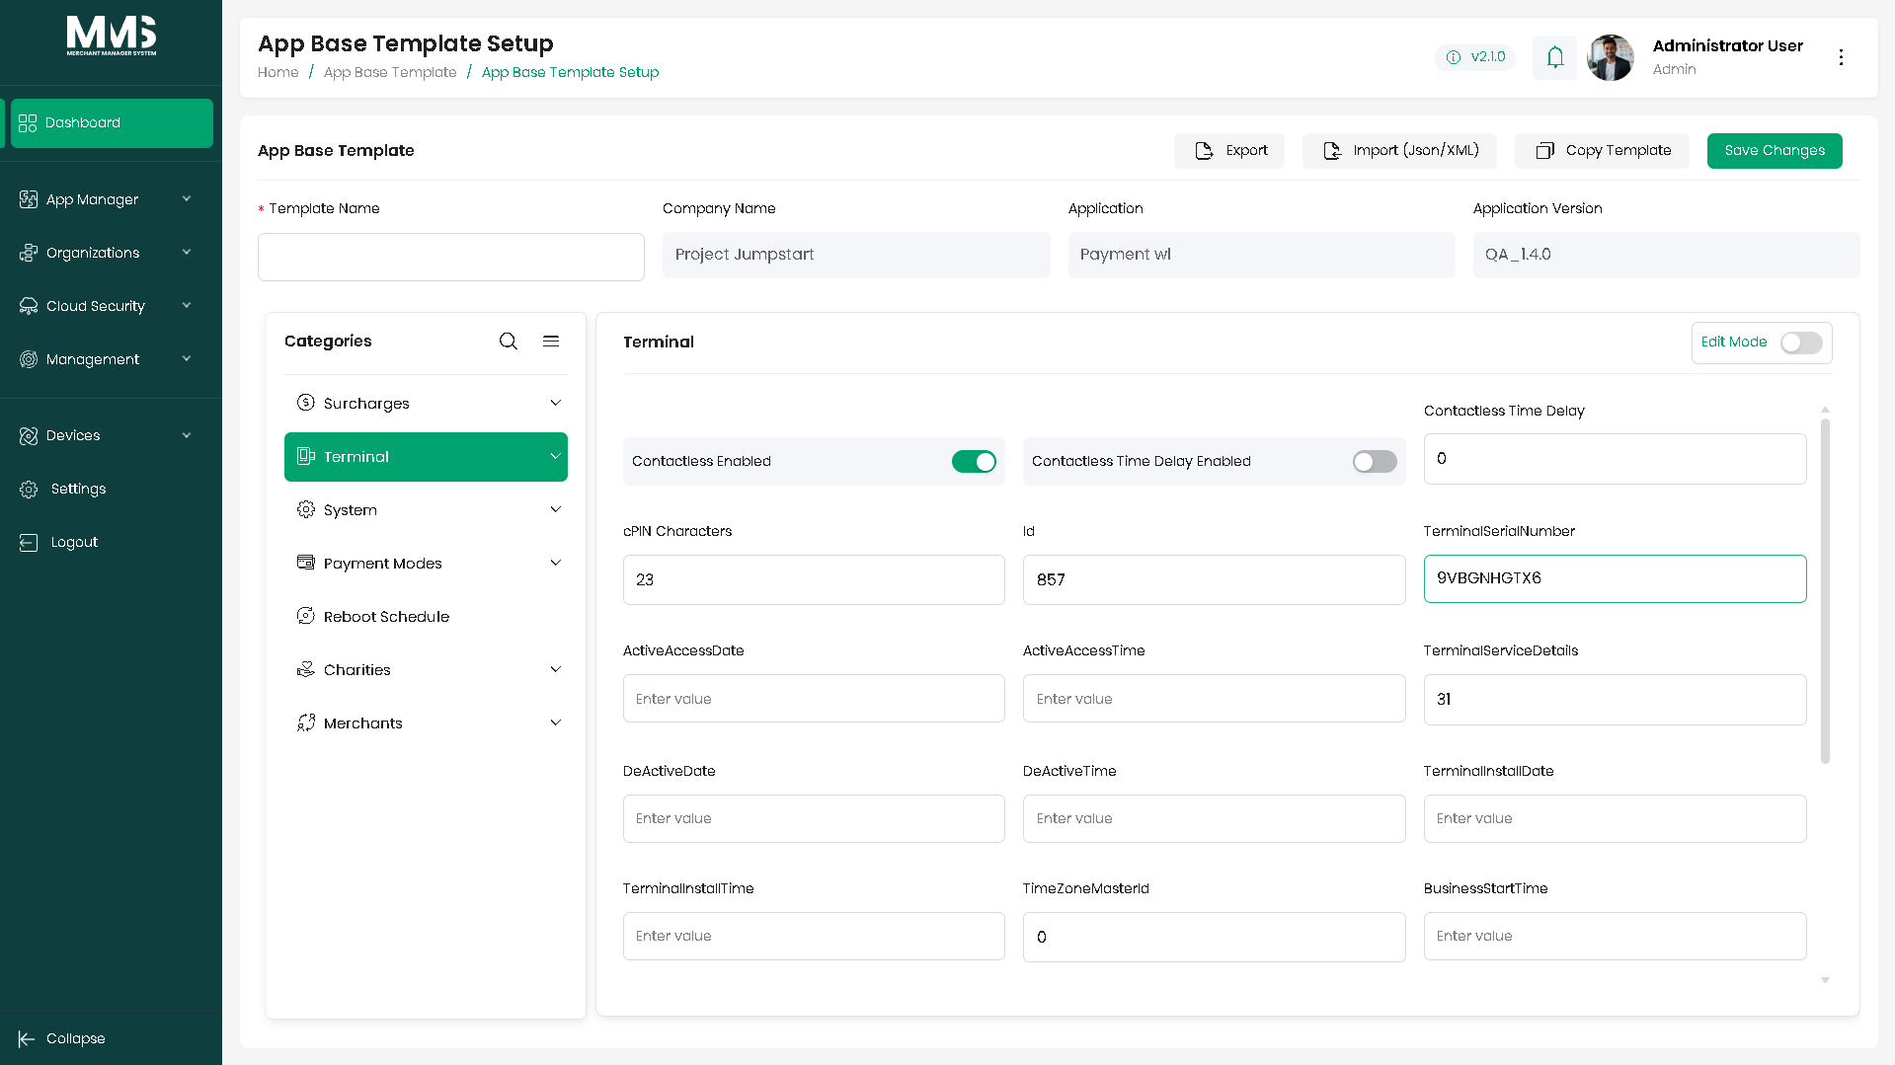
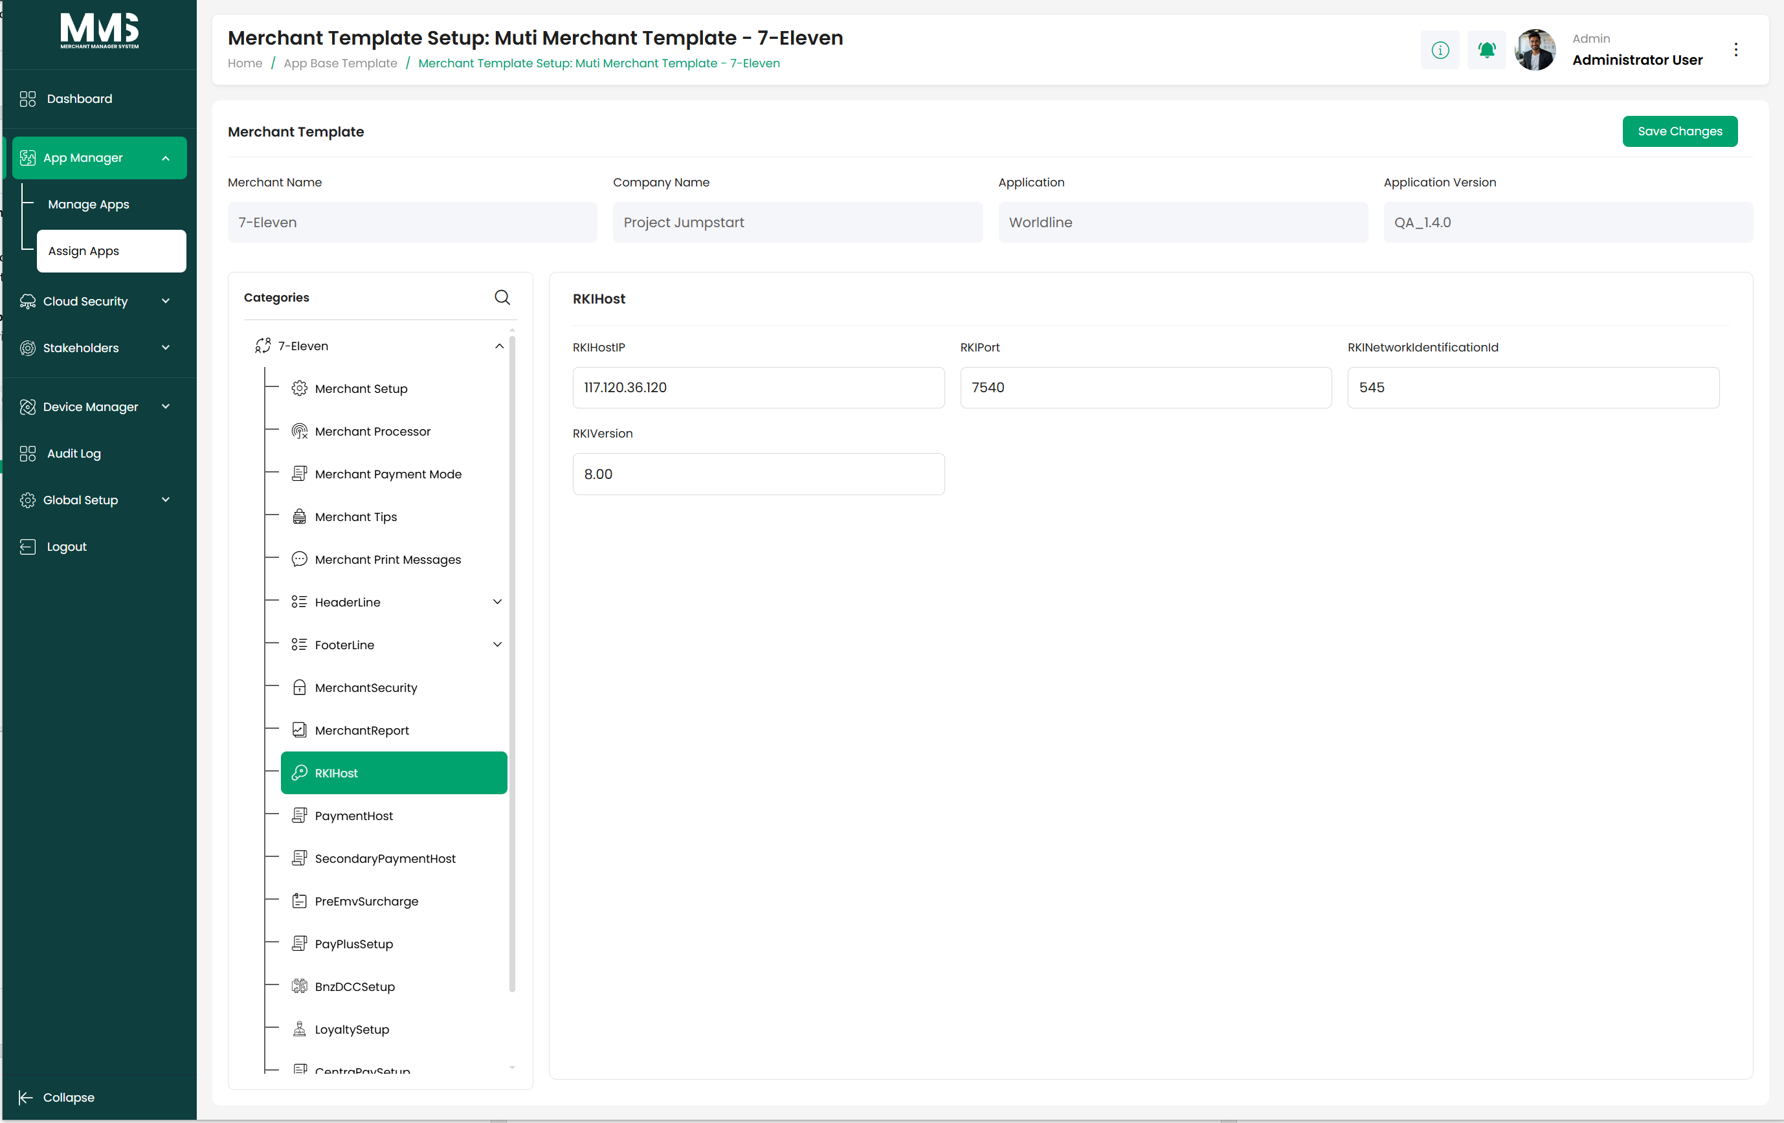

5. Cloud Security

5.1. Cloud Security Template
Description:
This guide explains how to create and manage reusable permission templates that define user roles and device access within the system. Templates simplify user onboarding and ensure consistent access control across multiple users.
Steps to Manage Permission Templates:
- View the list of existing templates
- Click Create Security Template
- Enter template information (e.g., Template Name, setup permisson)
- Define allowed actions for users, including:
  - Access to specific cloud modules
  - Permissions for system functions
- Click Save to create the permission template
- Select an existing template from the list to view or update details
Reference Images:
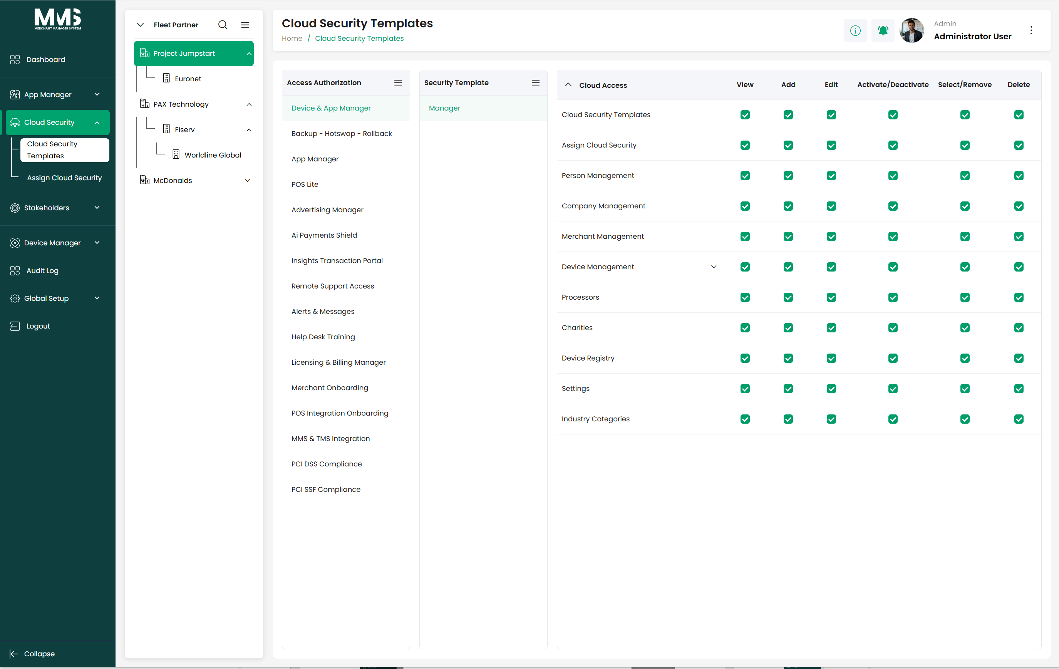
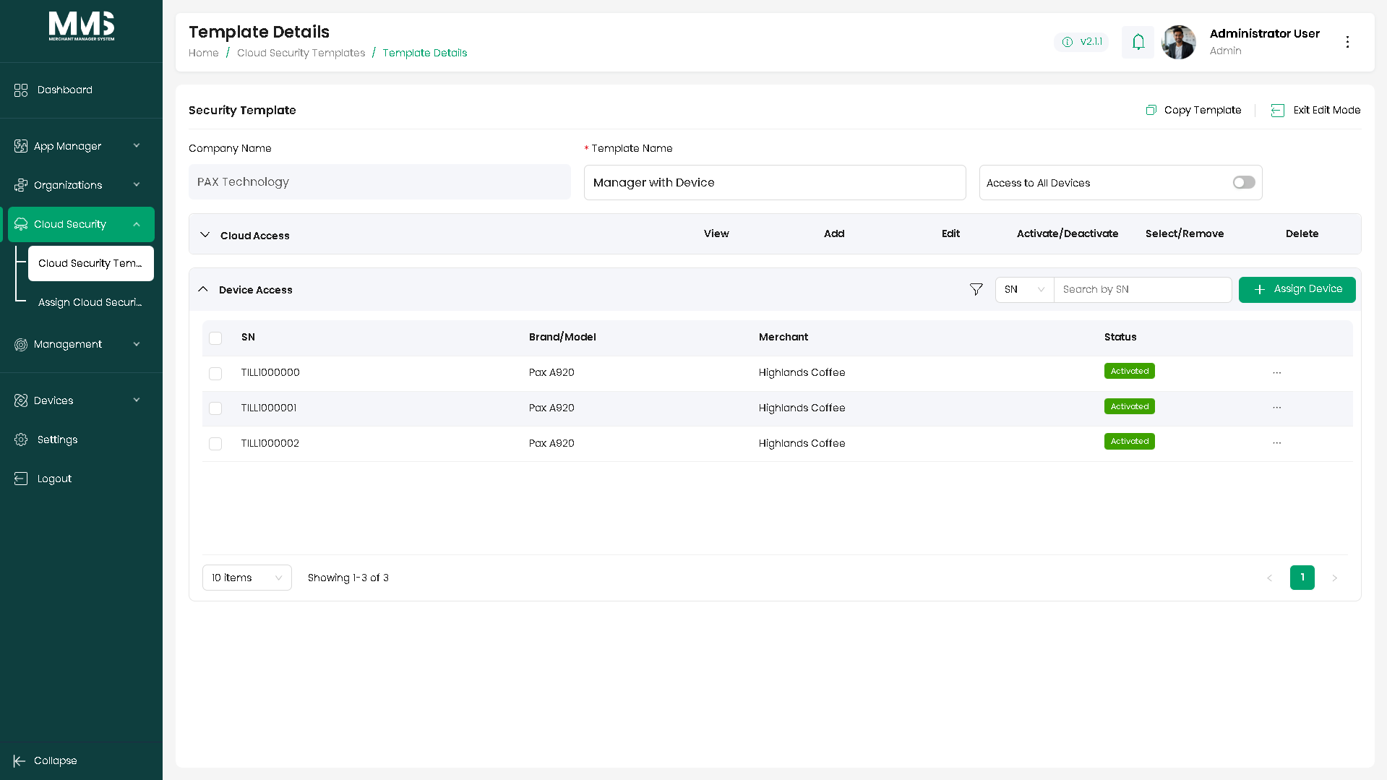
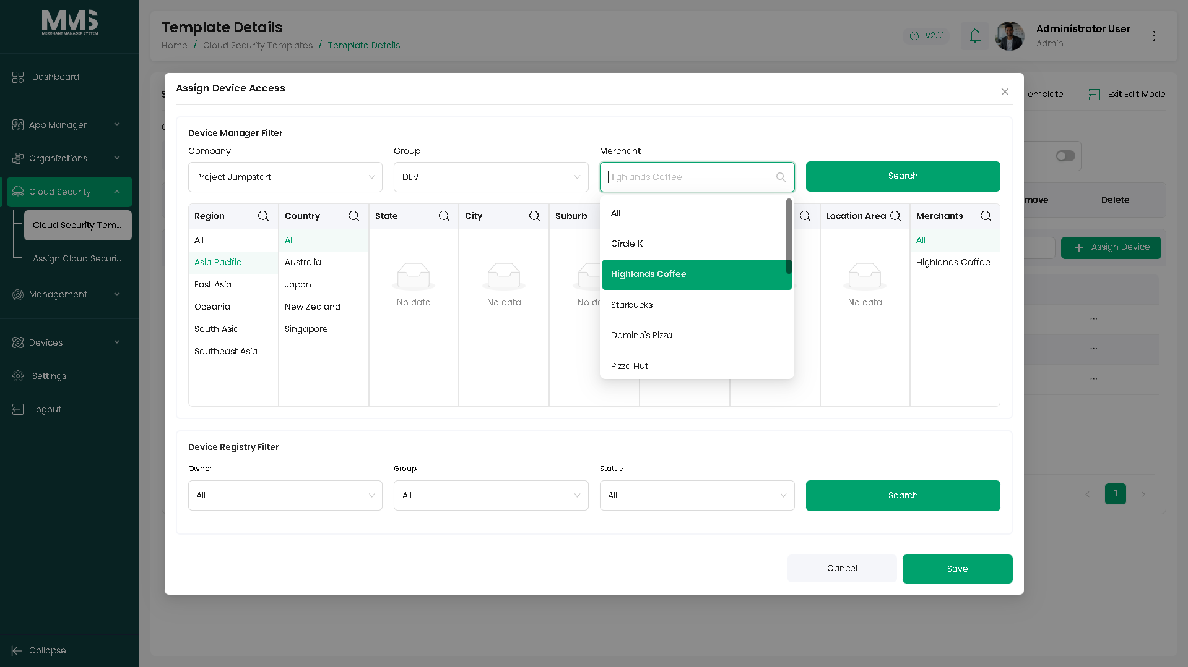

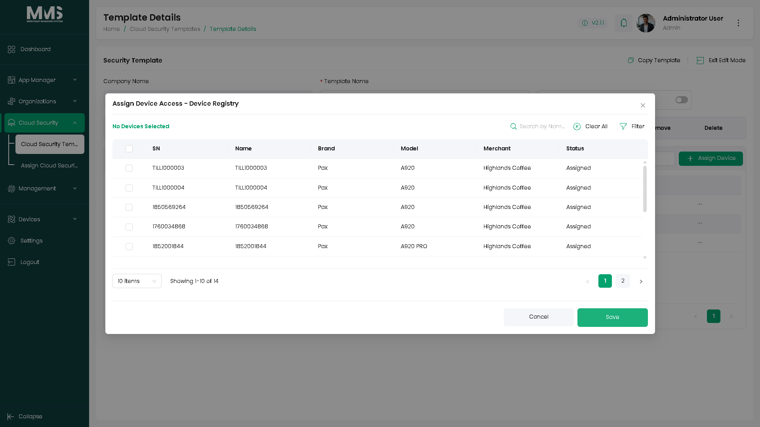

5.2. Assign Cloud Security - Restrict Access
Description:
This guide explains how to assign company-specific security templates to users, enabling consistent, role-based access control. Users inherit all permissions defined in the selected template automatically upon login, and administrators can restrict permissions, merchant locations, or linked merchants as needed.
Steps to Assign Security Templates:
- Select a Company
  - The system will load all Security Templates defined for that company
- Choose the Security Template to apply
- Select one or multiple Users of the company
  - Users must be previously set up in Company → Company User
- Optionally restrict permissions for selected users:
  - Limit specific actions/modules
  - Restrict access to certain Merchant Locations
  - Restrict access to specific Linked Merchant Groups
- Click Assign to apply the template and restrictions to the selected users
- Confirm the assignment
- Upon login, users inherit the permissions defined in the template, with any applied restrictions
Reference Images:
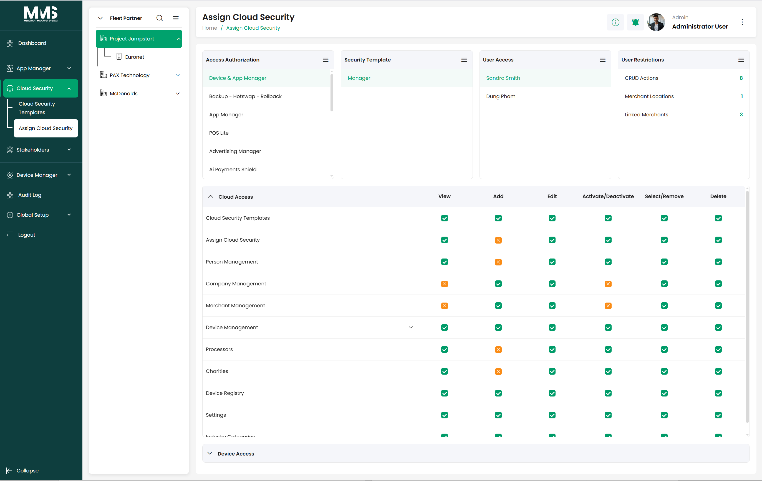
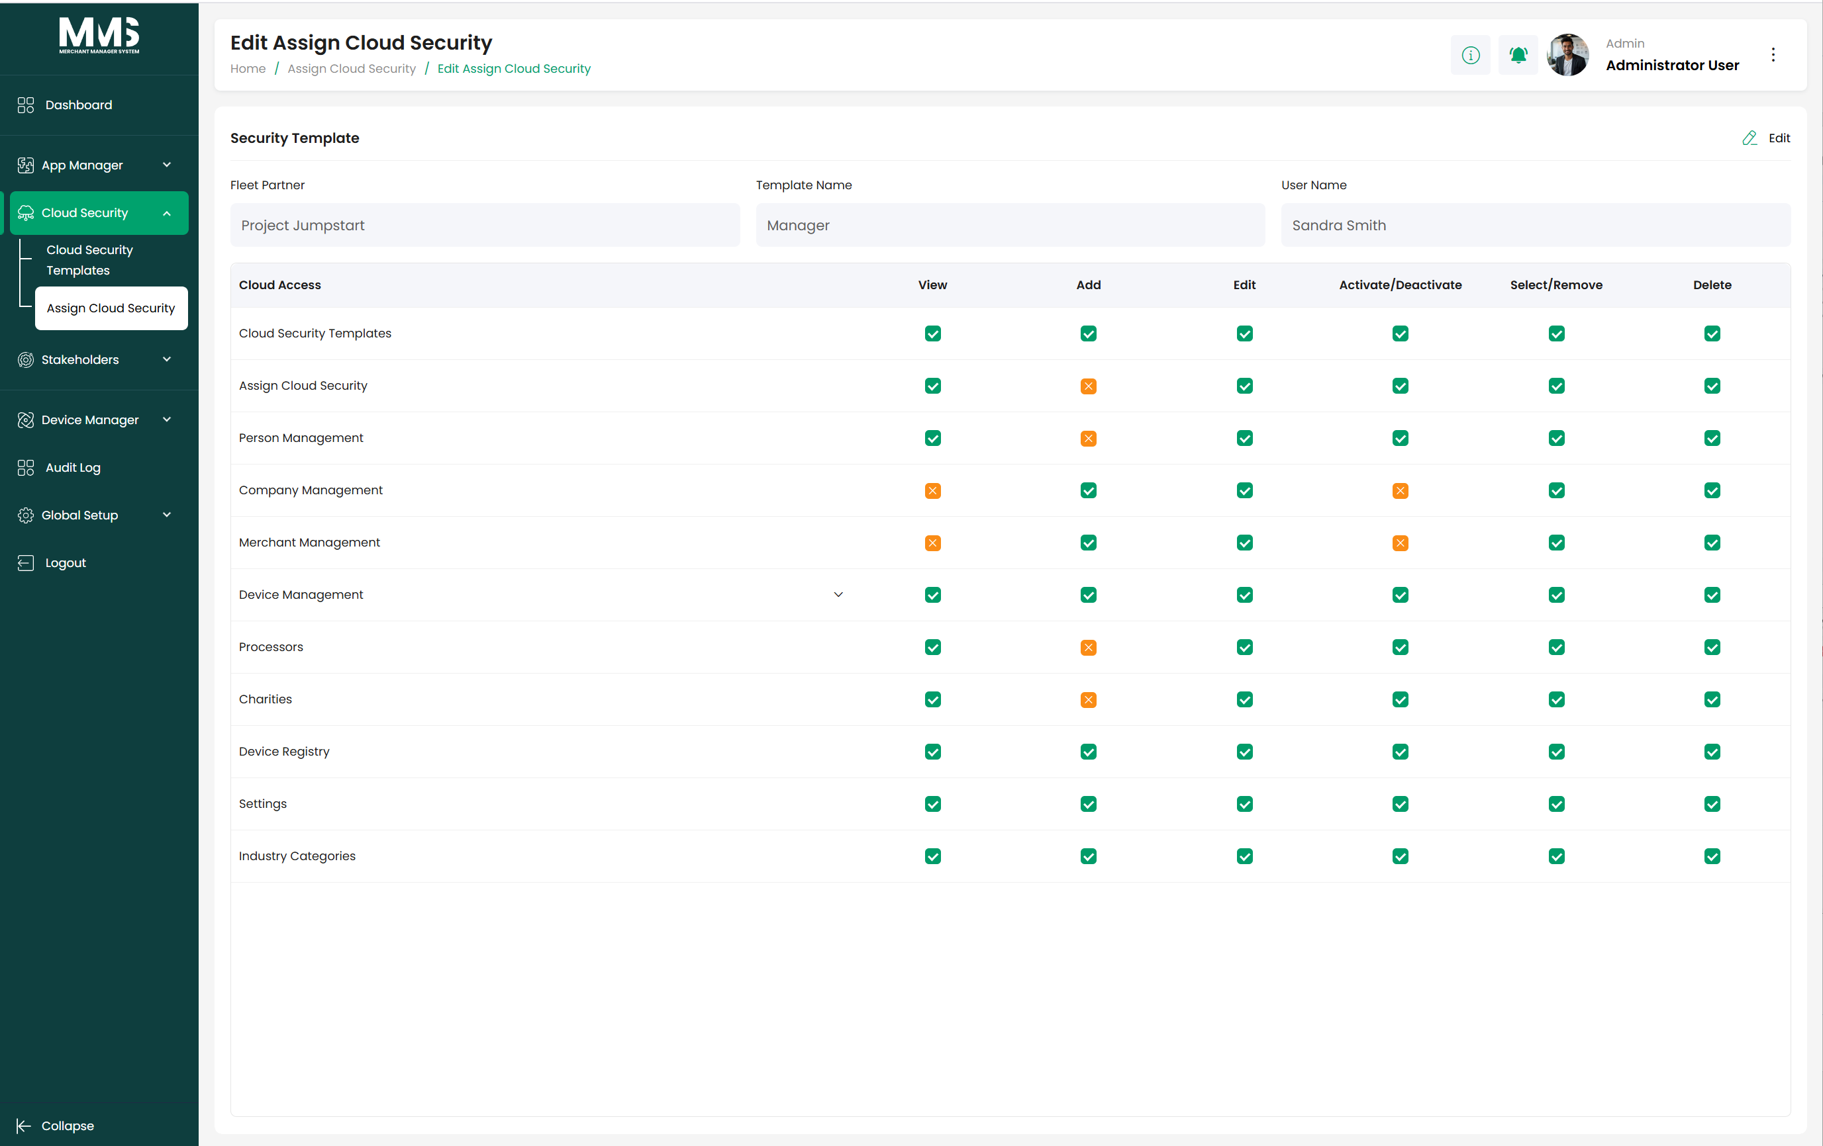
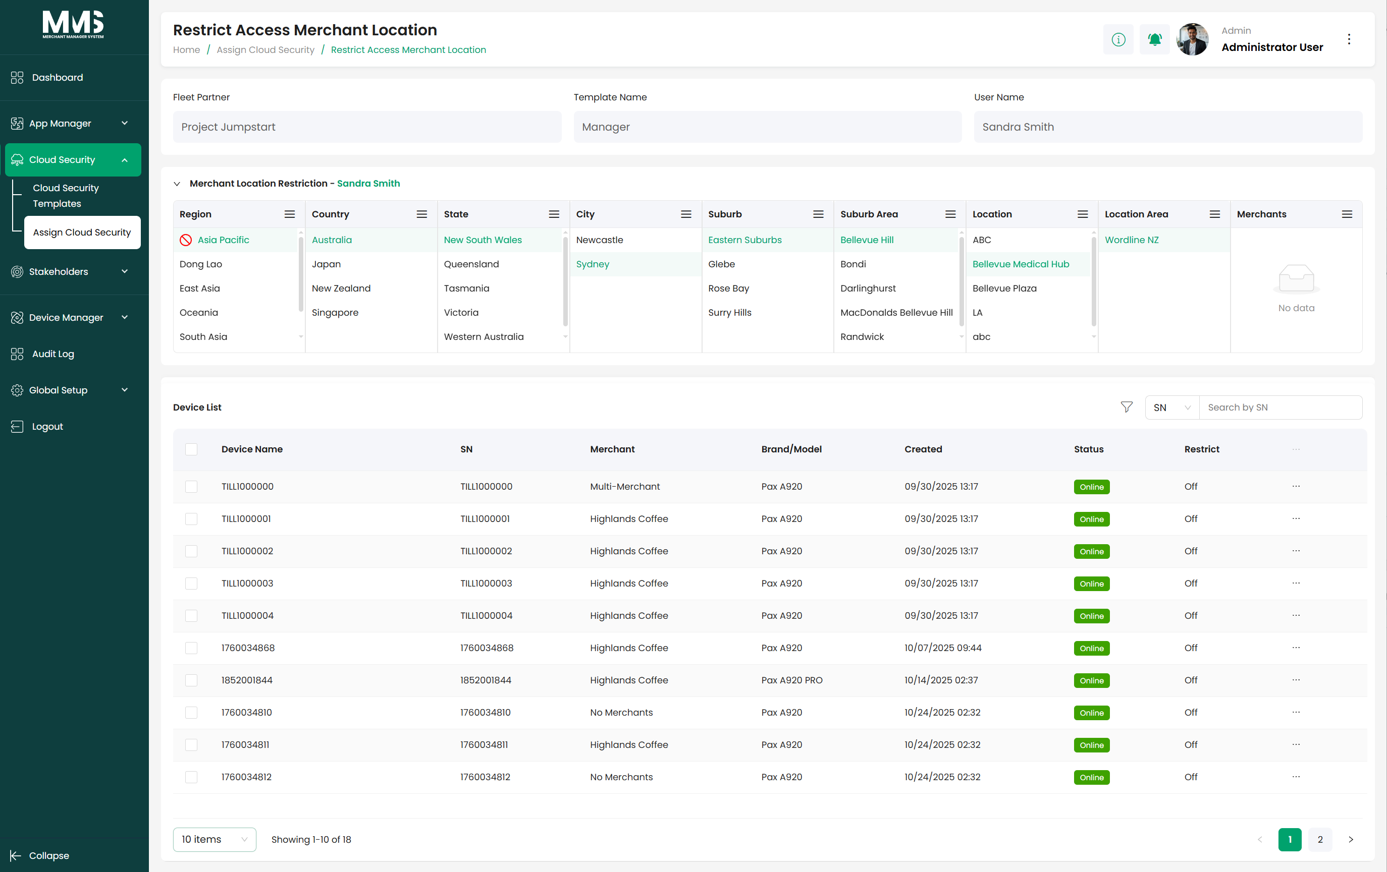
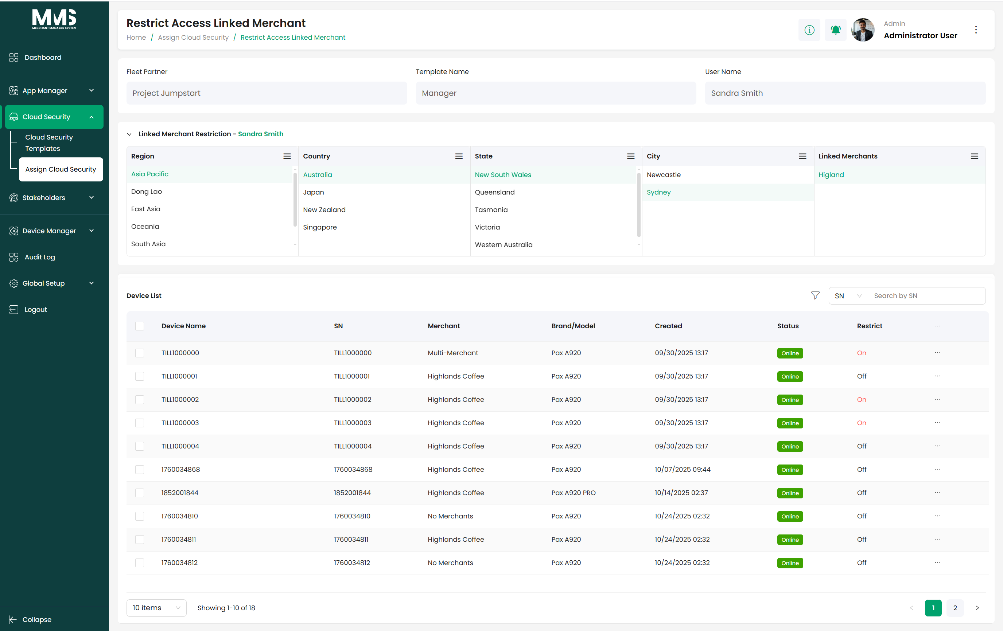

6. Global Setup

6.1. Settings
Description:
Provides centralized configuration options for managing system-wide and integration-related settings. The Settings module allows administrators to control global behavior, integrations, and core MMS configurations from a single location.
Key Capabilities:
- MMS Configuration: Configure core system settings that control overall MMS behavior and operational rules
- Integration Setup: Manage and configure integrations with external systems and services
- Global Setup: Define global parameters
- File Cleanup Settings: Manage your file logs retention and automatic cleanup policies.
Reference Images:
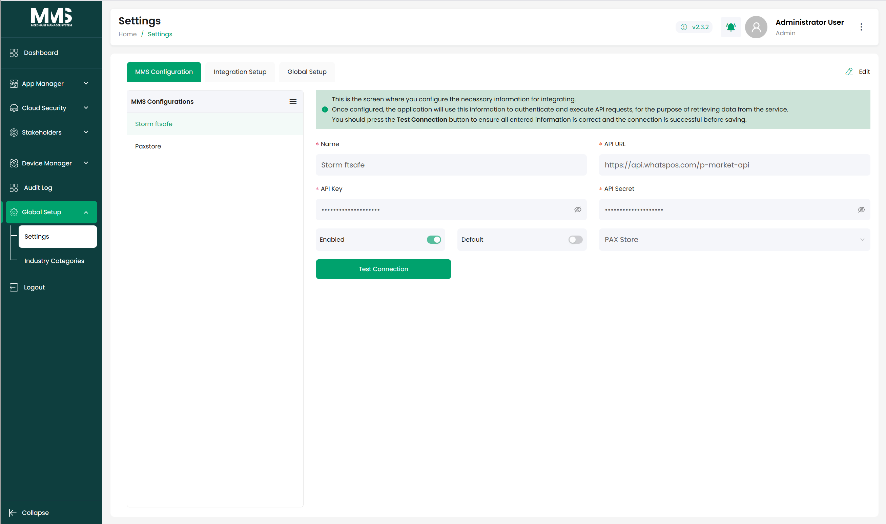

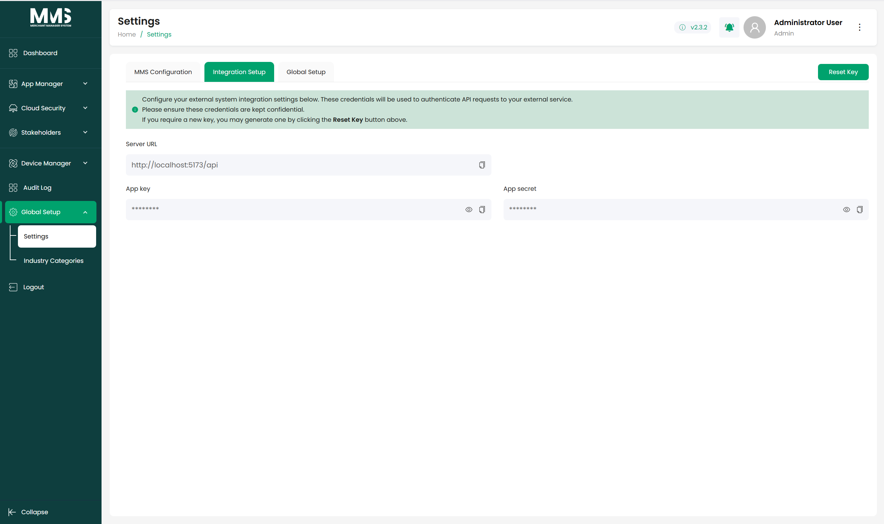
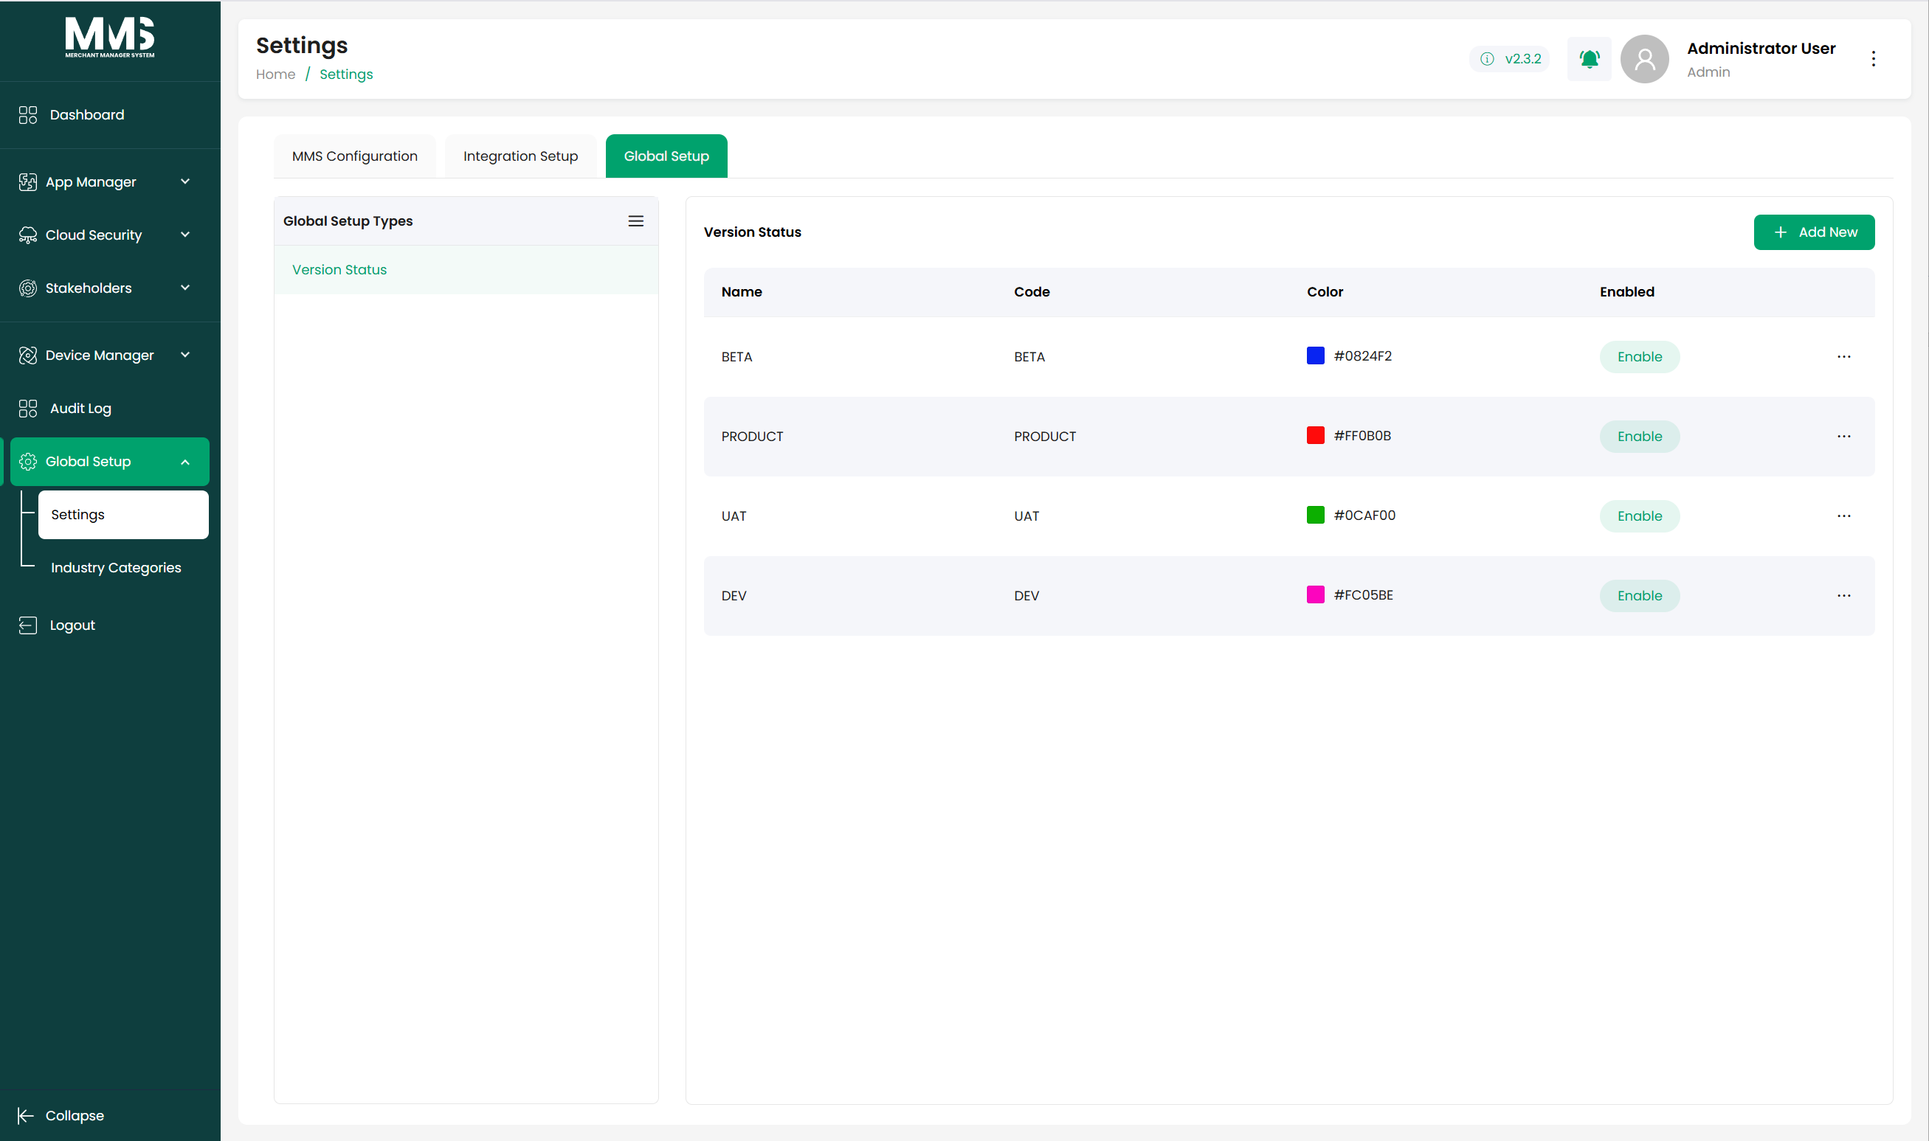
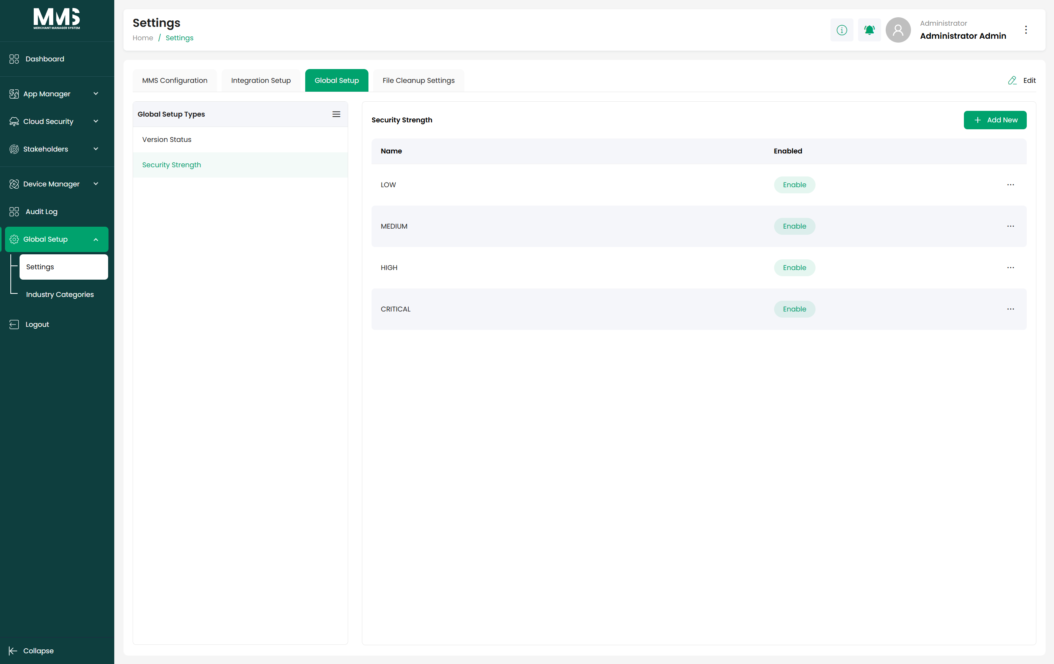
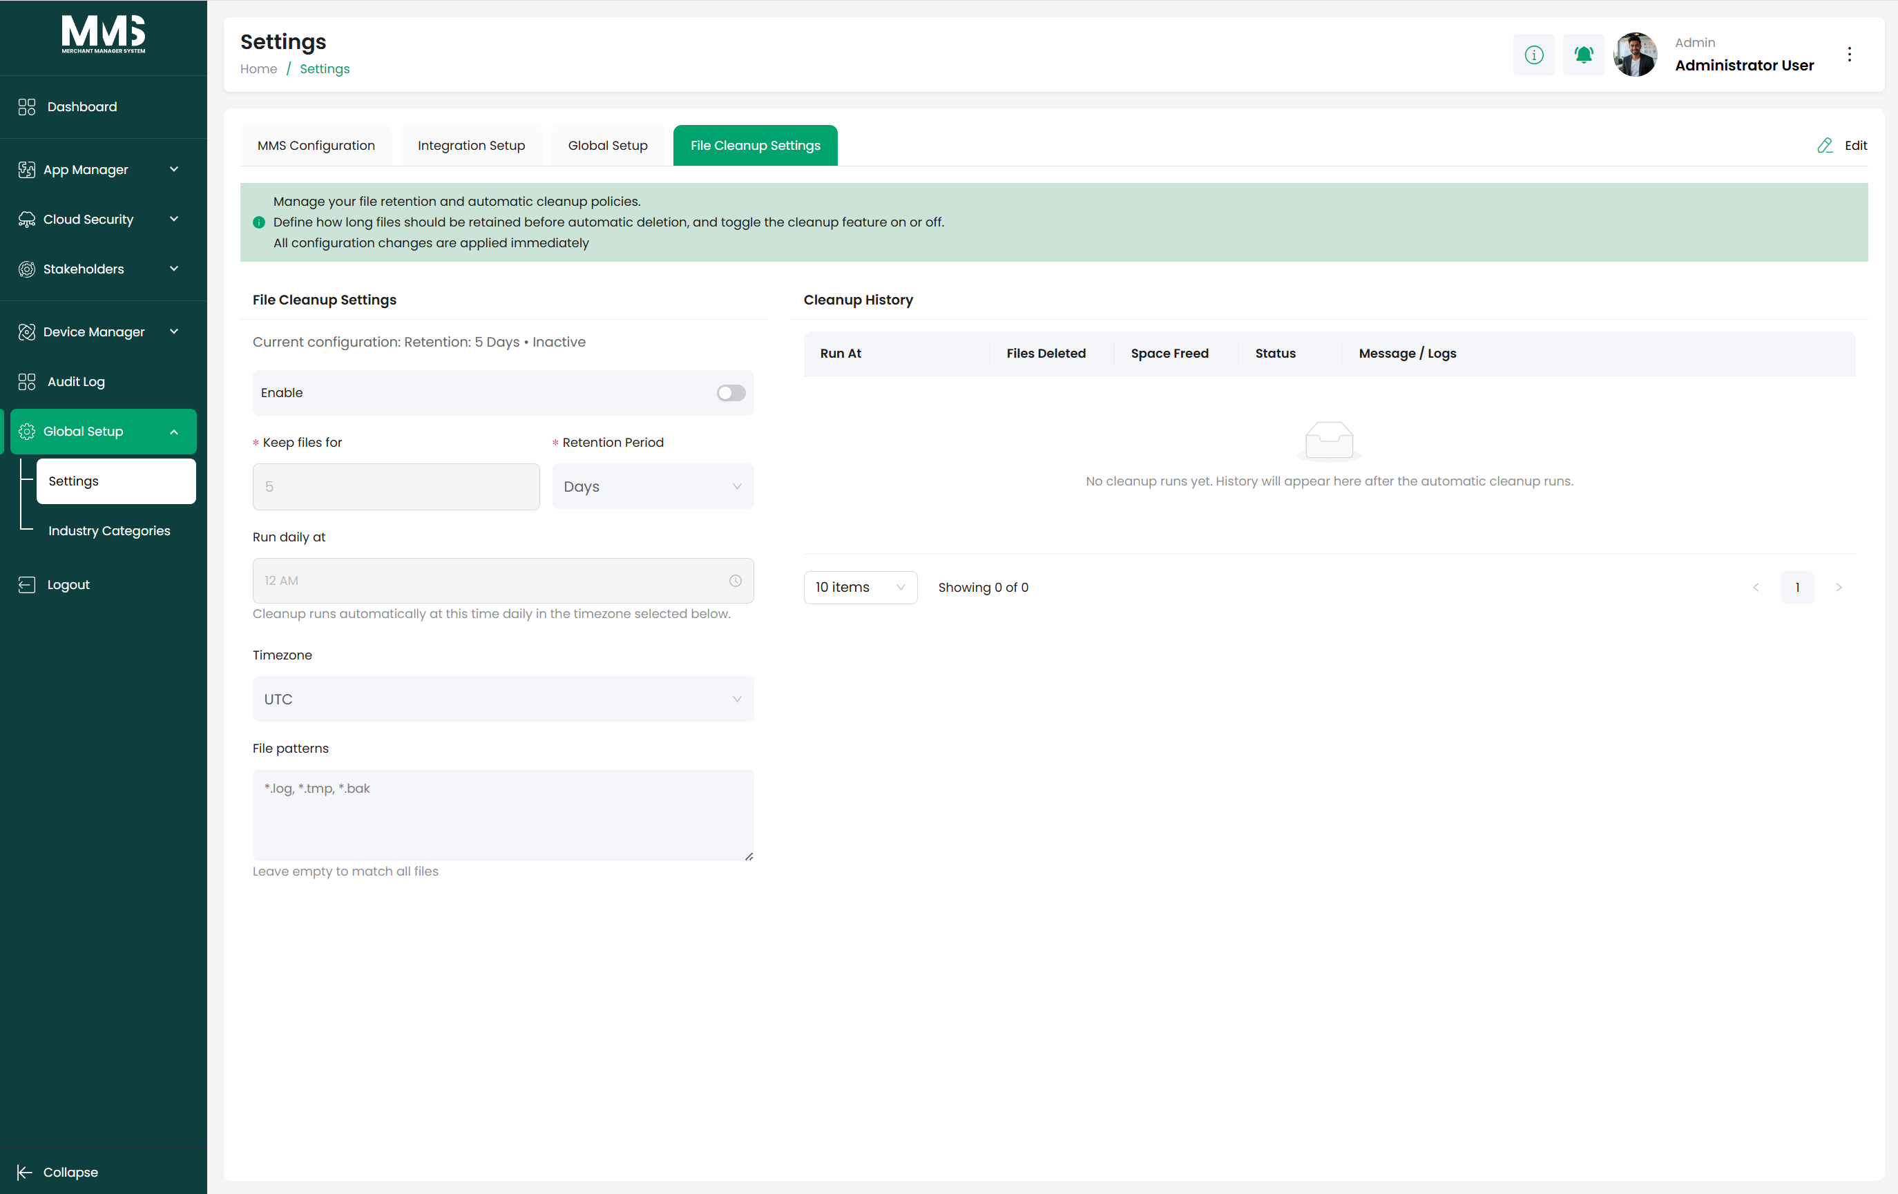

6.2. Industry Categories
Description:
Provides a standardized classification framework for defining industry types and industry categories within the system. Industry Categories are used to consistently classify merchants, enabling better organization, configuration, reporting, and industry-specific behavior across the platform.
Key Capabilities:
- Manage a centralized list of Industry Types (e.g., Retail, Hospitality, Restaurant, Hotel)
- Manage a centralized list of Industry Category (e.g., Cocktail Bar, Wine Bar, Fashion, Hardware)
Reference Images:
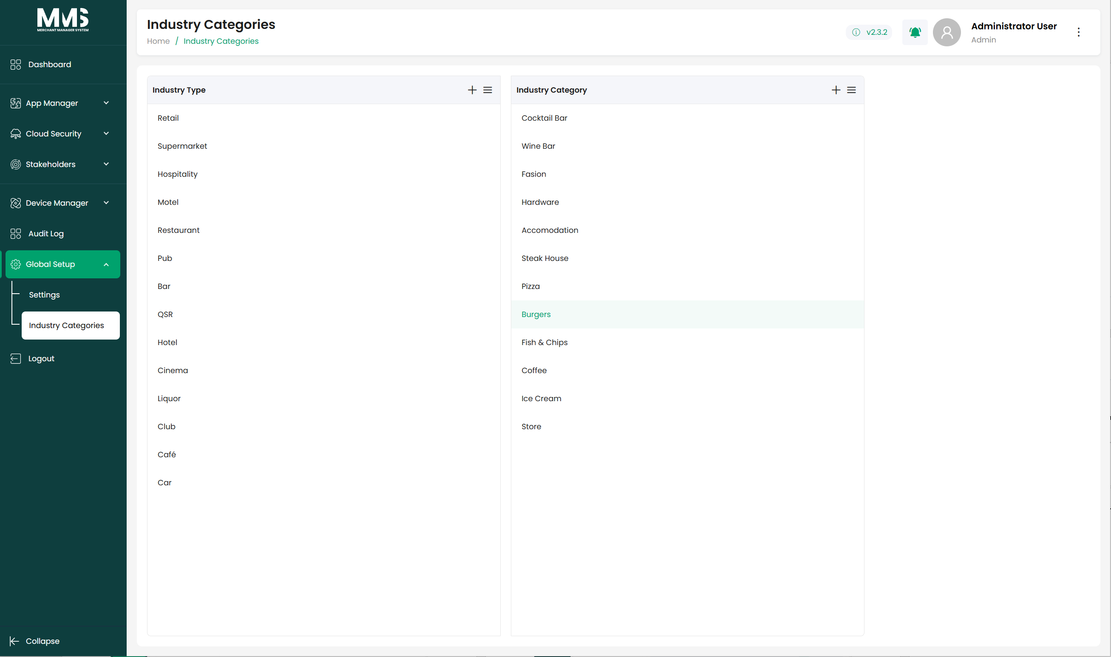

6.3. Timeouts
Description:
Provides centralized session timeout management to control user inactivity behavior across the system. The Timeouts module enables administrators to define default idle session durations, warning countdowns before automatic logout, and exception-based timeout extensions for specific pages or modules. This helps improve platform security while maintaining usability for operational workflows that require extended active sessions.
Key Capabilities:
- Configure a global session idle policy for automatic logout after inactivity
- Define default idle timeout duration for all users and sessions
- Configure warning countdown duration before session expiration
- Display session activity timeline including active, warning, and logout states
- Manage Time Extension White List for specific modules or pages requiring longer session duration
- Configure extended timeout values for selected routes or system functions (e.g., Audit Log)
- Support centralized editing and maintenance of timeout configurations across the platform
Reference Images:
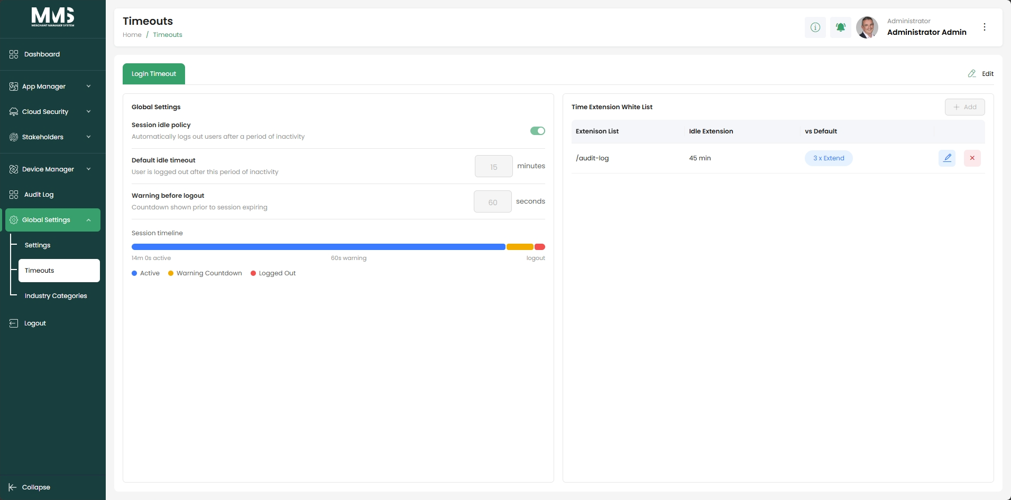

7. Audit Logs
Description:
Provides centralized audit logging and activity tracking across the system. The Audit Log module records user actions, configuration changes, system events, and operational activities to ensure traceability, accountability, and security monitoring. It enables administrators to review historical activities, monitor system usage, and support compliance and troubleshooting processes.
Key Capabilities:
- Capture and maintain detailed records of user and system activities
- Track configuration changes, updates, and operational actions performed within the platform
- Record user information, IP address, accessed resource URL, and event timestamp for each activity
- Provide separate views for Operation Logs and System Logs
- Support centralized monitoring of administrative and operational events
- Enable filtering and searching of audit records for easier investigation and analysis
- Support export of audit log data for reporting, compliance, and external review purposes
- Provide chronological tracking of activities to support troubleshooting and security investigations
- Support pagination and scalable viewing of large audit datasets
Reference Images:
